Beyond HEPA: Part III

Clinical Evidence of Harm from Submicron Particulates (<0.3 µm) and Implications for Post-Remediation Health

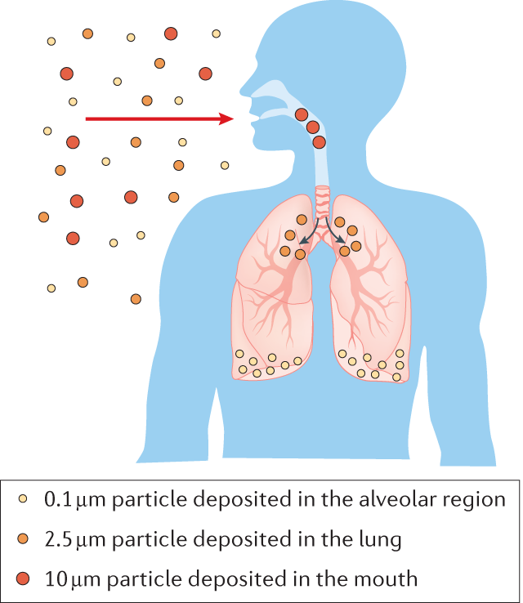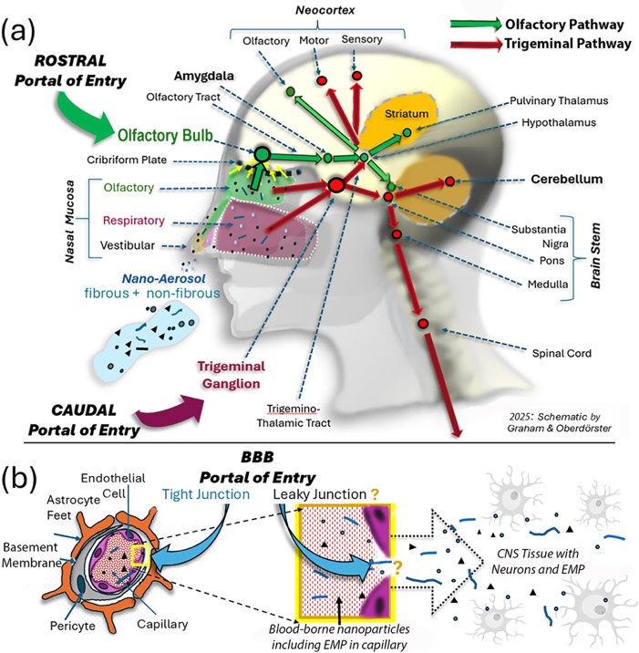

White Paper: Clinical and Translational Observations
By Cesar Collado

Executive Summary
Post-remediation environments frequently meet established visual, moisture, and spore-based clearance criteria, yet a subset of occupants continues to experience persistent respiratory, neurological, and systemic symptoms. This recurring clinical pattern suggests that conventional remediation endpoints do not fully capture biologically relevant exposure.
Evidence from aerosol science, environmental microbiology, and clinical research indicates that a substantial portion of residual exposure exists within the submicron particulate fraction (<0.3 µm). In indoor environments impacted by mold, this fraction is dominated not by intact spores, but by fragmented fungal material, hyphal debris, and dust-bound microbial metabolites, including mycotoxins.
These particles are exponentially more numerous than larger particles, remain airborne for prolonged periods, penetrate deeply into the respiratory tract, and are capable of initiating both local and systemic inflammatory responses. Experimental and clinical literature further demonstrates that ultrafine particles may access central nervous system pathways directly or indirectly through inflammatory signaling.
Importantly, these mechanisms may occur despite negative urine mycotoxin testing, as environmental exposure and systemic excretion are governed by different biological variables.
This paper synthesizes clinical and mechanistic evidence supporting the role of submicron particulate exposure in persistent post-remediation illness and reframes mold exposure as a problem of particle behavior and biological interaction, rather than organism viability alone.

The Clinical Disconnect: Clean Environment, Persistent Symptoms
Across multiple clinical disciplines, a consistent pattern is observed in patients recovering from mold exposure. Homes that have undergone remediation often meet inspection standards and pass environmental testing, yet occupants continue to report symptoms including cognitive dysfunction, fatigue, respiratory irritation, and heightened environmental sensitivity.
This disconnect is not adequately explained by residual active mold growth. Instead, it reflects a limitation in how exposure is currently measured and understood. Traditional assessment methods focus on viable organisms and spore counts, while largely overlooking the contribution of non-viable particulate matter that persists in the environment.
Prior observations have established that post-remediation spaces may contain significant concentrations of ultrafine particles composed of fungal fragments and toxin-associated dust, even when conventional metrics indicate successful cleanup . These particles represent a biologically active exposure pathway that is not captured by standard testing methodologies.

The Exponential Burden of Submicron Particles
Aerosol physics provides a critical framework for understanding this phenomenon. Particle number increases exponentially as particle diameter decreases, resulting in a disproportionately large population of ultrafine particles in indoor air.
Typical indoor particle distributions demonstrate that concentrations increase from approximately 10⁶ particles per cubic meter at 0.3 µm to 10⁷–10⁸ particles per cubic meter at 0.12 µm . This shift represents a 10–100 fold increase in particle number within a size range that is highly respirable and biologically active.
This distribution is not theoretical. It reflects fundamental aerosol dynamics. The practical implication is that exposure within the submicron range is dominated by particle number, not particle mass. As a result, even small residual concentrations of ultrafine material may represent a significant biological burden.
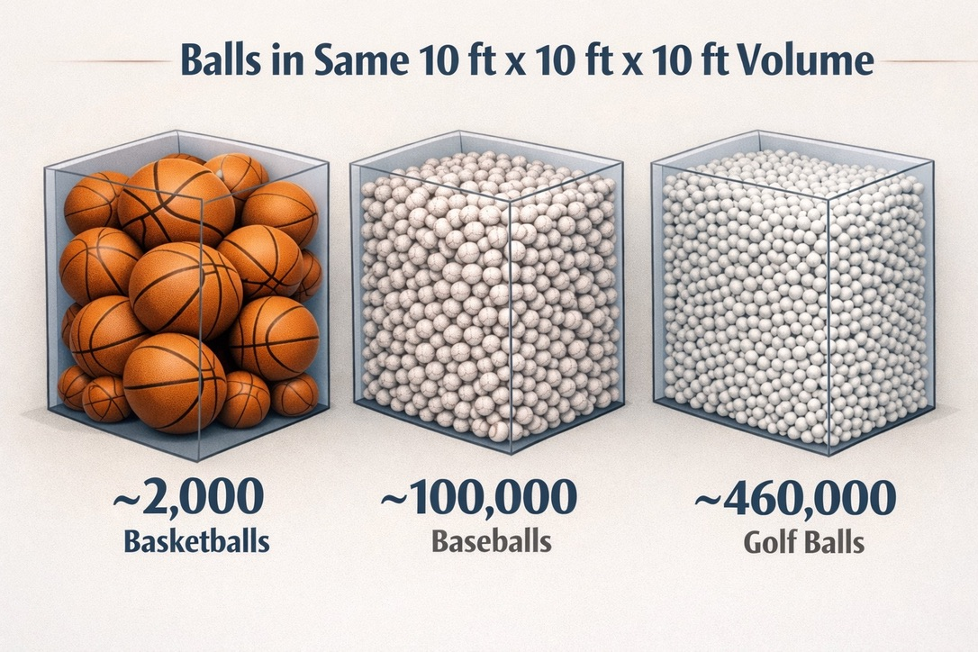

Fungal Fragments: The Dominant Residual Exposure
Mold growth generates a complex mixture of particulate matter beyond spores, including fragmented hyphae, cell wall components, and microbial debris. Mechanical disturbance, drying cycles, and remediation activities further increase fragmentation, producing large quantities of submicron particles.
Górny et al. (2002) demonstrated that fungal fragments are present in concentrations exceeding those of intact spores and are predominantly submicron in size. These particles persist in indoor environments long after active growth has been eliminated and are readily re-aerosolized with minimal disturbance.
From an exposure standpoint, this shifts the dominant inhalable material from spores to fragments. This transition has significant clinical implications, as fragments differ from spores in both aerodynamic behavior and biological impact.
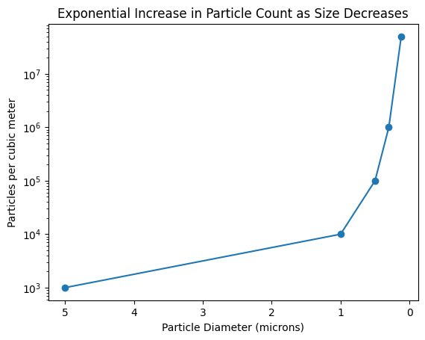

Mycotoxins and Particle-Bound Exposure
Mycotoxins are low-volatility compounds that associate with particulate matter rather than existing as freely diffusing gases in typical indoor environments. Brasel et al. (2005) demonstrated the presence of airborne mycotoxins bound to dust particles independent of fungal viability.
This finding establishes two important principles. First, elimination of active mold growth does not eliminate toxin-associated exposure. Second, the persistence of mycotoxins is governed by the behavior of particles rather than the presence of living organisms.
From a clinical perspective, this helps explain why patients may continue to experience symptoms after remediation and why traditional testing methods, including spore-based sampling and urine mycotoxin assays, may not correlate with ongoing exposure.

Respiratory Deposition and Systemic Signaling
Submicron particles deposit efficiently in the alveolar regions of the lung, where clearance mechanisms are limited and immune interactions are pronounced. Cho et al. (2006) demonstrated that fungal fragments exhibit greater respiratory deposition than intact spores due to their smaller aerodynamic diameter.
Once deposited, these particles initiate local inflammatory responses characterized by cytokine release and oxidative stress. Even in the absence of significant systemic translocation, pulmonary inflammation can propagate systemic signaling pathways that influence distant organs, including the central nervous system.
This indirect mechanism provides a biologically plausible pathway linking inhaled submicron mold fragments to systemic symptom profiles observed in environmentally sensitive individuals.

Neuroinflammatory Pathways and Central Nervous System Effects
Ultrafine particles have been shown to interact with the central nervous system through multiple pathways. Experimental studies demonstrate that particles in the ultrafine range can translocate along the olfactory nerve, bypassing the blood–brain barrier and reaching the olfactory bulb.
In addition, inflammatory signaling originating in the lungs can alter blood–brain barrier permeability and promote neuroinflammation. Block and Calderón-Garcidueñas (2009) reviewed evidence linking ultrafine particulate exposure to microglial activation and neurodegenerative processes.
Clinically, these mechanisms may manifest as cognitive dysfunction, mood disturbances, sleep disruption, and autonomic instability. Importantly, these effects may occur independently of measurable systemic toxin levels, reflecting localized exposure and signaling rather than systemic accumulation.

Why Conventional Testing Underestimates Exposure
Current environmental assessment methods are not designed to quantify submicron particulate burden. Spore-based air sampling captures viable organisms but does not detect non-viable fragments or toxin-associated dust. DNA-based methods quantify genetic material but do not provide information on particle size distribution or inhalation dynamics.
Similarly, urine mycotoxin testing reflects systemic absorption and excretion over a limited time window and does not measure localized deposition or tissue-level interactions. Environmental burden and biological excretion are governed by distinct processes, and the absence of detectable urinary metabolites does not exclude ongoing inhalation exposure.
This limitation contributes to the observed disconnect between environmental measurements and clinical outcomes.

Implications for HEPA Filtration and Post-Remediation Cleaning
HEPA filtration is highly effective at capturing particles that reach the filter; however, capture efficiency assumes that particles are successfully entrained into airflow. Submicron particles behave differently from larger particles. They adhere electrostatically to surfaces, remain suspended in boundary layers, and re-aerosolize with minimal disturbance.
As previously described, these particles behave more like aerosols than settled dust, allowing them to persist in indoor environments despite conventional cleaning efforts . As a result, environments may meet HEPA-based clearance criteria while still containing substantial ultrafine particulate loads.
Addressing this fraction requires strategies that account for particle behavior, including agglomeration and high-efficiency removal within the submicron range.

Implications for Sensitive Populations
Individuals with heightened sensitivity to environmental exposures, including those with mast cell activation, chronic inflammatory conditions, or prior mold-related illness, may exhibit increased susceptibility to submicron particulate exposure. In these populations, even low levels of residual particulate matter can trigger disproportionate physiological responses.
This susceptibility provides a coherent explanation for symptom persistence and relapse following re-entry into remediated environments. The clinical experience of these individuals aligns with the mechanistic evidence supporting the biological impact of ultrafine particles.

Addressing Skepticism
It is appropriate to anticipate skepticism regarding the role of submicron mold fragments in clinical outcomes.
“Most clinical data involve combustion particles, not mold.”
This is accurate. However, the biological mechanisms described in the literature are governed primarily by particle size, surface area, and chemical composition rather than source category. Particles within similar size ranges exhibit similar aerodynamic and biological behavior.
“HEPA filters capture particles below 0.3 microns.”
HEPA filtration efficiency increases below the most penetrating particle size due to diffusion mechanisms. However, capture efficiency does not address the challenge of particle entrainment or surface adhesion. Residual particle burden may remain significant even after high-percentage capture.
“There is limited direct human evidence specific to mold fragments.”
Direct human studies are limited; however, the convergence of aerosol physics, environmental microbiology, and clinical observations provides a coherent mechanistic framework that aligns with reported patient outcomes.

Conclusion
The submicron particulate fraction represents a biologically significant and under-recognized component of mold-related exposure. Particles within the 0.12–0.3 µm range are exponentially more numerous than larger particles, readily inhaled, and capable of initiating pulmonary and neuroinflammatory responses.
These particles persist after conventional remediation, are not adequately captured by standard testing methods, and may contribute to ongoing symptoms in susceptible individuals. Addressing this exposure requires a shift from organism-centered models of remediation to approaches that account for particle behavior, distribution, and biological interaction.
This paper does not assert that all mold exposure results in systemic illness or neurological effects. Rather, it presents a mechanistic framework explaining how submicron particulate dynamics may contribute to persistent symptoms in a subset of individuals despite successful remediation by conventional standards.

Key References
- Oberdörster G et al. (2005). Environmental Health Perspectives
- Block ML & Calderón-Garcidueñas L (2009). Trends in Neurosciences
- Cho SH et al. (2006). Atmospheric Environment
- Górny RL et al. (2002). Applied and Environmental Microbiology
- Brasel TL et al. (2005). Applied and Environmental Microbiology
- Straus DC (2011). Toxicology and Industrial Health
- WHO (2009). Dampness and Mould
- Hinds WC (1999). Aerosol Technology

