Beyond HEPA: Why Agglomeration + ULPA Vacuuming More Effectively Reduces Mold-Related Health Risk Than HEPA Vacuuming Alone

A White Paper on Mold Fragments, Mycotoxin-Associated Dust, and Submicron Particulate Control in Post-Remediation Environments

By Cesar Collado
Executive Summary
Most mold remediation efforts are built around a simple goal: identify and correct moisture, remove visible and hidden growth, and capture airborne spores using HEPA filtration. In many cases, this works well enough to satisfy inspection criteria and laboratory benchmarks.
And yet, a familiar pattern keeps repeating. Homes “pass,” but occupants do not recover. Symptoms persist, relapse occurs after re-entry, and remediation teams have no clear response.
HEPA is not enough!
The core issue is that mold exposure is not only a biological problem, but also a particle behavior problem. Submicron mold fragments and mycotoxin-associated dust remain after visible mold is gone and spores are reduced. These particles behave differently than spores, interact differently with airflow and surfaces, and are not reliably removed by HEPA vacuuming alone.
By applying basic aerosol physics, this paper explains why agglomeration-based fogging using propylene glycol, followed by ULPA vacuuming, more effectively reduces biologically relevant particulate exposure in post-remediation environments. This approach does not replace standard remediation practices. It completes them.
Multiple studies have demonstrated that fungal fragments outnumber intact spores by orders of magnitude and are predominantly submicron in size, contributing disproportionately to inhalation exposure. Mycotoxins have been detected on airborne dust particles independent of mold viability. As particle size decreases, particle number increases exponentially, a well-established principle in aerosol physics.”

The Gap Between “Clean” and “Healthy”
In the field, remediation success is usually defined by checklists and measurements: visible mold removed, moisture corrected, air samples improved, and clearance achieved.
From a procedural standpoint, the job is finished. From a human standpoint, it often isn’t. Occupants report lingering respiratory symptoms, neurologic complaints, fatigue, cognitive issues, and heightened sensitivity to the space itself. These outcomes are frequently dismissed as unrelated, psychosomatic, or outside the scope of remediation.
But there is another explanation: the dominant exposure pathway was never fully addressed.

Mold Exposure Is Not Just About Living Mold
Once mold growth occurs in a building, it produces far more than spores. Mechanical disturbance, drying cycles, aging colonies, and cleanup activities all generate vast quantities of microscopic debris. This includes broken hyphae, cell wall fragments, and dust particles coated with fungal metabolites such as mycotoxins.
The critical point is that killing mold does not remove these particles. They persist long after growth has stopped. They are light and redistribute easily. And in many cases, they represent the majority of inhalable fungal material remaining in most spaces.

Conceptual Size & Exposure Chart
Particle Size (µm) | Representative Particulate | Where It Comes From | Why It Matters
5–10 µm | Large dust, pollen, debris | Foot traffic, settled dust | Visible, settles quickly
2–5 µm | Intact mold spores | Active or disturbed growth | Captured well by HEPA
1–2 µm | Small spores, fragmented spores | Disturbance, drying | Longer airborne time
0.5–1.0 µm | Mold fragments, hyphal debris | Mechanical damage, remediation | Penetrates deep lung
0.3–0.5 µm | Fine mold fragments, toxin-bearing dust | Fragmentation + dust binding | Dominates exposure burden
0.1–0.3 µm | Mycotoxin-associated ultrafine dust | Chronic indoor reservoirs | Reaches alveoli
<0.1 µm | Ultrafine debris (smoke-like) | Fragmentation, combustion | High surface area, inflammatory

Particle Size Changes Everything
Mold spores are relatively large. Most fall in the 1–10 micron range. HEPA filtration is well suited to capturing them once they are entrained into airflow. Mold fragments are different. Many fragments fall below 1 micron, often in the 0.1–0.5 micron range. These particles behave less like dust and more like smoke. They remain airborne longer, penetrate deeper into the lungs, and adhere more strongly to surfaces and fibers.
Mycotoxins further complicate the picture. They are not volatile gases. They bind to dust and fragments, creating biologically active particles that are often submicron in size and persist indefinitely. From an exposure standpoint, these smaller particles matter more than spores, not less.

Typical indoor air (order-of-magnitude, per m³)
Particle Diameter (≥) | Approx. Count
5.0 µm | 10³
1.0 µm | 10⁴
0.5 µm | 10⁵
0.3 µm | 10⁶
0.12 µm | 10⁷ – 10⁸
Key insight:
Dropping the capture threshold from 0.3 µm → 0.12 µm exposes 10–100× more particles. This is not a marginal improvement — it’s a different problem space.

Why HEPA Vacuuming Has Limits
HEPA filtration is frequently misunderstood. A HEPA filter is extremely effective at capturing particles that reach the filter. What it does not guarantee is that those particles will be dislodged from surfaces, pulled through boundary air layers, or entrained before being re-aerosolized
Submicron particles tend to cling electrostatically to materials, remain suspended in boundary layers, and become airborne with minimal disturbance. Vacuuming can temporarily increase airborne concentrations of these particles before capture occurs.
What HEPA Vacuuming Misses:
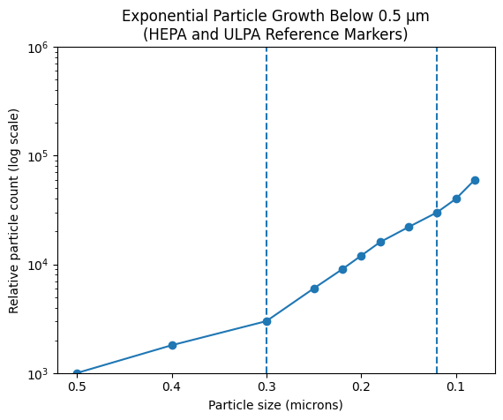
The result is a paradox familiar to many remediators: aggressive cleaning, excellent equipment, and still a space that feels contaminated to sensitive occupants. This is not a failure of HEPA filtration. It is a limitation of particle capture mechanics.

Agglomeration: Changing the Physics Before Removal
Propylene glycol-based fogging is often misunderstood because it is grouped with disinfectants and oxidizers. In this context, that framing is incorrect. The value of propylene glycol here is not chemical. It is physical.
When dispersed as a fine aerosol, propylene glycol causes agglomeration. This allows ultrafine particles to collide and stick together. Brownian motion increases collision frequency. Electrostatic charges are neutralized. Effective particle mass increases. In practical terms, particles that once behaved like smoke begin to behave like dust. They settle. They detach. They become removable:
- Particle collisions increase
- Effective size increases
- Electrostatic adhesion decreases
- Gravitational settling accelerates
- Particles become removable
See Example A:
This step does not claim sterilization, neutralization, or chemical destruction. It simply changes particle behavior in a way that makes physical removal possible. HavenFog utilizes propylene glycol as the carrier and delivers a non-toxic, botanical based molecules that collide with mold spores, breaking the cell wall due to acidity, bioflavonoids, and ascorbic acid.

Why ULPA Vacuuming Follows Fogging
Once agglomeration occurs, the particle size distribution in the space shifts upward. The ultrafine fraction is reduced, and remaining particles are more easily entrained into airflow.
ULPA filtration adds value at this stage not because spores require it, but because cleanup loads are high and particle sizes are transitional. The additional efficiency and reduced leakage risk provide a margin of safety during final removal, particularly in sensitive environments. The benefit is not theoretical. It is operational.

Health Relevance: Why Fragments and Dust Matter
Smaller particles penetrate deeper into the respiratory tract. They interact more readily with innate immune receptors. They persist longer in indoor reservoirs such as furnishings, textiles, and settled dust. This explains why people often relapse after re-occupancy despite “successful” remediation. The space may be biologically quiet, but it is still particulately active. Dead mold is not inert mold. Fragmented mold is often the most problematic form.

A Practical Comparison (1,000 sq ft Home)
Assume a typical residential scenario where moisture source corrected, visible mold removed, no or active growth found. The end goal is post-remediation exposure reduction.
In that context, HEPA vacuuming alone often produces meaningful improvement, but primarily by removing spores and coarse dust. Total biologically relevant particulate reduction typically falls in the moderate range.
When agglomeration-based fogging is performed first, followed by ULPA vacuuming, removal extends to fragments and toxin-associated dust that would otherwise persist. The overall reduction in biologically relevant particulate burden is substantially greater. The difference is not subtle for medically sensitive occupants.

Comparative Effectiveness:

Assumptions
- 1000 sq. ft. home
- Source removal completed
- No active growth
- Objective: post-remediation particulate risk reduction

Relative Reduction in Biologically Relevant Particulates
Strategy | Spores | Fragments | Mycotoxin Dust | Overall Risk Reduction
HEPA vacuum only | High | Low | Low | ~40–60%
PG fog + ULPA vacuum | Very high | High | High | ~75–90%

Interpretation:
The incremental benefit is driven almost entirely by improved removal of submicron and toxin-associated particles, not by marginal improvements in spore capture.

9. Why Oxidizing or Disinfecting Fogging Is Not Equivalent
Oxidizers target biological viability. They do not reliably remove particulate mass. In some cases, they increase ultrafine particle counts by fragmenting debris. They also introduce additional chemical exposures that can be toxic or problematic for sensitive individuals. Agglomeration-based approaches avoid these issues by focusing on physical removal rather than chemical action.

Conclusion
Mold remediation often fails not because mold remains alive, but because exposure remains. Effective remediation must address what people actually inhale. This includes mold fragments and mycotoxin-associated dust that persist after growth is eliminated. Agglomeration-based fogging followed by ULPA vacuuming does not replace standard remediation practices. It completes them by aligning cleanup methods with particle behavior and health relevance. Killing mold is not the same as removing exposure. Particle physics determines outcomes.
Final clean-up using Haven fog and ulpa vacuuming after mold inspection, repairs, and remediation should be considered for best results for mold sensitive occupants.

Key Scientific References
- Górny, R. L., Reponen, T., Willeke, K., Schmechel, D., Robine, E., Boissier, M., & Grinshpun, S. A. (2002).
Fungal fragments as indoor air biocontaminants.
Applied and Environmental Microbiology, 68(7), 3522–3531.
(Seminal paper showing that mold fragments vastly outnumber spores and are predominantly submicron.)
- Reponen, T., Grinshpun, S. A., Trunov, M., Willits, N., & Willeke, K. (2007).
Size distribution of airborne mold spores in buildings.
Indoor Air, 17(5), 354–363.
(Demonstrates particle size distributions and confirms the importance of small particles for exposure.)
- Cho, S. H., Seo, S. C., Schmechel, D., Grinshpun, S. A., & Reponen, T. (2006).
Aerodynamic characteristics and respiratory deposition of fungal fragments.
Atmospheric Environment, 40(30), 5454–5465.
(Shows deep lung penetration and higher inflammatory potential of fragments vs spores.)
- Brasel, T. L., Martin, J. M., Carriker, C. G., Wilson, S. C., & Straus, D. C. (2005).
Detection of airborne mycotoxins from toxigenic fungi in indoor environments.
Applied and Environmental Microbiology, 71(11), 7376–7388.
(Confirms mycotoxins are present in airborne dust, not dependent on mold viability.)
- Straus, D. C. (2011).
Molds, mycotoxins, and sick building syndrome.
Toxicology and Industrial Health, 27(1), 1–13.
(Reviews health relevance of non-viable mold components.)
- Oberdörster, G., Oberdörster, E., & Oberdörster, J. (2005).
Nanotoxicology: An emerging discipline evolving from studies of ultrafine particles.
Environmental Health Perspectives, 113(7), 823–839.
(Establishes that smaller particles have disproportionate biological impact.)
- WHO (2009).
Dampness and Mould: Health Risks, Prevention and Remedial Actions.
World Health Organization.
(Recognizes health risks from non-viable mold components, fragments, and dust.)
- Hinds, W. C. (1999).
Aerosol Technology: Properties, Behavior, and Measurement of Airborne Particles.
Wiley-Interscience.
(Gold-standard reference for 1) exponential particle number increases at small sizes 2)Brownian motion, 3)agglomeration, 3) settling behavior)
- Morawska, L., et al. (2009).
Size distribution and sites of origin of droplets expelled during respiratory activities.
Journal of Aerosol Science, 40(3), 256–269.
(Supports general aerosol behavior principles used in agglomeration discussions.)
- U.S. Department of Energy (DOE).
HEPA Filters.
(Defines 99.97% efficiency at 0.3 µm and explains most penetrating particle size (MPPS).)
- EN 1822-1:2019.
High efficiency air filters (EPA, HEPA, and ULPA).
(European standard defining H13/H14 HEPA and ULPA (U15–U17) performance.)

Example A

What agglomeration with propylene glycol (PG) actually does.
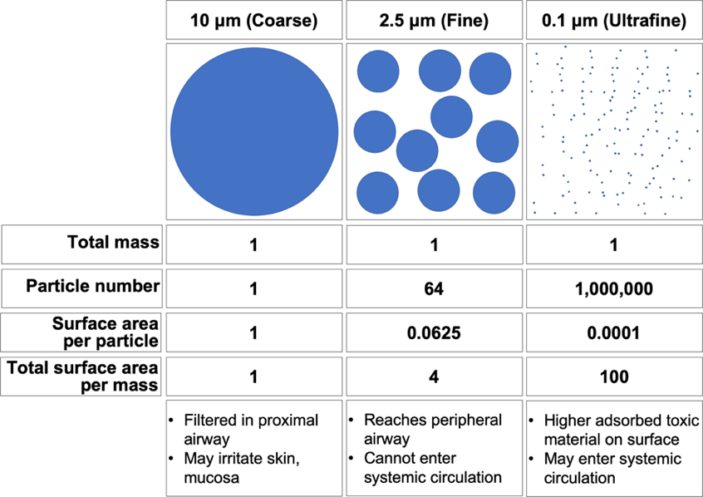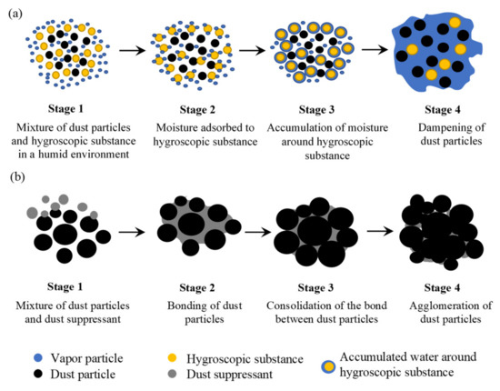

At a physics level, propylene glycol fogging does not “kill” particles. It changes their behavior. In simple terms, PG fog turns millions of invisible, biologically active ultrafine particles into fewer, heavier, removable particles.

Step-by-step: What happens in the room?

In the Pre-fog state , ultrafine particles (<0.3 µm) are Brownian (they move randomly), suspended for hours to days, poorly captured by HEPA, and highly respirable. These include mycotoxin fragments, hyphal debris, endotoxin fragments, combustion, and skin cell, ultra-fines. These particles behave more like a gas than dust.

Upon introduction of Propylene Glycol fog, PG fog droplets are typically 1–5 µm when properly generated. They create a dense collision field (overfill volume of room), high surface area, and are Hygroscopic (slightly “sticky”) contact.

Agglomeration has three mechanisms. PG fog causes simultaneous effects:

Brownian interception- Ultrafine particles collide with PG droplets due to random motion.

Van der Waals adhesion. Once contact occurs, particles stick. They don’t bounce off.

Mass loading. Multiple ultrafine particles accumulate onto one droplet, creating a composite particle.
- Result:
  - 10–1,000 ultrafine particles → one larger particle
  - Effective diameter shifts from: <0.3 µm → >1–3 µm

Before agglomeration. ULPA required to reliably capture fragments. HEPA capture is inconsistent, and particles stay airborne. After agglomeration, particles behave like dust, settle faster, and are are trivially captured by HEPA and ULPA. Thay are also more easily removable from surfaces and air.

Quantitative impact (conceptual but accurate)
Let’s revisit your earlier numbers:
- Room has 1 billion particles ≥0.12 µm
- Fogging causes:
  - 100:1 agglomeration ratio (very realistic)

After fogging:
- Effective particle count: 10 million
- Effective size: 1–5 µm
- Settling velocity increases by ~100×
- Capture efficiency approaches near-total with ULPA vacuuming
Fogging didn’t “remove” particles, it made removal possible. Propylene glycol matters because it is low vapor pressure (stays airborne long enough), hygroscopic but not corrosive, and is FDA GRAS for inhalation exposure at low levels. It is non-oxidizing (unlike chlorine dioxide, ozone, peroxide). PG has historically been used for hospital air sanitation, theater fog, cleanroom particle visualization.

More important, potential impact on occupants is significant after fogging. Ultrafine particles trigger innate immune activation, mast cell response, neuroinflammation. Agglomeration reduces respirable fraction, deep lung penetration, and total inflammatory signaling
After fixing the moisture source, rebuilding, and killing living spore, remaining mold residuals can be remediated through physical removal. Chemistry and biology are irrelevant at this time.

