EII | ENTERPRISE INTELLIGENCE INSTITUTE  Advancing the Science and Practice of Enterprise Intelligence
FOR IMMEDIATE RELEASE
Enterprise Intelligence Institute Launches to Establish a New Professional Discipline for the Modern Digital Enterprise
  - New nonprofit professional institution brings together research, standards, education, technology, organizational leadership, artificial intelligence, and academic collaboration to advance the science and practice of Enterprise Intelligence.
DATELINE | MIAMI, FLORIDA | SEPTEMBER 18, 2026
WEBSITE | eiiglobal.org

Today marks the formal establishment of the Enterprise Intelligence Institute, EII, an independent professional institution created to advance the science, standards, research, education, professional development, and practice of Enterprise Intelligence.
“Every enterprise should understand the health and readiness of its digital environment as confidently as it understands its financial condition, operational performance, and strategic position.”
EII defines Enterprise Intelligence as an emerging professional discipline focused on helping leaders understand, measure, and improve the health, intelligence, resilience, adaptability, and Mission Readiness of the modern enterprise.
The Institute is being created in response to a fundamental shift occurring across modern organizations. Cybersecurity, artificial intelligence, data, identity, digital infrastructure, operational resilience, privacy, third-party dependencies, workforce behavior, governance, and business continuity increasingly affect one another, yet they are still largely managed as separate disciplines.
What remains missing is a professional discipline capable of answering a broader executive question:
“How healthy is the digital enterprise, what is changing, why does it matter, what should leadership do next, and how will those decisions affect the organization’s ability to fulfill its mission?”

From a Framework to a Professional Discipline
The intellectual path toward EII began with the development of the Clinical Cybersecurity Framework, CCF, which introduced a clinical approach to understanding cybersecurity maturity, resilience, and organizational wellness.
CCF challenged the assumption that cybersecurity should be measured only through controls, vulnerabilities, threats, compliance, and incidents. Instead, it introduced a different question: How healthy is the digital enterprise?
That question led to a broader body of work around Enterprise Digital Wellness, Enterprise Digital Anatomy and Physiology, Digital Biomarkers, Digital Vital Signs, Wellness Performance Indicators, Cyber Wellness Plans, Mission Readiness, Digital Wellness Performance, the CCF Body of Knowledge, and the CCF Clinical Delivery System.
EII now provides an independent professional home in which these ideas, alongside future contributions from researchers, practitioners, universities, enterprises, governments, and technology organizations, can be tested, challenged, validated, standardized, taught, and continuously improved.
EII advances the profession. CCF provides a foundational methodology. Academic partners support independent education and research. Commercial firms and technology platforms may implement and advance the practice without owning the profession.

Research. Standards. Education. Practice.

Research
EII will establish research programs examining Enterprise Digital Wellness, Digital Biomarkers, Digital Vital Signs, Wellness Performance Indicators, Mission Readiness, AI, resilience, organizational outcomes, and the emerging measurement science behind Enterprise Intelligence.
Enterprise Digital Wellness Measurement Science: Research into the progression from telemetry and clinical observations through Digital Biomarkers, Digital Vital Signs, Wellness Performance Indicators, physiological system health, Enterprise Digital Wellness, Mission Readiness, and business outcomes.
CCF Organizational Pilot Program: A structured organizational research program designed to test methodology, establish baselines, observe interventions, measure treatment effectiveness, and create anonymized case studies.
State of Enterprise Intelligence: An annual research initiative examining Enterprise Digital Wellness, AI readiness, Mission Readiness, digital trust, resilience, executive decision confidence, workforce readiness, and emerging enterprise conditions.

Standards
EII will develop a transparent standards environment for the emerging discipline. Initial active working groups are planned to include:
- WG-100 | Foundations, Governance and Terminology
- WG-400 | Measurement and Digital Biomarkers
- WG-600 | Research and Validation
“Sponsorship cannot buy standards influence.”
Future work will expand into Enterprise Anatomy and Physiology, Clinical Delivery and Practice, AI and Enterprise Intelligence, and Education and Professional Development.

Education and Professional Development
EII intends to help establish Enterprise Intelligence as a recognized professional career path. Its educational strategy will encompass professional competency models, university curriculum standards, executive education, practitioner development, continuing professional development, authorized education providers, case-based learning, academic research, student participation, and future professional credentials.
- Education first.
- Competency standards second.
- Assessment design third.
- Professional certification only after the discipline is sufficiently mature.

Professional Community and Chapters
EII will become a professional home for a multidisciplinary community of enterprise executives, Board members, CIOs, CISOs, CTOs, CROs, enterprise architects, cybersecurity and AI professionals, resilience leaders, researchers, faculty, students, government leaders, risk and finance executives, technology organizations, universities, and institutional partners.
The Institute is developing infrastructure for professional membership, chapters, working groups, mentorship, volunteer service, research participation, publishing, executive forums, and the future Enterprise Intelligence Summit.

A Founding Ecosystem
The Institute begins with an intentionally multidisciplinary group of organizations contributing different capabilities to the development of Enterprise Intelligence. No single partner owns the Institute. No commercial platform is required to participate in the profession. No academic institution controls the research agenda.
dōlogiic  Founding Technology Partner | dōlogiic serves as EII’s Founding Technology Partner and develops the dōlogiic Cortex, an Enterprise Digital Cortex that can operationalize elements of Enterprise Digital Wellness and CCF. The relationship demonstrates how commercial technology can implement the discipline while preserving EII’s vendor neutrality. dōlogiic does not own EII, and Cortex is not required to practice Enterprise Intelligence.

Florida Memorial University  Founding Academic Partner | Florida Memorial University serves as a foundational academic and research collaborator in the development of Enterprise Intelligence. Its role encompasses research collaboration, curriculum development, student programs, faculty participation, case-based education, pilot learning environments, professional education, and research validation. EII remains institutionally independent while creating a pathway for additional universities to participate in the emerging discipline.

Key Focus Group  Founding Organizational Strategy and Workforce Partner | Key Focus Group brings an essential organizational and people-centered dimension to the EII ecosystem. Its role supports organizational strategy, workforce development, leadership, professional readiness, change enablement, executive engagement, community development, and human-centered Enterprise Intelligence. This contribution helps ensure that Enterprise Intelligence addresses the human systems required to translate standards and insight into organizational capability.

Tier4ai  Founding AI and Innovation Partner | Tier4ai brings artificial intelligence and applied innovation expertise into the founding EII ecosystem. Its role supports Enterprise AI, AI governance, responsible AI, agentic systems, AI-enabled decision intelligence, research and experimentation, AI education, innovation, human oversight, and AI-enabled professional practice. The relationship helps ensure that Enterprise Intelligence develops alongside the rapidly evolving AI environment.

NXT GEN Technology  Founding Technology Enablement and Digital Transformation Partner | NXT GEN Technology brings an implementation and technology-enablement perspective to the founding ecosystem. Its role supports enterprise technology, digital modernization, technology implementation, infrastructure, integration, professional services, workforce enablement, enterprise adoption, and innovation programs. This contribution helps connect EII standards, research, and professional practices to the environments in which those practices must operate.

One Institution, Multiple Contributions
The founding partner model reflects an important EII principle: Enterprise Intelligence cannot be created by cybersecurity alone. Academia brings inquiry and validation. Technology brings operationalization. Artificial intelligence brings new forms of digital cognition. Organizational strategy brings leadership and human systems. Practitioners bring real-world experience. Enterprises bring evidence. Researchers bring scientific discipline. Standards provide consistency. Community allows the discipline to evolve.

Enterprise Intelligence Institute Business Model Canvas
EII operates through an institutional flywheel linking research, evidence, standards, the Body of Knowledge, education, professional competency, practice, organizational outcomes, and continuous improvement.
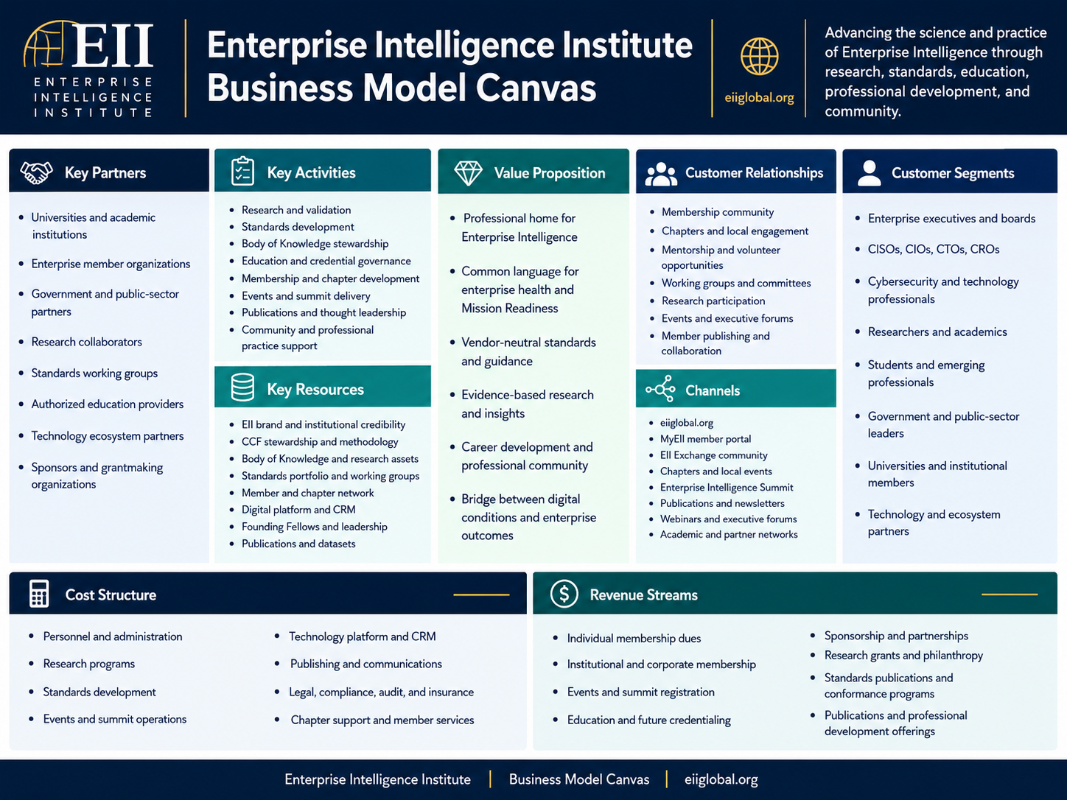
Revenue sustains the mission. Revenue does not define the mission.

The Founding Assembly
September 18, 2026 represents Day Zero for the institutionalization of Enterprise Intelligence. The Founding Assembly formally introduces:
- The Enterprise Intelligence vision
- The Enterprise Intelligence Institute
- The Founding Declaration
- The Founding Council
- Founding Fellows
- The initial research agenda
- The Enterprise Intelligence Summit
- Initial standards working groups
- Charter Membership applications
September 18 should be remembered as the institutional beginning of a profession, not simply the launch of another organization or website.

Looking Ahead
YEAR / PHASE | INSTITUTIONAL PRIORITY
2026 | FOUND | Create legitimacy and establish the institution.
2027 | VALIDATE | Test the methodology, begin organizational pilots, publish research, and deepen academic participation.
2028 | PROFESSIONALIZE | Establish professional competency standards, practitioner pathways, chapters, and mature standards processes.
2029 | SCALE | Expand organizational adoption, research cohorts, benchmarking, university participation, and professional programs.
2030 | INSTITUTIONALIZE | Become an accepted institutional reference point for Enterprise Intelligence.
2031 | STEWARD | Ensure the profession can continuously evolve through independent governance, international collaboration, longitudinal research, and a multi-vendor ecosystem.

A New Question for the Enterprise
For decades, executives have learned to ask how the organization is performing financially, operationally, strategically, and from a risk perspective. EII introduces another question:
“How healthy is our digital enterprise?”
The Institute’s long-term vision is a world in which the answer to that question is supported by research, measurement science, professional standards, qualified practitioners, academic education, trusted evidence, and executive understanding.
Success will look like this: a CEO asks the question; a Board understands it; a practitioner knows how to answer it; a published methodology defines how it should be measured; research supports the interpretation; standards govern the practice; universities teach it; technology can operationalize it; and organizations can compare results over time.

Founder’s Statement
“What began as a question about the health of the digital enterprise has evolved into a much larger responsibility. The challenge before us is no longer simply to create another framework. It is to build the research, standards, education, professional practice, and community capable of advancing Enterprise Intelligence for generations to come.
The Enterprise Intelligence Institute belongs to that future. It must become larger than any founder, company, technology, or university. September 18 is not the completion of this work. It is its institutional beginning.”
Patrick Doliny
Founder and Founding Chair, Enterprise Intelligence Institute
Chief Architect, Clinical Cybersecurity Framework

About the Enterprise Intelligence Institute
The Enterprise Intelligence Institute, EII, is an independent professional institution dedicated to advancing the science and professional practice of understanding, measuring, and improving Enterprise Digital Wellness, resilience, intelligence, adaptability, and Mission Readiness. Its work encompasses research, standards, education, professional development, publications, membership, chapters, professional practice, academic collaboration, and the advancement of Enterprise Intelligence as an emerging professional discipline.
RESEARCH. STANDARDS. EDUCATION. PRACTICE.
eiiglobal.org

Founding Ecosystem
The founding ecosystem reflects EII’s commitment to multidisciplinary collaboration while preserving institutional independence, vendor neutrality, academic openness, and standards integrity.
ORGANIZATION | FOUNDING ROLE
Enterprise Intelligence Institute | Independent Professional Institution and Steward
dōlogiic | Founding Technology Partner
Florida Memorial University | Founding Academic Partner
Key Focus Group | Founding Organizational Strategy and Workforce Partner
Tier4ai | Founding AI and Innovation Partner
NXT GEN Technology | Founding Technology Enablement and Digital Transformation Partner

Institutional Independence Principles
- No commercial partner owns or controls EII.
- No technology platform is required to practice Enterprise Intelligence.
- No academic partner controls the Institute’s research agenda.
- Sponsorship does not purchase standards influence, credentials, or governance authority.

Media and Institutional Inquiries
Enterprise Intelligence Institute
eiiglobal.org
Media Contact: [Insert approved media contact]
Email: [Insert approved press email]
###

