1 September 2026

Dear families,

We want to let you know about our school’s emergency management plan. Our school plans for a range of hazards, such as bushfire, severe weather or medical emergencies. We develop specific response procedures to address these risks.
We also conduct drills regularly, ensuring that our core procedures of on-site and off-site evacuation, sheltering-in-place, and lockdown/lockouts are well-rehearsed and understood by staff and students.
Our school is considered at risk of bushfire or grassfire. We are Category 1 on the Bushfire At-Risk Register/Category 4 List. This means that we will relocate when the fire danger rating is Extreme in our local government area (LGA), Manningham. Our school will close on days of Catastrophic fire danger in the Manningham LGA. Action your family’s bushfire survival plan if your own triggers are met. We encourage you to follow your family bushfire survival plan and the advice of emergency services.
For more information about our bushfire risk, please refer to the attached bushfire information or find this on our website, warrandyteps.vic.edu.au . The Country Fire Authority also has more information for schools at risk of fire: https://www.cfa.vic.gov.au/schools.
If we enact our emergency management plan, we will notify you by Compass notification, with updates on our actions. Please do not come to the school unless directed to do so, as you may put yourself and others in danger. If there is anything we need you to do, we will let you know.
During an emergency, the school will work closely with emergency services to get specific advice to keep our community safe. Additionally, the Department of Education has dedicated emergency management staff to help monitor the situation and provide additional support to schools during emergencies.
If you have any questions about our school’s emergency management plan, please contact us at (03)9844 3537 or email warrandyte.ps@education.vic.gov.au Please be assured our top priority is the safety of our students and school community.
Thank you for your cooperation and understanding.
Yours sincerely,
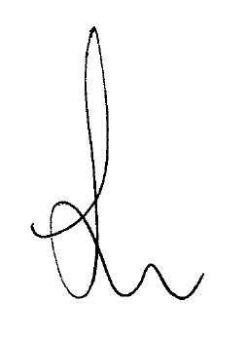
Nieta Manser
Principal

