SCHOOL ASBESTOS MANAGEMENT PLAN
Warrandyte Primary School
Department of Education

School Asbestos Management Plan details:
Asbestos register details: | Date 17/12/2025
Current Division 5 asbestos audit report prepared on | March 2025
Current Division 5 asbestos audit report expires on | March 2030
Current school asbestos register last updated on | March 2025
Work orders are set up in AIMS?  - The work order for the Annual School Asbestos Management Plan Review has been set up in AIMS  - Quarterly Asbestos Inspection Work Orders have been set up in AIMS (required only if active asbestos is currently onsite) | Y Date of review: Feb 2026

Soil management details (applicable where asbestos in soil has been listed in the Division 5 Asbestos Audit Report or if asbestos was found in soil as part of an incident):
Is there a current soil management plan? | N/A
Soil management plan last updated on
Last soil walkover conducted on

Version control
Version Number
Date | 10 September 2025

SCHOOL ASBESTOS MANAGEMENT PLAN
Table of Contents

School Asbestos Management Plan details: 2
SCHOOL ASBESTOS MANAGEMENT PLAN 3
EXECUTIVE SUMMARY 5
ASBESTOS MANAGEMENT CHECKLIST FOR SCHOOLS 6
SCHOOL ASBESTOS MANAGEMENT PLAN 8
Introduction 8
How to Use this Document 8
Risk Rating of Asbestos 9
ACMs in Government Schools 9
Occupational Health and Safety Framework 10
Occupational Health and Safety (OHS) Assurance Program 11
IDENTIFICATION PROCESS 12
1. Identification 13
1.1. Division 5 Asbestos Audit Report 13
1.2. New Division 5 Asbestos Report 14
1.3. Asbestos is Located in Inaccessible Areas 15
2. Labels 15
2.1. Label School Buildings 15
2.2. Seek Approval to Remove Labels 16
2.3. Replace Damaged Labels 16
3. Asbestos Register 17
3.1. Up-to-date Asbestos Register 17
3.2. Quarterly Inspections 18
4. Inductions and Division 6 Audits 19
4.1. Inductions 19
4.2. Division 6 Audits 19
CHECKLIST—IDENTIFICATION OF ACMs 20
MANAGEMENT PROCESS 21
5. Asbestos Coordinator 22
5.1. School Asbestos Coordinator 22
5.2. Mandatory Position 22
6. Training 23
6.1. Asbestos Awareness Courses 23
6.2. eLearning 23
6.3. Asbestos Management Information and Training Session 23
7. Make Safe Hotline for Schools (24/7) 24
7.1. Isolate the Area 24
7.2. Call the 24hr Asbestos Hotline 24
24
7.3. Report Asbestos Incidents on eduSafe Plus 25
7.4. Occupational Hygienist Recommendations 25
CHECKLIST—MANAGEMENT OF ACMs 26
REMOVAL PROCESS* 27
8. Construction ZONEs 28
8.1. Identify and Remove Asbestos 28
8.2. Capital Works Project Budget 28
9. Legal and departmental Requirements 28
9.1. Notify the department 28
9.2. A Class Asbestos Removalists 29
9.3. Asbestos Removal ‘Must’ Occur Out of School Hours 29
9.4. Air Monitoring and Clearance Results 30
9.5. Update this SAMP 30
9.6. Record Removals 31
CHECKLIST—REMOVAL OF ACMs 32
FAQs 33
GLOSSARY 35
APPENDIX A - LIST OF OCCUPATIONAL HYGIENISTS AND CLASS A ASBESTOS REMOVALISTS 38
APPENDIX B - SCHOOL NEWSLETTER TEMPLATE 39
APPENDIX C - FURTHER ASSISTANCE 40
RELATED DOCUMENTATION 40

EXECUTIVE SUMMARY
The Occupational Health and Safety (OHS) Regulations 2017 require schools, as workplace managers, to manage the risks associated with asbestos-containing materials (ACMs).
This School Asbestos Management Plan (SAMP) outlines both the legal and departmental policy requirements that schools must follow in order to fulfil their obligations for asbestos management. Schools are responsible for developing, implementing and reviewing the SAMP for each school campus.
To assist in implementing the SAMP, the Department of Education (the department) has developed a checklist of 10 requirements that schools must follow. These 10 requirements are divided into 3 categories:
- Identification of ACMs
- Management of ACMs
- Removal of ACMs.
The checklist on the following page outlines the 10 requirements along with more detailed steps to follow for each requirement.
Departmental policy requirements
The department’s policy requirements regarding asbestos removal go beyond the OHS Regulations 2017 due to the presence of children and young people on school sites. These requirements are:
- Asbestos-removal works must only be carried out by Class A removalists
- Asbestos-removal works must only be carried out during out-of-school hours (with no one on site)
- Air monitoring results are required for clearance and reoccupation of the school.
The department is committed to working with schools to facilitate the safe and effective management of asbestos.
By following the steps outlined in this SAMP, schools can be assured that they are managing ACMs safely and appropriately.

ASBESTOS MANAGEMENT CHECKLIST FOR SCHOOLS
REQUIREMENT 1: DIVISION 5 ASBESTOS AUDIT REPORT
* | The school has a Division 5 asbestos audit report for each campus
* | The Division 5 asbestos audit report is less than five years old
* | The school assumes ACMs are present in inaccessible areas
REQUIREMENT 2: ASBESTOS LABELS ON SCHOOL BUILDINGS
* | The school has labelled its facilities with:  - signage at the front gate instructing all visitors to report to the general office  - signage at the general office notifying that all persons undertaking work are required to undergo an induction, which includes reviewing the current Division 5 audit report and school asbestos register  - labels fixed at the entrances of all buildings indicating the presence of known—or suspected—ACMs
* | The school has obtained the department’s written approval prior to removing any asbestos labels
REQUIREMENT 3: ASBESTOS REGISTER AND QUARTERLY INSPECTIONS
* | The school has an up-to-date asbestos register in addition to the Division 5 asbestos audit report
* | The school has scheduled and undertaken quarterly visual inspections of workplace facilities where ACM and asbestos labels have been identified and recorded.
REQUIREMENT 4: INDUCTIONS AND DIVISION 6 AUDITS
* | The school informs third parties regarding the presence and risk of ACMs through OHS inductions and Division 6 audits.  A division 6 audit must be undertaken prior to any demolition or refurbishment works.
REQUIREMENT 5: ASBESTOS COORDINATOR
* | The school has an appointed asbestos coordinator
* | In the absence of an asbestos coordinator, the responsibility sits with the principal.
REQUIREMENT 6: TRAINING
* | The principal and asbestos coordinator have:  - completed the online Managing asbestos in schools eLearning Module on commencement of their role and refreshed the training once every 3 years; and  - attended one of the Asbestos Management Information and Training sessions as part of the Bricks and Mortar training at least once in the past 5 years and retained a record of this attendance.
REQUIREMENT 7: ASBESTOS MAKE SAFE HOTLINE FOR SCHOOLS (24/7)
* | The school isolates the area of an asbestos-related incident
* | The school reports any asbestos-related incidents to the department’s 24-hour Asbestos Make Safe hotline on 1300 133 468
REQUIREMENT 8: ASBESTOS IN SOIL
* | The school manages ACMs in soil as set out in the Soil, Mulch or Loose Fill policy.
* | The school reports ACMs in soils to the department’s 24-hour asbestos make safe hotline to seek support for short-term management
* | Where required, the school implements a Soil Management Plan for the long-term management of ACMs
* | The school does not accept contaminated landfill
* | The school reports asbestos-related incidents on eduSafe Plus
REQUIREMENT 9: CONSTRUCTION ZONES
* | For VSBA-led works, project managers identify and remove ACMs before demolition or refurbishment works
* | The cost of identifying and removing ACMs is fully covered by the capital project budget
REQUIREMENT 10: LEGAL AND DEPARTMENTAL REQUIREMENTS
* | The school notifies the department of any proposed asbestos removal works (at asbestos.reform@education.vic.gov.au)
* | Removal works are only carried out by Class A removalists
* | Removal works are only conducted during out-of-school hours with no one on site
* | Air monitoring results are required for clearance and reoccupation of the school
* | The school updates the School Asbestos Management Plan following asbestos-removal works
* | The school keeps all removal documentation, uploads to AIMS and provides a copy (for school-led works) to the department (asbestos.reform@education.vic.gov.au)

SCHOOL ASBESTOS MANAGEMENT PLAN

Introduction
This School Asbestos Management Plan (SAMP) outlines a school’s responsibilities regarding the identification, management and removal of asbestos-containing materials (ACMs).
All schools are required to have a SAMP for each campus. Schools with ACMs must review and complete required actions as outlined in their SAMP quarterly and then update the details in the tables on pages 5-6 of this document. Schools must also attach or link in AIMS the school’s asbestos register and labels register.
Principals and the appointed school asbestos coordinator are responsible for updating this SAMP. Principals and asbestos coordinators are ultimately accountable for implementing and complying with this SAMP requirements. As part of the OHS Assurance Program, the department checks schools to ensure compliance with the SAMP requirements.
Principals and asbestos coordinators should refer regularly to the checklist at pages 5-6 to ensure they have completed all required actions and are compliant with legislative and policy requirementsError! Reference source not found..
24 HOUR ASBESTOS HOT LINE
Call the department’s 24-hour Asbestos Make Safe hotline on 1300 133 468 to report any occurrences where disturbed, damaged, degraded or suspected ACMs have been identified in an educational facility.

How to Use this Document
This SAMP details the specific actions that the school must take in fulfilling responsibilities for each of its campuses as set out in the OHS Regulations 2017 and Department policies. By undertaking those actions, the school will ensure it is providing a safe learning and teaching environment.
The school’s responsibilities regarding ACMs are divided into three broad categories:
- identification of ACMs
- management of ACMs
- removal of ACMs
This SAMP forms part of the Occupational Health and Safety Management System (OHSMS) to identify and control the risks associated with risks in schools.

Risk Rating of Asbestos
ACMs in Victorian public schools are risk rated using information on friability and condition with A1 being the highest risk and A5 being the lowest risk. For further information on the risk rating please refer to see Table 2.
Table 2. Risk rating of ACMs.
Risk | Description
High (A1-A2) | - Friable or poorly bonded (located in accessible or reasonably accessible areas)  - Severely damaged material, water damaged or unstable (further damage or deterioration is likely due to disturbance through contact)  - Asbestos debris or stored asbestos material in reasonably accessible areas  - A1–A2-rated ACMs should be scheduled for immediate removal
Medium  (A3) | - Friable material or poorly bonded  - Possibility of fibre release through non-aggressive disturbance, contact or deterioration through weathering  - Bonded products located in accessible areas  - Enclose, encapsulate or seal—manage and re-inspect periodically  - A3-rated ACMs should be scheduled for removal in the medium term (refer to FAQs for more information).
Low  (A4-A5) | - Further disturbance or damage unlikely (other than during maintenance or service)  - Stored material in rarely accessed areas (for instance, asbestos friction materials, gaskets and brake linings)  - Firmly bonded to substrate and readably visible for inspection  - Inaccessible or fully contained  - A4-rated ACMs should be managed and re-inspected periodically  - A4-rated ACMs are recommended to be scheduled for removal during maintenance or refurbishment works  - A5-rated ACMs should be managed and reinspected periodically

ACMs in Government Schools
There are numerous materials and locations where ACMs can be present in educational facilities across Victoria. The department has categorised the most common types of ACMs (see Table 3).
Table 3. Types of ACMs in schools.
Types of ACMs
Adhesive to vinyl floor / tiles | Kiln / Bain Marie
Bituminous lining to sink / drain | Mastic to Windows / Expansion Joints / Block Work / Pebble Mix
Cement Sheet Ceiling / Panels / Eaves / Porch / Walls | Other—Water Tank / Vermiculite Sprayed Beams
Cement sheet debris | Pipe / Flange / Gasket
Cement sheet other | Roof Membrane
Millboard Lining to Vinyl Top Desk | Science Equipment / Hotplate
Filling Cabinet / Fire Rated Safe | Sink Splashback
Fire Door | Switchboard / Electrical Backing Board
Heater Flue | Telco Pit
Incinerator | Internal insulation to incubator

Occupational Health and Safety Framework
The Occupational Health and Safety Act 2004 creates a legislative framework to ensure the health, safety and welfare of employees and other persons at work. The OHS Regulations 2017 determine the necessary precautions for the safe management and removal of ACMs.
WorkSafe Victoria’s Compliance Codes provide practical guidance for employers and workplace managers to fulfil their obligations.
The framework includes the:
- Occupational Health and Safety Act 2004
- Occupational Health and Safety Regulations 2017
- WorkSafe Victoria’s Compliance Code: Managing Asbestos in Workplaces
- WorkSafe Victoria’s Compliance Code: Removing Asbestos in Workplaces
There are two main areas in the OHS Regulations 2017 which schools must follow because they establish the main obligations, and these include:
- Division 5 ‘Asbestos in the workplace’; and
- Division 6 ‘Demolition and refurbishment where asbestos is present’ (see Table 5).
Table 5. Obligations on the management of ACMs.
Responsibility | What is required | Reference
Identification | - Identify all asbestos in the workplace as far as reasonably practicable (that is, through a visual audit) to develop an asbestos register. | Division 5
Identification | - Indicate the presence of asbestos by labelling | Division 5
Identification | - Update the asbestos register by noting and recording the change of condition to asbestos in the workplace. | Division 5
Identification | - Prior to demolition or refurbishment works, identify asbestos that may be disturbed (that is, through an intrusive audit). | Division 6
Management | - If asbestos removal is not reasonably practicable, enclosing and sealing of the asbestos should be done to eliminate asbestos risk | Division 5
Management | - Review and revise any measures implemented to control asbestos risks before changes to the workplace, after an incident or if the measures are inadequate | Division 5
Removal | - Eliminate asbestos risks as far as reasonably practicable by removing the asbestos (that is, through planned removal) | Division 5
Removal | - During demolition and refurbishment works, remove asbestos if reasonably practicable | Division 6
Removal | - Ensure asbestos removal is performed by a licensed asbestos removalist | Division 6

Failure to comply with a duty or obligation under the OHS Regulations 2017 is an offence to which a penalty applies. WorkSafe Victoria, as Victoria’s health and safety regulator, also organises inspections to monitor and enforce OHS laws in workplaces. When a WorkSafe inspector detects a contravention of OHS laws, the inspector will take action to ensure the contravention is remedied by the duty holder (that is, the school and/or the department).

Occupational Health and Safety (OHS) Assurance Program
The department and principals, as an employer and workplace manager, jointly owe a duty of care to students, parents, contractors, employees and visitors to reduce the likelihood of being exposed to health or safety risks.
Therefore, the management of ACMs is a shared responsibility between the department and government schools. The department provides guidance and procedural advice regarding the identification, management and removal of ACMs through this SAMP of which principals must implement.
The OHS Assurance Program provides proactive support to confirm schools are implementing the OHS management system to manage health, safety and wellbeing, consistent with the Occupational Health and Safety Act 2004. It is a supportive assessment of each school’s safety management practices.
Each school generally participates approximately every 4 years, depending on safety performance. Requirements established in this SAMP are checked as part of the assurance program and schools receive a report regarding compliance.
Further information on the OHS Assurance Program can be found in the Audits, Reviews and Assurance Programs in Schools policy.

IDENTIFICATION PROCESS
TERM 4
Quarterly Visual Inspection of ACMs and Labels if known asbestos is on-site.
Conduct inductions and communicate Div 5 audit outcomes to inform of the presence of asbestos
Update the school asbestos register following each quarterly inspection (or following asbestos-removal works)
TERM 3
Quarterly Visual Inspection of ACMs and Labels if known asbestos is on-site.
TERM 2
Quarterly Visual Inspection of ACMs and Labels if known asbestos is on-site.
TERM 1
Quarterly Visual Inspection of ACMs and Labels if known asbestos is on-site.
Download or view the school asbestos register
Label external doors to school buildings to indicate the presence of ACMs and complete SAMP
Obtain current Division 5 audit report (available on AIMS)

Identification

Division 5 Asbestos Audit Report
All schools will have a Division 5 Asbestos Audit Report per campus, including the learning centres and camp sites. Division 5 audits are arranged by the Victorian School Building Authority (VSBA) every 5 years and are visual inspections of a school site conducted by a qualified Occupational Hygienist. The Division 5 audit identifies and classifies ACMs on the school site and presents these results in the Division 5 report. The report details the location of ACMs in the buildings and grounds, as well as information about their condition and priority classification (A1 - A5). The report also provides recommendations on how to manage each identified ACM. Schools must follow all the recommendations provided in the report.
To find your Division 5 Asbestos Audit Report access the Asset Information Management System (AIMS). Email mailto:PRMS21@education.vic.gov.au schoolasset.leadership@education.vic.gov.au to gain access to the website and ensure you ask for access to your schools ‘Asbestos Files’.
Print the Division 5 report for your school campus and attached it to this SAMP and make sure this copy can be made available at front reception.
Step 1. Select Facilities Management in the Start Centre.
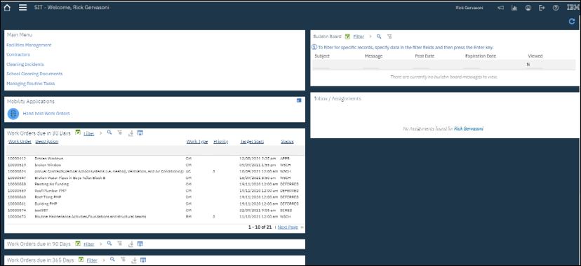
Step 2. Select School Documents
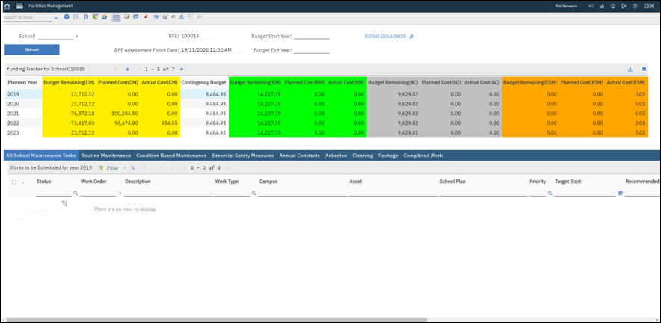
Step 3. Division 5 asbestos audit is listed in ‘pop-up’ box.
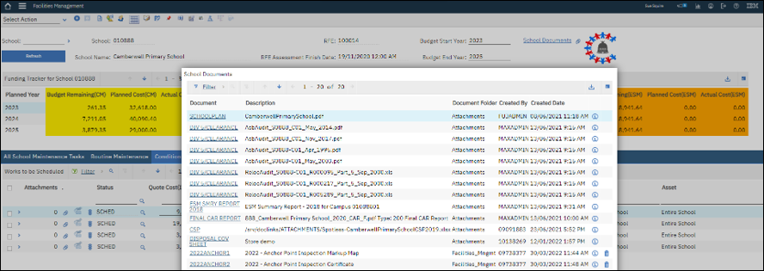

New Division 5 Asbestos Report
A new Division 5 audit must be conducted every 5 years to develop an updated report. If your Division 5 report is older than 5 years or you do not have a report contact the asbestos.reform@education.vic.gov.au.
Audits may be conducted during school hours, provided they do not disrupt school activities. The school must ensure access is granted to the whole site (that is, no locked storerooms), so that all accessible ACMs can be inspected, and the resulting report is inclusive of all spaces.

Asbestos is Located in Inaccessible Areas
All schools must presume asbestos is present in inaccessible areas. ACMs may still be present in inaccessible areas, including behind walls, subfloors, ceiling voids, machinery, live electrics and heights above three metres that are not inspected as part of the Division 5.

INACCESSIBLE AREAS
The school’s Division 5 audit report will most likely include statements assuming the presence of asbestos, such as:
‘Where No Access or Limited Access areas have been identified, it should be presumed that ACMs are present in these areas until further investigation can confirm or refute the presence’
‘No inspection can guarantee to locate all asbestos in a specific location. The assessment cannot be regarded as absolute, without extensive invasion of structures. Future demolition and or renovation to site structures may expose situations, which were concealed or otherwise impractical to access during this assessment.’
The assumed presence of asbestos means that the school must appropriately label the buildings as containing ACMs (refer to Labels). In addition, the school is required to organise and fund a Division 6 Hazardous Building Materials Audit (Division 6 audit) before undertaking works that may include demolition, refurbishment, installation of new equipment, hanging displays, painting, soil works, excavation works and so on (refer to Removal of ACMs). The school must inform staff and third parties about the suspected presence of ACMs.

Labels

Label School Buildings
All schools must label their buildings if the Division 5 audit report states or assumes there is asbestos present. In line with the OHS Regulations 2017, if ACMs have been identified in the school, their presence and location must be indicated by labelling. The location of any labels needs to be consistent with the results of the school’s Division 5 audit report and asbestos register.
Based on the current Division 5 audit report, the following asbestos labels need to be displayed at the school:
- signage at the front gate instructing all visitors to report to the general office
- signage at the general office notifying that all persons undertaking work are required to undergo an induction, which includes reviewing the current Division 5 audit report and school asbestos register (see section 4.1 Inductions)
- labels fixed at the entrances of all buildings indicating the presence of known or suspected ACMs
Signage
Front Office Signage | Signage at the general office notifying that all persons undertaking work are required to undergo an induction, which includes reviewing the current Division 5 audit report and school asbestos register | 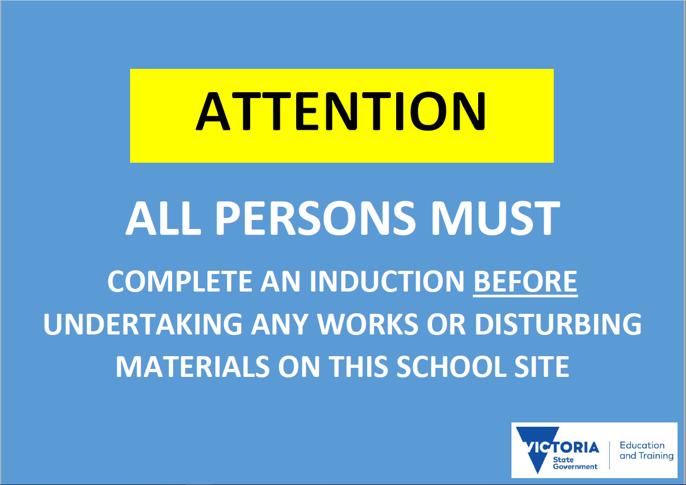
Building Signage | Labels fixed at the entrances of all buildings indicating the presence of known or suspected ACMs | 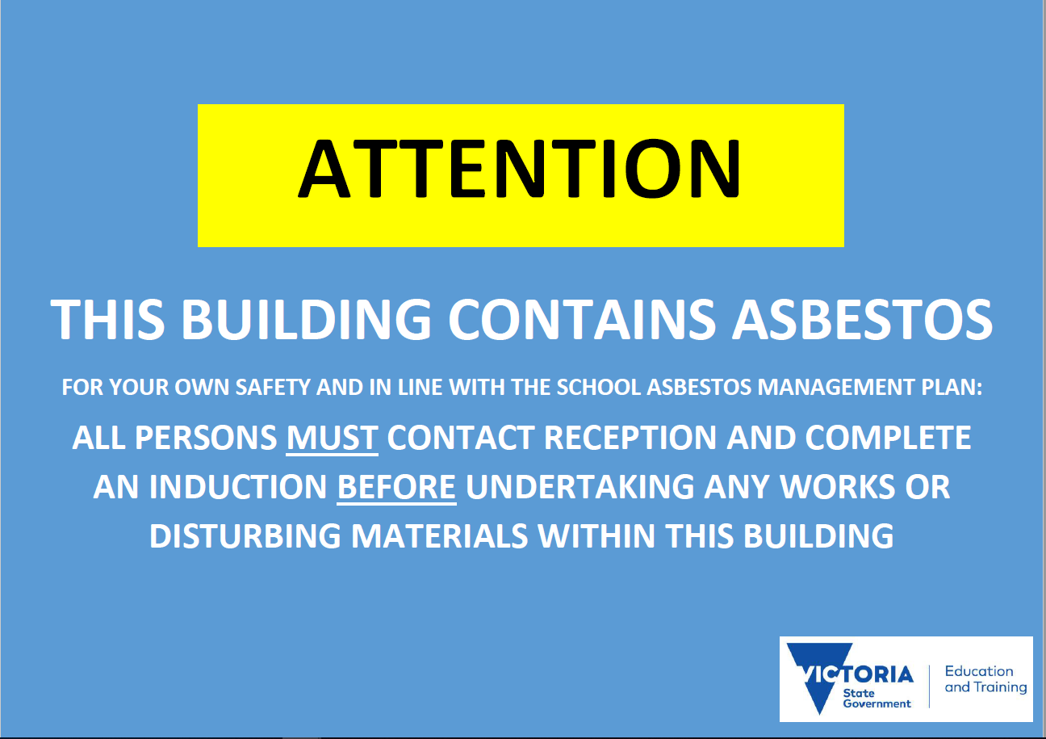
Figure 2. Asbestos labels.

LABEL INACCESSIBLE AREAS
Labels are applicable to buildings on the Division 5 audit report with identified ACMs, as well as buildings with assumed ACMs. If the school is missing labels in required locations, or needs replacement labels, please contact the department’s 24-hour Asbestos Make Safe hotline on 1300 133 468.

Seek Approval to Remove Labels
All schools must obtain approval from the department prior to removal of asbestos labels. Since asbestos labels reflect the current Division 5 audit report, they must not be removed unless a new report has been issued. To remove the labels, the new report must not identify or assume any ACMs in the entire building.
Schools should be aware that even if identified ACMs have been removed and cleared in the current Division 5 audit report, the report may still assume the presence of ACMs in inaccessible areas. For this reason, labels must still be applied to buildings with assumed ACMs. Prior to removing any asbestos labels, schools must contact the department to obtain written approval (asbestos.reform@education.vic.gov.au).

Replace Damaged Labels
If labels become torn, damaged or need to be replaced, contact the department’s 24-hour Asbestos Make Safe hotline on 1300 133 468 to organise replacement labels.

Asbestos Register

Up-to-date Asbestos Register
All schools must maintain a live asbestos register for each campus. The school asbestos register is originally prepared by the department and is available on AIMS.
The Division 5 audit report will contain an Asbestos Register in its appendix section. The Asbestos Register is a table, which includes each identified or presumed ACM item. It includes information about their location, approximate quantity, material type, risk rating and comments about their condition.
The Asbestos Register also informs where asbestos labels should be located and how the school should manage asbestos risks.
Schools can also update information about asbestos labels using the Asbestos Label Register in AIMS.
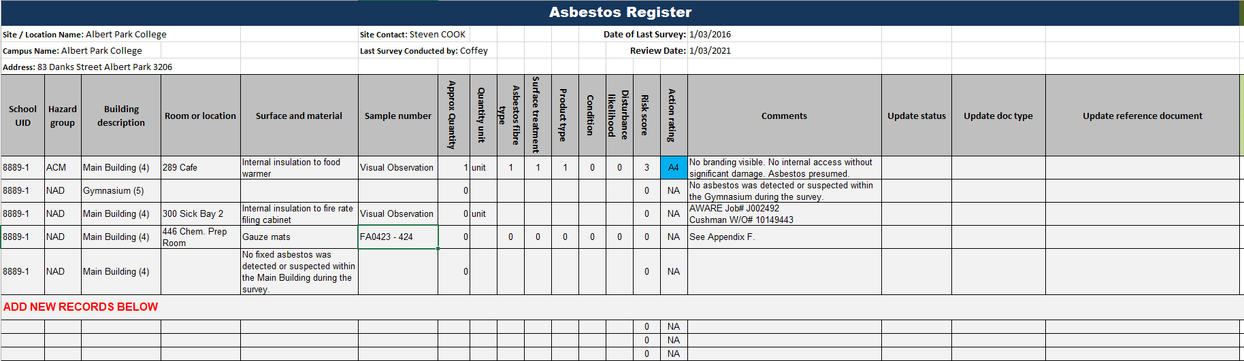
Figure 3: Asbestos Register example
As the Division 5 audit reports are only updated every five years, information in the Asbestos Register will be outdated as the condition of school buildings and ACMs change before a new report becomes available. Table 6 details the difference between the school’s Division 5 audit report and its asbestos register.
Table 6. Division 5 audit report and asbestos register.
Document | Status | Responsibility | Update
Division 5 audit report | Static | Occupational Hygienist | Every five years
School asbestos register | Live | School | Every quarterly visual inspection or after asbestos-removal works
The school must refer to this asbestos register when conducting quarterly inspections. Schools can generate an AIMS report that they can use for each quarterly inspection.
The school must ensure that a copy of the asbestos register is readily accessible to any employee, self-employed person, contractor and any person engaged to do work at the school.

Quarterly Inspections
All schools must conduct quarterly visual inspections of all ACMs if there are known ACMs on site to monitor their status and condition and to review the condition of all the asbestos labels.
In line with the OHS Regulations 2017 and the OHS Management System, the school must:
- revise its asbestos register to keep it current; and
- include any changes regarding the condition and/or removal of ACMs.

To meet the aforementioned requirements the school needs to:
- obtain the current version of school asbestos register template
- record information from quarterly inspections of previously identified ACMs
- if asbestos-removal works have been undertaken since the last inspection, strike-through the entry and add a corresponding comment (for example, ‘Kiln’ removed on 29/07/2019).
Clearance reports and clearance certificates need to be kept with the register/visual inspection documents as evidence of asbestos-removal works. The school must send a copy of these documents to the department’s asbestos data manager (asbestos.data@education.vic.gov.au) to be uploaded to the school documents section in AIMS.
After the data has been entered into the spreadsheet, save the spreadsheet with a name that reflects the month and year of the inspection (for example, AsbQuarterly_s9999-c99_Apr_2018).
During a Quarterly Inspection
If the school finds ACM disturbed or damaged during its quarterly inspection, it needs to immediately contact the department’s 24-hour Asbestos Make Safe hotline on 1300 133 468.

Schools which have had all identified asbestos removed will still need to conduct quarterly inspections of labels where these are in place due to the presumption of asbestos being present in inaccessible areas.

Inductions and Division 6 Audits

Inductions
All schools must inform third parties regarding the presence and risk of ACMs through inductions. Inductions should include information regarding:
- the current Division 5 audit report
- the current asbestos register
- a Division 6 audit report, which schools must organise and fund prior to commencing refurbishment or demolition works (including soil or excavation works)
- the name and responsibilities of the school asbestos coordinator
- the risk associated with the presence of ACMs
- the outcomes of the last quarterly visual inspection of ACMs.
All contractors and volunteers, including those attending ‘working bees’, must report to the front reception office on arrival at site to undertake the induction. The induction must be completed by the school principal and/or the asbestos coordinator. The induction should cover all the OHS risks (not only asbestos-related risks). For more information, please refer to the department’s
- Contractor OHS Management Policy and Contractor OHS Management Procedure
- Volunteer OHS Management Policy and Volunteer OHS Management Procedure

Division 6 Audits
All schools must organise for a Division 6 audit to be completed prior to the school undertaking works. Prior to any demolition or refurbishment the school must inform third parties regarding the presence or absence of asbestos through a Division 6 audit. A Division 6 (intrusive) audit is restricted to areas potentially impacted by the proposed works and is a requirement wherever asbestos may be disturbed by the proposed works. If any asbestos is found, it must be removed prior to the works commencing.
Division 6 audits are conducted by occupational hygienists and must be funded from within the project budget whether school-led or undertaken by a VSBA program (if it is a school-led project, the Division 6 audit must be funded by the school). A list of occupational hygienists is provided at APPENDIX A.

CHECKLIST—IDENTIFICATION OF ACMs
Once the school has followed all the guidance documented in the previous pages. The requirements 1 to 4 are achieved.
REQUIREMENT 1: DIVISION 5 ASBESTOS AUDIT REPORT
* | The school has a Division 5 asbestos audit report for each campus
* | The Division 5 audit report is less than five years old
* | The school assumes ACMs are present in inaccessible areas
REQUIREMENT 2: ASBESTOS LABELS ON SCHOOL BUILDINGS
* | The school has labelled its facilities with:  - signage at the front gate instructing all visitors to report to the general office  - signage at the general office notifying that all persons undertaking work are required to undergo an induction, which includes reviewing the current Division 5 audit report and school asbestos register  - labels fixed at the entrances of all buildings indicating the presence of known—or suspected—ACMs
* | The school has obtained the department’s written approval prior to removing any asbestos labels
REQUIREMENT 3: ASBESTOS REGISTER AND QUARTERLY INSPECTIONS
* | The school has an up-to-date asbestos register in addition to the Division 5 audit report
* | The school conducts quarterly inspections to update its asbestos register
REQUIREMENT 4: INDUCTIONS AND DIVISION 6 AUDITS
* | The school informs third parties regarding the presence and risk of ACMs through OHS inductions and Division 6 audits

MANAGEMENT PROCESS
School does not accept contaminated landfill
School keeps a record of all asbestos-related documentation (including Bricks and Mortar training certificate or record of attendance)
School reports asbestos-related incidents on eduSafe Plus
School reports asbestos-related incidents to the department’s 24-hour Asbestos Make Safe hotline on 1300 133 468 (including soils)
Nominated asbestos coordinator is trained on asbestos management
Principal is trained on asbestos management
Asbestos coordinator is appointed

Asbestos Coordinator

School Asbestos Coordinator
The principal is responsible for ensuring the school fulfils its obligations to identify, manage, and remove ACMs under the OHS Regulations 2017. To assist with this role the principal can choose to appoint an asbestos coordinator. The asbestos coordinator becomes the main point of contact for asbestos-related matters at the school, under the direction and control of the principal. Asbestos coordinators are responsible for:
- developing and updating the school’s Asbestos Management Plan in conjunction with the principal
- implementing all requirements within this SAMP to identify, manage and remove ACMs
- liaising with Departmental stakeholders and WorkSafe Victoria (if required) to demonstrate compliance to regulatory and policy requirements.
Before undertaking the role of asbestos coordinator, the nominated person is required to:
- complete asbestos training (see Training)
- be aware of the contents of this SAMP.
The asbestos coordinator’s contact details need to be listed on this SAMP. The appointment needs to be communicated to all staff members (for instance, through staff contact lists, organisational charts, regular staff meetings and school newsletters). If there is no asbestos coordinator appointed, then the school principal must assume this role.
The role of asbestos coordinator at a school can be delegated by the principal to a person who also has the role of Health and Safety Representative (HSR).
However, it should be noted that these are two distinct roles:
- the asbestos coordinator has the responsibilities as outlined above
- the role of a health and safety representative is outlined in the OHS Consultation and Communication policy and procedure.
There is no expectation that a health and safety representative should also have to take on the role of the asbestos coordinator.

Mandatory Position
The asbestos coordinator position must never be vacant, on leave or terminated. If the asbestos coordinator is on leave, the principal takes on the role temporarily. In the event of permanent vacancy, the principal would be the asbestos coordinator until the new coordinator has been appointed and completed the asbestos training as required.
The principal is responsible for ensuring there is always an appointed asbestos coordinator at the school. In the event that the appointed asbestos coordinator is unavailable (due to leave of absence or staff turnover), a temporary or new asbestos coordinator must be appointed. The incoming asbestos coordinator must complete the asbestos training and be aware of the contents of this SAMP.
The contact details of the incoming asbestos coordinator need to be listed on this SAMP. The appointment, even if it is an interim arrangement, must be clearly communicated to school staff. Given the time and training required to effectively perform this role, the school should plan replacement arrangements if the asbestos coordinator is going on leave or is departing the school.

Training

Asbestos Awareness Courses
School principals and asbestos coordinators must:
- complete the online Managing asbestos in schools eLearning Module on commencement of the role, and refresh this training every 3 years; and
- attend one of the face-to-face or online Asbestos Management Information and Training Sessions, which are provided as part of the department’s Bricks and Mortar Asset Management Workshop (every 5 years).
Completed asbestos training needs to be recorded on this SAMP, in AIMS or in the Schools OHS training register/planner (as per the OHS induction and Training policy).
Even if the principal and asbestos coordinators have not changed roles over time, they must complete the eLearning Module and an Asbestos Management Information and Training Session as listed above (or sooner if required).

eLearning
The Managing asbestos in schools eLearn can be accessed on LearnED, via eduPay. Principals are automatically enrolled when completion is required. Asbestos coordinators will need to be enrolled by the principal on their appointment and for refreshment. Further details are available in the Mandatory and Priority Training Planner.
Principals and asbestos coordinators will receive a certificate upon successful completion of the module. To access the certificate, go to My Learning, choose completed learning (Press Go) and press the print ICON.

Asbestos Management Information and Training Session
Principal class employees and asbestos coordinators must complete the Asbestos Management Information and Training Session, which is provided as part of the department’s annual Bricks and Mortar Asset Management Workshop.
Principal class employees and asbestos coordinators must be enrolled in this workshop on commencement of the role and at least once every 5 years thereafter.
The principal and asbestos coordinator must retain evidence of attendance at the Bricks and Mortar Asset Management Workshop. This may be saved in AIMS or the training may be recorded in the Schools OHS training register/planner (as per the OHS induction and Training policy).

Make Safe Hotline for Schools (24/7)

Isolate the Area
All schools must isolate the areas after an asbestos-related incident. Asbestos-related incidents are defined as events or occurrences where disturbed, damaged and degraded or suspected ACMs have been identified at the school.
If an asbestos-related incident has taken place, all persons need to be vacated from the affected area. Access to an area where damaged or suspected ACMs have been identified needs to be restricted by:
- locking a room (where possible); or
- erecting temporary fencing and/or placing tape around the area.
Signage needs to be displayed at entrances of the affected area indicating that unauthorised personnel must not enter. Principals and asbestos coordinators need to ensure that students do not access the affected area.

Call the 24hr Asbestos Hotline

24 HOUR ASBESTOS HOT LINE
Call the department’s 24-hour Asbestos Make Safe hotline on 1300 133 468 to report any occurrences where disturbed, damaged, degraded or suspected ACMs have been identified in an educational facility

The department’s program superintendent for the Incident Response Program will respond to the 24-hour asbestos hotline report and provide further advice on treatment and management of ACMs.
The program superintendent will seek additional information regarding the incident to provide advice and/or issue a Make Safe order. Once a Make Safe order is issued, the program superintendent will send an Occupational Hygienist, asbestos removalists and contractors to the school to assess the situation as soon as possible.
The program superintendent will organise any necessary Make Safe works (that is, works required to ensure that the area is safe for reoccupation). Make Safe works may include, but are not limited to, partial asbestos removal, encapsulation of asbestos, patching up affected areas and so on.
As part of the Make Safe works, the Occupational Hygienist will provide a clearance certificate and an air monitoring report to confirm the area is safe for reoccupation. In the meantime, the area needs to remain isolated until the Occupational Hygienist provides these documents.
In some instances, the Occupational Hygienist may recommend maintaining the affected area isolated for the medium or long term. In this instance, further works may be necessary to ensure the area is safe for reoccupation.
It should be noted that Make Safe works do not automatically include reinstatement works. Eligibility requires means testing and there are other specific criteria that must be met as outlined in the Make Safe program guidelines.
Reinstatement works are defined as any additional consequential or ancillary work necessary in order for the affected area/facility to be used for its intended purpose or to be in a condition at least as acceptable as it was prior to the Make Safe works.

Report Asbestos Incidents on eduSafe Plus
All schools must report on all incidents involving disturbance or damage to ACMs, or where suspected ACMs has been newly identified, need to be reported on eduSafe Plus.
eduSafe Plus allows all Departmental employees to report incidents, injuries and hazards. Departmental employees can also report incidents on behalf of other employees. When lodged, the reports are sent to the employee’s line manager for appropriate action.
Visitors, volunteers and contractors who are unable to access eduSafe Plus must notify the principal or their school contact regarding any near misses or incidents to have them reported on their behalf.

Occupational Hygienist Recommendations
All schools must follow the Occupational Hygienist’s recommendation and keep a copy of the risk assessment report with this SAMP. Following an asbestos-related incident, an Occupational Hygienist will provide a risk assessment report, which is the formal clearance, several days after the Make Safe works. The risk assessment report will include recommendations regarding the management of ACMs.
The program superintendent, Occupational Hygienists, asbestos removalists and the department will provide advice in relation to the management of damaged—or suspected—ACMs. The school must keep a copy of all the asbestos-related records in its asbestos file (including emails, risk assessment reports, clearance certificates, air-quality monitoring reports and so forth).

CHECKLIST—MANAGEMENT OF ACMs
Once the school has followed all the guidance documented in the previous pages. The requirements 5 to 8 are achieved.
REQUIREMENT 5: ASBESTOS COORDINATOR
* | The school has an appointed asbestos coordinator
* | The asbestos coordinator position is not vacant
REQUIREMENT 6: TRAINING
* | The principal and asbestos coordinator have:  - completed the online Managing asbestos in schools eLearning Module every 3 years  - attended one of the face-to-face or online Asbestos Management Information and Training Session as part of the Bricks and Mortar Asset Management Workshop on commencement and at least once every 5 years  - retained evidence of their Bricks and Mortar Asset Management Workshop attendance.
REQUIREMENT 7: ASBESTOS MAKE SAFE HOTLINE FOR SCHOOLS (24/7)
* | The school isolates the area of an asbestos-related incident
* | The school reports any asbestos-related incidents to the department’s 24-hour Asbestos Make Safe hotline on 1300 133 468
* | The school reports asbestos-related incidents on eduSafe Plus
* | The school implements all the Occupational Hygienist’s recommendations and keeps asbestos-related records following an incident
REQUIREMENT 8: ASBESTOS IN SOIL
* | The school manages ACMs in soils
* | The school reports ACMs in soils to the department’s 24-hour asbestos make safe hotline to seek support for short-term management
* | The school implements a Soil Management Plan for the long-term management of ACMs
* | The school does not accept contaminated landfill

REMOVAL PROCESS*
Allocate funds in project budget for ACM identification and removal

Provide Division 5 asbestos audit report and asbestos register to project manager

Engage occupational hygienist to undertake Division 6 audit for ACM identification in construction zone

Engage Class A removalist to undertake removal works, and Occupational Hygienist to supervise and conduct air monitoring

Provide all documentation to the Class A removalist to submit risk control and notification to WorkSafe

After WorkSafe approval, notify parents, carers, other school community members and neighbours of impending works

Organise site access for Class A removalist and Occupational Hygienist to undertake works outside of school hours with no one else on site

Following completion of works, obtain clearance documentation from Occupational Hygienist to ensure area is safe for re-occupation

Provide copies of clearance documentation to VSBA (asbestos.reform@education.vic.gov.au), and file documents in the School Asbestos Management Plan

Once VSBA has issued updated school asbestos register, print copy and replace older version in the School Asbestos Management Plan

*The school is responsible for all activities in school-led projects. For Capital Works and Planned Maintenance Projects, a VSBA project manager will support the school with this process. ‘Project Manager’ refers to the person managing the project, whether this be a school staff member or VSBA staff.

Construction ZONEs

Identify and Remove Asbestos
All schools must complete a Division 6 intrusive audit to confirm the presence or absence of asbestos prior to demolition and or construction. Division 5 audits/asbestos registers cannot be relied on for demolition or refurbishment works in schools. This is because there will be areas that were not accessed during the visual inspection. If there is doubt as to whether an area has asbestos, it should be assumed to be present.
It is not uncommon that asbestos is present in school buildings or soil within the construction zone of capital projects. The project manager will:
- identify ACMs that are likely to be disturbed by the proposed demolition or refurbishment works
- ensure that the ACMs are removed under controlled asbestos removal conditions
- provide copies of removal documentation to the principal.
To identify the ACMs in the construction zone, the school will liaise with the project manager and provide copies of the Division 5 audit report and asbestos register to the engaged asbestos removalist.
If ACMs have been identified in the construction zone through a Division 6 audit report, the project manager must ensure that all ACMs, regardless of their risk rating, are fully removed before:
- commencing any demolition works in order to minimise the risk of making ACMs friable and/or contaminating soil on the school site
- the reinstatement of buildings for refurbishment works in order to eliminate the ongoing risks of ACMs.
These requirements apply to all capital works projects on school sites including schools led works. For a list of occupational hygienists who can conduct Division 6 audits, see APPENDIX A.

Capital Works Project Budget
Asbestos removal must be included in the scope of a capital works project. It is a legal requirement to identify and remove ACMs that are likely to be disturbed by a proposed demolition or refurbishment. The related costs must be covered by the project budget, including for school-led projects. The department does not provide additional ‘top-up’ funding for asbestos removal works in capital projects.
The project budget must fully cost all expected costs associated with conducting Division 6 audits.

Legal and departmental Requirements

Notify the department
All schools must arrange for asbestos removal works to be performed in accordance with ‘Division 7- Removal of Asbestos’ of the OHS Regulations 2017. It is critical that the contractors undertaking asbestos removal works will fully comply with the Regulations, particularly if they were engaged by the school. This SAMP outlines the key obligations that the school must fulfil prior to commencing any asbestos removal works. We also recommend referring to the Compliance Code for Removing Asbestos in Workplaces which provides more comprehensive guidance to employers, workplace managers and removalists on how to fulfil their obligations.
The school must also consider the departmental policies regarding asbestos removal including:
- limit access to school facilities when asbestos removal is being completed, including community members using school facilities outside of school hours
- asbestos removals are only to be undertaken out of school hours
- ensure letter drop communications to neighbouring properties are completed prior to removal works being undertaken, where appropriate (that is, if removal is in close proximity of neighbours)
- engaging an Occupational Hygienist to identify ACMs in the construction zone
- engaging a Class A removalist to remove all ACMs in the construction zone
- engaging an Occupational Hygienist to supervise the removal works and provide clearance
- engaging builders to undertake reinstatement works
- the need to engage sensitively with the school community on the issue of asbestos management, as it can be a matter of concern to parents, carers, staff and the broader community.
To ensure the school understands and complies with all of the regulatory and department requirements, the department must be contacted prior to commencing any asbestos removal works at the school (asbestos.reform@education.vic.gov.au).
The department will review the proposed works and provide practical advice, including a compliance checklist. Additionally, the department will provide the school with an ‘Asbestos Removal Completion Form’ which must be completed by an Occupational Hygienist and returned to the department once works are completed.

A Class Asbestos Removalists
All schools must only engage Class A asbestos removalists to undertake asbestos removal works. Class A asbestos removalists are permitted to remove all types of friable and non-friable ACMs, as opposed to Class B asbestos removalists, who are only permitted to remove non-friable ACMs.
The department requires the exclusive use of Class A removalists due to their ability remove all types of ACMs. This requirement guarantees that in the event of discovering friable asbestos in the course of removing non-friable asbestos, works do not need to stop to find a suitably qualified removalist. As a result, disruptions to learning environments are minimised. If works are subcontracted out, the head contractor must ensure that Class A removalists are engaged.
For a list of Occupational Hygienists and Class A removalists please see APPENDIX A.

Asbestos Removal ‘Must’ Occur Out of School Hours
All schools must only allow asbestos removal works to be conducted out-of-school hours. Any departures from this policy requirement must be approved by the Victorian School Building Authority (VSBA) and will only be granted where the highest level of safety to persons on-site can be assured.
This policy requirement is in place primarily to protect students and other community members against exposure to airborne asbestos fibres. Whilst risk controls will always be in place during asbestos removal works (for example, isolation), the dynamic nature of school environments means that additional measures are considered appropriate to ensure the safety of students and the broader community.
The school must also take into account the use of school facilities by community groups. Since removal works must only be carried out during out-of-school hours, the school must ensure no one is on site, including external community groups. Asbestos removal works should be scheduled during school holidays or weekends depending on the volume being removed.
The department recommends the use of the ‘school newsletter’ template provided at APPENDIX B when informing schools communities about the removal.

Air Monitoring and Clearance Results
All schools must ensure Occupational Hygienists undertake air monitoring during and after asbestos removal works. Air monitoring measures the number of airborne asbestos fibres in a particular area, and lets you know when an area is safe to be occupied.
The use of air monitoring during and after asbestos removal works provides an added level of assurance beyond the visual clearance required by the OHS Regulations 2017. Once asbestos removal works are completed the results of the air monitoring and visual clearance are communicated to the school to provide reassurance that the school/work site is safe to be reoccupied.
An example of an air monitoring report is provided in Figure 3. When the number of asbestos fibres in the air during this Sample period is below 0.01 fibres per millilitre of air an area is considered ‘cleared’ of airborne asbestos fibres.
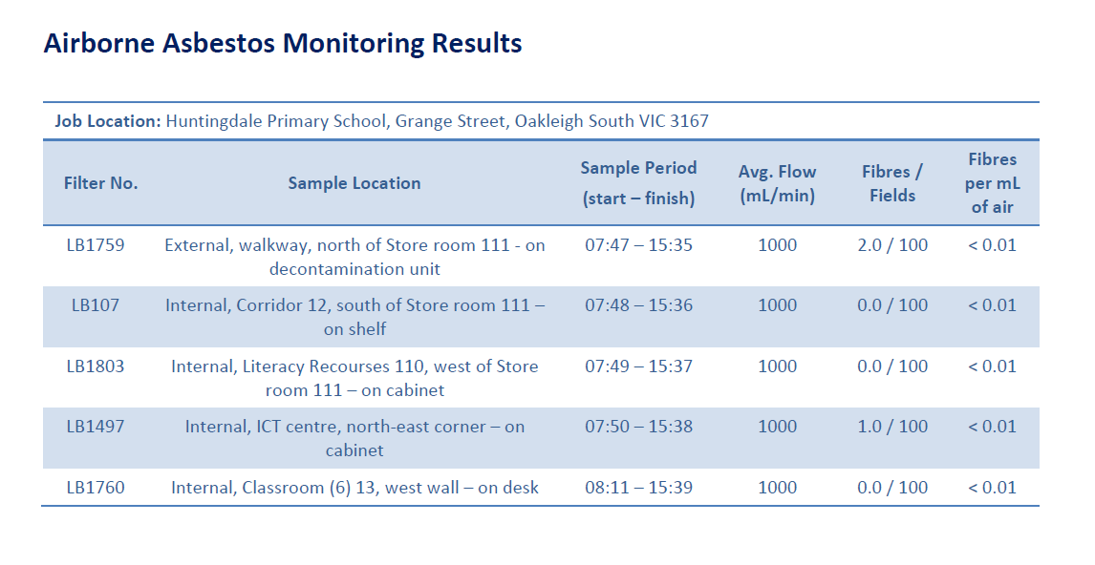
Figure 3. Example of air monitoring report.

Update this SAMP
The Asbestos Coordinator must update this SAMP by appending all removal documentation for instance, air monitoring results and clearance certificates. Following the completion of asbestos removal works. In addition, the school must ensure that the supervising Occupational Hygienist completes the ‘Asbestos Removal Completion Form’.

Record Removals
The asbestos coordinator must keep all the relevant asbestos-related records, including Safe Work Method Statements, asbestos removal completion forms, air monitoring reports, clearance certificates and waste clearance certificates. The school must also send a copy of these documents to the department (asbestos.reform@education.vic.gov.au). Following the removal of ACMs, the asbestos register will be updated to include the date of removal.

CHECKLIST—REMOVAL OF ACMs
Once the school has followed all the guidance documented in the previous pages. The requirements 9 to 10 are achieved.
REQUIREMENT 9: CONSTRUCTION ZONES
* | Project managers identify and remove ACMs before demolition or refurbishment works
* | The cost of identifying and removing ACMs is fully covered by the capital project budget
REQUIREMENT 10: LEGAL AND DEPARTMENTAL REQUIREMENTS
* | The school notifies the department of any proposed asbestos removal
* | Removal works are only carried out by Class A removalists
* | Removal works are only conducted during out-of-school hours with no one on site
* | Air monitoring results are required for clearance and reoccupation of the school
* | The school updates the School Asbestos Management Plan following asbestos-removal works
* | The school keeps all removal documentation and provides a copy to the department (asbestos.reform@education.vic.gov.au)

FAQs

The school undertook asbestos removal works. Can the department organise a new Division 5?
No, Division 5 audits only need to be updated every 5 years. Only the school asbestos register needs to be updated to reflect the asbestos removal works.

Do I need to create an asbestos label register?
Yes, schools are required to review the location and condition of all asbestos labels. However, a template for the asbestos label register is available on the Asset Information Management System (AIMS).

How can the school order new asbestos labels to replace the faded ones?
If labels need replacement, please contact the department’s 24-hour Asbestos Make Safe hotline on 1300 133 468.

All identified asbestos has been removed from the school. Can the asbestos labels be removed?
No, as per the OHS Regulations 2017, the presence of ACMs must be assumed in inaccessible areas. Therefore, labels must remain in place.

Can the department organise a Division 6 audit for the school?
No, schools are required to organise and fund Division 6 audits prior to undertaking any works. For Capital Works and Planned Maintenance projects led by the department, the cost of the Division 6 audit will be included in that projects scope?

Is the school required to pay for a Division 6 Audit for a project funded by the department?
Yes, if the school received funding for a school-led project, the necessary funds to cover the cost of a Division 6 audit need to be covered by the school prior to undertaking any works.

Do I need to organise a Division 6 Audit for minor works (such as hanging a picture frame in a classroom)?
If there is asbestos present in the location where the works will be occurring, or any uncertainty as to whether asbestos is present, then yes, a Division 6 audit needs to be organised. This applies to works that may include demolition, refurbishment, installation of new equipment, hanging displays, painting, soil works, excavation works and so on.

A new asbestos coordinator needs to be appointed. Can the department organise asbestos training for the nominated asbestos coordinator?
principals are automatically enrolled into the Managing asbestos in schools eLearning module. Principals must manually enrol the asbestos coordinator into this eLearn on commencement of their role and when required to be refreshed (as per the Asbestos management policy). The face-to-face Asbestos Management Information and Training Sessions are provided as part of the Bricks and Mortar Training Program. All principals and nominated asbestos coordinators should refer to the Bricks and Mortar Training Schedule to make a booking at a suitable date and time for the upcoming training session.

Can the department organise asbestos removal at the school?
The department only organises the removal of A3 risk-rated ACMs through the Planned Removal Program.

Can the department fund soil remediation works for the school?
No, the department’s default approach for the long-term management of asbestos-contaminated soils is management in-situ (that is, the material is encapsulated in the soil and monitored over time).

GLOSSARY
Glossary
ACM (Asbestos Containing Material) | Any manufactured material or object that, as part of its design, contains one or more of the fibrous forms of mineral silicates belonging to the serpentine or amphibole groups of rock-forming minerals, including actinolite, amosite (brown asbestos), anthophyllite, crocidolite (blue asbestos), chrysotile (white asbestos) or tremolite. Examples of ACMs include: asbestos-containing cement sheets, cement pipes, vinyl tiles, sprayed insulation, telecommunications pits, pipe lagging, millboard and gaskets.
Asbestos Coordinator | A person who is responsible for the safe management of ACMs within the workplace who, by default, is the school principal. It can also be a suitable person delegated by the school principal. The asbestos coordinator is the main contact for asbestos-related issues in the school.
Asbestos Register | The asbestos register contains current information about the existence and location of any known or presumed ACMs on the school site, based on an initial Division 5 audit report (that is, a visual assessment to identify the location and condition of ACMs) and subsequent quarterly visual inspections to update the register.
Asbestos Removal Completion Form | A form completed by an Occupational Hygienist at the conclusion of asbestos-removal works to verify that the atmospheric monitoring results and clearance certificates meet the required safety standards to allow the area to be re-occupied. The asbestos coordinator must counter-sign to verify that they have been provided with the relevant documents.
Capital Works Program | Schools receive Capital Works funding through the annual State Budget process to upgrade their facilities. To ensure that the Capital Works Program meets the needs of school communities, the department works in close collaboration with schools during the delivery of Capital Works projects.  Due to the presence of ACMs in a significant proportion of government schools across Victoria, it is not uncommon to unexpectedly find ACMs during the delivery of Capital Works projects. When this occurs, the department is required to review the original scope of works to ensure that the necessary project funds are allocated towards the removal of ACMs. Additional funding for asbestos-removal works cannot be allocated to existing Capital Works projects.
Contractor | A contractor includes any service providers/individuals who are not direct employees of the department and are providing services/works in relation to maintenance and repair work. This includes contractor employees, sub-contractors and sub-contractor’s employees.
Division 5 Asbestos Audit | A visual inspection conducted by an Occupational Hygienist at least every five years to identify the existence, location and condition of any known or presumed ACMs on the school site. Results of the audit are reported in a Division 5 audit report.
Division 6 Hazardous Building Materials Audit | Mandated sampling required of suspected ACMs (where there is uncertainty) to verify the existence of asbestos prior to work commencing in an affected area of the school. Results of this sampling are documented in a Division 6 Asbestos Audit Report.
eduSafe Plus | The departmental online hazard and incident reporting and management system. Employees can log on using their employee number and password.
Employee | A person employed under a contract of employment or contract of training
Friable Asbestos | ACM that can be crumbled or pulverised by hand pressure to a powder when dry.
Hazardous Building Materials | Asbestos (friable and non-friable)  Polychlorinated Biphenyls (PCB)  Synthetic Mineral Fibres (SMFs)  Lead-Based Paint  Copper Chrome Arsenate (CCA)-Treated Timber
HSR | Health and Safety Representative
IRIS (Immediate Response Information System) | The department emergency response reporting system.
Non-Friable Asbestos | Bonded ACM that cannot be crumbled by hand pressure alone.
OHSMS | Occupational Health and Safety Management System
Planned Maintenance Program | The department has implemented the Planned Maintenance Program to allocate funding to those individual school buildings in the poorest condition, based on the results of the 2012 Condition Audit of all Victorian government schools and the Rolling Facilities Evaluation. This funding is in addition to the school maintenance funding provided through the Student Resource Package (SRP).  It is also not uncommon to unexpectedly find ACMs during the delivery of Planned Maintenance projects. When this occurs, the department is required to review the original scope of works to ensure that the necessary project funds are allocated toward the removal of ACMs. Additional funding for asbestos-removal works cannot be allocated to existing Planned Maintenance projects.
SWMS (Safe Work Method Statement) | A document which describes the high risk work being performed, the health and safety risks associated with the work and the risk control measures that will be applied to ensure the work is carried out in a safe manner. Must be reviewed by the Principal or Asbestos Coordinator prior to the commencement of work.
School Asbestos Management Plan | A school asbestos management plan is a documented outline of how asbestos in each school will be managed.
SRP | Student Resource Package
Volunteer | A person approved by the Workplace Manager, who without payment or reward, voluntarily engages in schoolwork. Volunteers may be community members who assist in working bees, reading to students, serving at the canteen or assisting in school events such as swimming or athletics carnivals and fetes
VSBA | Victorian School Building Authority

APPENDIX A - LIST OF OCCUPATIONAL HYGIENISTS AND CLASS A ASBESTOS REMOVALISTS
Occupational Hygienists
LRM Global  (03) 9371 3400 | Prensa  03 9508 0100 | EH Solutions  1300 856 510

A Class Asbestos Removalists
Elite Building & Environmental Services Pty Ltd  03 9543 4322 | Australia Wide Asbestos Removal Encapsulation Pty Ltd  03 9580 5326 | Kennedy Australia  03 9393 9100 | AR Environmental  (03) 9435 4511

APPENDIX B - SCHOOL NEWSLETTER TEMPLATE
The Department of Education will soon be undertaking some proactive asbestos removal works at the [INSERT SCHOOL NAME] in the [INSERT BUILDING NAME].
Asbestos-containing materials will be removed from the school grounds in strict accordance with the Victorian Occupational Health and Safety Regulations 2017 and environmental Regulations. We will be working closely with the Victorian School Building Authority (VSBA), the responsible body for asbestos removal and remediation works within the department, to ensure disruption to students and staff is minimal.
Work will be undertaken by a licensed asbestos removalist engaged by the department. As a further precaution, an Occupational Hygienist will monitor air quality during applicable removal works and must issue a clearance certificate before any person can re-occupy the area.
As a precaution, it is requested that parents and carers ensure that children are not on the school grounds between [XX/XX/XXXX] and [XX/XX/XXXX]. I appreciate your cooperation and patience during this process.
If you would like further information, you may contact me on [XXXX XXXX] or by email: [EMAIL ADDRESS].

APPENDIX C - FURTHER ASSISTANCE

RELATED DOCUMENTATION
- Asbestos Label Register
- Asbestos Register
- Asbestos Removal Completion Form
- Contractor OHS Induction Checklist
- Soil, Mulch and Loose Fill Policy
- OHS Activities Calendar
- OHS Induction Checklist-School staff
- OHS Training Register
- Safe Work Method Statement
- Volunteer OHS Induction Checklist

Further information, advice or assistance on any matters related to asbestos management is available by contacting the VSBA Asbestos Reform Unit (asbestos.reform@education.vic.gov.au).
The department's OHS Advisory Service is available for assistance with the implementation and ongoing management of the OHS Management System asbestos requirements.
The OHS Advisory Service can be contacted on:
ph. 1300 074 715
email: safety@education.vic.gov.au

Ratings based on the United Kingdom’s Method for the Determination of Hazardous Substances. See ‘Methods for the Determination of Hazardous Substances (MDHS) guidance’, Health and Safety Executive, accessed on 09 November 2018, http://www.hse.gov.uk/asbestos/risk-assessments.htm

