

WARRANDYTE PRIMARY SCHOOL DRESS CODE POLICY

 | Help for non-English speakers  If you need help to understand the information in this policy, please contact Warrandyte Primary school on 9844 3537 or warrandyte.ps@education.vic.gov.au.

PURPOSE
The purpose of the Student Dress Code is to outline Warrandyte Primary School’s requirements for student dress and appearance and to provide information about uniform purchase and support, dress code implementation and exemption processes.
This dress code has been developed by Warrandyte Primary School’s School Council in close consultation with our school community to ensure that it respects the rights of individual students whilst reflecting the values and interests of our community.
The Student Dress Code aims to:
- foster a sense of community and belonging and encourages students to develop pride in their appearance
- support Warrandyte Primary School’s commitment to ensuring that our students feel equal and are dressed safely and appropriately for school activities
- reduce student competition on the basis of clothing
- enhance the profile and identity of the school and its students within the wider community.

SCOPE
Students are expected to comply with this Student Dress Code while traveling to and from school, during school hours and when attending school activities.

UNIFORM AND APPEARANCE
The full list of Warrandyte Primary School’s compulsory school uniform items is available in Appendix A to this policy.

Health and safety
Shoulder length or longer hair is to be tied back to help restrict the spread of lice and for student safety. Loose braids or
Jewellery, nails, hair accessories and similar items that interfere with students’ ability to engage with school activities safely and fully are not permitted.
In line with our SunSmart Policy, from 1 Sep – 30 Apr and on any day with a high UV rating, all children will be required to wear a “SunSmart” school hat, legionnaire or broad brimmed navy with school logo, or a plain navy hat of the same style when outside. This includes lunch time, recess, and Physical Education classes, sports sessions and other outside class activities.
Hats are not to be worn inside. Hats that don’t fall inline with uniform will be collected and temporarily held, being returned at the end of the school day.

PURCHASE OF UNIFORMS
Uniform items can be purchased from the parent run Uniform Shop at school, open on Tuesday mornings 9-9.30am during school terms, or parents may order online through FlexiSchools.
The parent run uniform shop also operates a second-hand uniform store for parents.
The School Council has considered affordability in the development of this dress code. However, if you are facing difficulty meeting uniform costs the Help with school costs and fees page provides advice on support offered by the Victorian Government. If your child is starting Prep or Year 7 and is eligible to receive support via the Camps, Sports and Excursions Fund, you may be eligible to access the Affordable School Uniform (ASU) program.
Please contact the principal or the school office staff to discuss support that we may be able to provide.

IMPLEMENTATION
Warrandyte Primary School will ensure that this Student Dress Code is communicated to all families and students through our website and in student transition and enrolment packs. Newly implemented policy will also be covered during whole-class discussions as part of our whole-school Positive Classroom Management Strategies. We will assist students who may be experiencing difficulties complying with this policy where possible.
If a student is out of school uniform or otherwise breaches the Student Dress Code on a recurring basis, a note will be provided to the student and parents by the classroom teacher. If non-compliance with the dress code becomes a continued occurrence, the principal will be informed and a phone call home may be required. In this event, the school will continue to work with the student and family to support compliance.
Measures taken by Warrandyte Primary School to address concerns about student non-compliance with the Student Dress Code will also be addressed in accordance with our Student Wellbeing and Engagement Policy.

EXEMPTIONS TO STUDENT DRESS CODE
We acknowledge that there might be instances where the enforcement of this dress code could impact students differently.
Students and their parents or carers may apply either in writing or in person to the principal for an exemption to this Student Dress Code if:
- an aspect of this code prevents the student from complying with a requirement of their religious, ethnic or cultural beliefs or background
- the student has a particular disability or health condition that requires a departure from the dress code
- the student or their parents/carers can demonstrate particular financial hardship that prevents them from complying with the dress code.
When the Principal receives a request for an exemption, they will:
- consider the grounds for the exemption request
- explain the process to the student and/or their parents/carers
- encourage the student and/or their parents/carers to support their application with evidence.
The Principal or delegate will then try to negotiate a resolution that is acceptable to all parties. If an exemption is not allowed, then written reasons will be provided to the student and/or their parents or carers.

CONCERNS ABOUT THIS STUDENT DRESS CODE
Warrandyte Primary School welcomes feedback from the school community in relation to this Student Dress Code. If you have a concern or complaint about the Student Dress Code, further information about raising a concern or complaint is available in our school’s Parent Complaint Policy, available on our website.

COMMUNICATION
This policy will be communicated to our school community in the following ways:
- Available publicly on our school’s website (or insert other online parent/carer/student communication method)
- Reminders in our school newsletter
- Discussed in student forums – Junior School Council
- Included in staff handbook/manual
- Discussed at staff briefings/meetings as required
- Included in transition and enrolment packs
- Discussed at parent information nights/sessions
- Hard copy available from school administration upon request

FURTHER INFORMATION AND RESOURCES
- Warrandyte Primary School SunSmart Policy
- Warrandyte Primary School Parent Complaint Policy
- Warrandyte Primary School Student Wellbeing and Engagement Policy
- Department of Education and Training Student Dress Code
- Department of Education and Training Student Engagement policies and guidelines.

POLICY REVIEW AND APPROVAL
Policy last reviewed | August 2026
Consultation | School Community & School Council
Approved by | School Council
Next scheduled review date | August 2029

Appendix 1
Warrandyte Primary School Dress Code
NB: The term ‘plain’ in the dress code below is referring to no Warrandyte Primary School logo or markings of any kind.
Uniform Area | Everyday School Uniform | Requirements / Options
Tops | WPS branded | Short-sleeved polo • Long-sleeved polo • Windcheater • Fleece jacket • Bomber jacket • Rain jacket
 | Plain alternatives | Plain red T-shirt, polo shirt or jumper
Bottoms | Navy | Plain navy shorts • Pants • Skort • Netball skirt • Leggings
Summer option | School dress | Red and white summer school dress. Navy ½ or ¾ length leggings may be worn underneath.
Winter option | Pinafore | Navy pinafore with red polo shirt or skivvy underneath and navy tights.
Warm outerwear | Coats & vests | Navy puffer jackett/puffer vest (no logo required)
Footwear | School shoes or runners | Sneakers or black school shoes. Socks or tights must be black, navy or white.
Footwear – not permitted | For safety | No thongs, Crocs, slip-on shoes, heeled shoes or open-toed shoes. Exception: footwear used when travelling to and from swimming programs.
SunSmart hat | 1 September – 30 April | WPS broad-brimmed or legionnaire hat, or a plain navy hat of the same SunSmart style. Required outside during recess, lunch, PE, sport and outdoor learning. Also required outside on other days when UV levels require sun protection under the school’s SunSmart Policy.
Winter hat | Optional | WPS navy beanie or plain navy beanie.
Additional winter layers | Optional | Plain red T-shirt  Plain red or navy long-sleeved top  Red or navy skivvy worn underneath the uniform for warmth.
Year 6 Uniform
Uniform Area | Year 6 Options
Everyday uniform | All standard WPS everyday uniform options apply.
Commemorative uniform | Year 6 commemorative polo shirt and commemorative jumper may be worn as part of the everyday uniform.

Sports Uniform Years 3-6 Only
Uniform Area | Sports
Top | WPS sports polo shirt
Bottom | Navy shorts • Navy pants • Navy skort • Navy netball skirt
Footwear | Runners/sneakers
Socks | White, navy or black only
Hat | Navy WPS broad-brimmed or legionnaire school hat or navy unbranded navy broad-brimmed or legionnaire hat
When it can be worn | The sports top and netball skirt may be worn at school. They are not to be worn on excursions or when representing the school, except for sports-related activities.

For House Sport events only
Uniform Area | House Sports Requirements
Top | WPS sports polo shirt or House-coloured T-shirt for designated whole-school sporting events.
Brackenbury | 🟨 Yellow
Forbes | 🟦 Blue
Anderson | 🟥 Red
Yarra | 🟩 Green
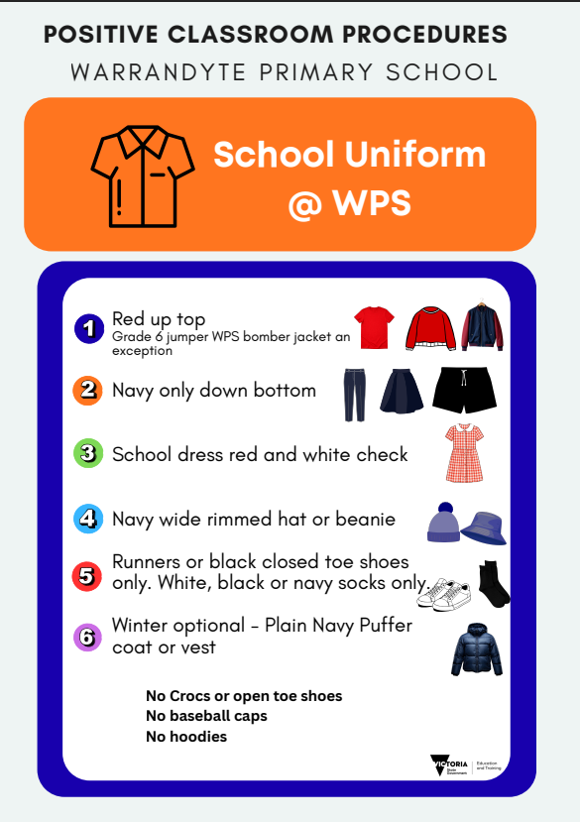

Appendix 2

WARRANDYTE PRIMARY SCHOOL
Student Uniform Exemption Request
Purpose. This form is for a student or parent/carer seeking an exemption from, or modification to, Warrandyte Primary School's Student Dress Code. The Principal manages the exemption process in accordance with the Victorian Department of Education Policy and Advisory Library (PAL) Student Dress Code guidance.
Confidentiality. Personal information provided to support this request will be treated confidentially. Applicants are encouraged to provide relevant supporting evidence where appropriate.
1. Student and applicant details
Student name: | Year level / class:
Parent/carer or student applicant: | Date:
Contact details:
2. Ground for exemption
Please indicate the ground that best applies to the request:
☐ An aspect of the dress code prevents the student from attending school or participating in school activities on the same terms as other students because of a protected personal characteristic.
☐ An aspect of the dress code offends a religious belief held by the student or parent/carer.
☐ An aspect of the dress code prevents the student from complying with a requirement of their religious, ethnic or cultural background.
☐ The student has a particular disability or health condition that requires a departure from the dress code.
☐ The student or parent/carer can demonstrate particular economic hardship that prevents compliance with the dress code.
☐ Other grounds for consideration at the Principal's discretion.
3. Dress code requirement affected
Identify the uniform item or dress code requirement for which an exemption or modification is requested:
________________________________________________________________________________
4. Reason for the request
Briefly explain why an exemption or modification is required:
________________________________________________________________________________
_______________________________________________________________________________
________________________________________________________________________________

5. Proposed alternative or modification
Where possible, describe an alternative arrangement that would meet the student's needs while maintaining the intent of the Student Dress Code:
________________________________________________________________________________
________________________________________________________________________________
6. Supporting evidence
Relevant supporting evidence may be attached where appropriate. Please identify any documents provided:
☐ Medical/health information ☐ Religious/cultural information ☐ Financial hardship information
☐ Other: ________________________________________________________________________
7. Requested duration
☐ Temporary: from __________________ to __________________
☐ Ongoing, subject to review ☐ Other: __________________________________________
Applicant declaration
I confirm that the information provided is accurate and request that the Principal consider this exemption request.
Signature: | Date:
For Principal / school use
PAL process: The Principal considers the grounds and supporting information and seeks, where possible, to negotiate a resolution acceptable to all parties. This may include modifying dress requirements, providing assistance to enable compliance, or setting conditions on an exemption.
Outcome | ☐ Exemption granted  ☐ Modified arrangement agreed  ☐ Exemption not granted
Agreed exemption / modification / conditions
Reasons for decision
Commencement date
End or review date
Principal / delegate
Signature / date
Record keeping: The school will keep a written record of the decision and the reasons provided. If an exemption is not granted, reasons will be provided in writing.
Reference: Victorian Department of Education, Policy and Advisory Library - Student Dress Code: Exemption procedures (updated 3 June 2025).

