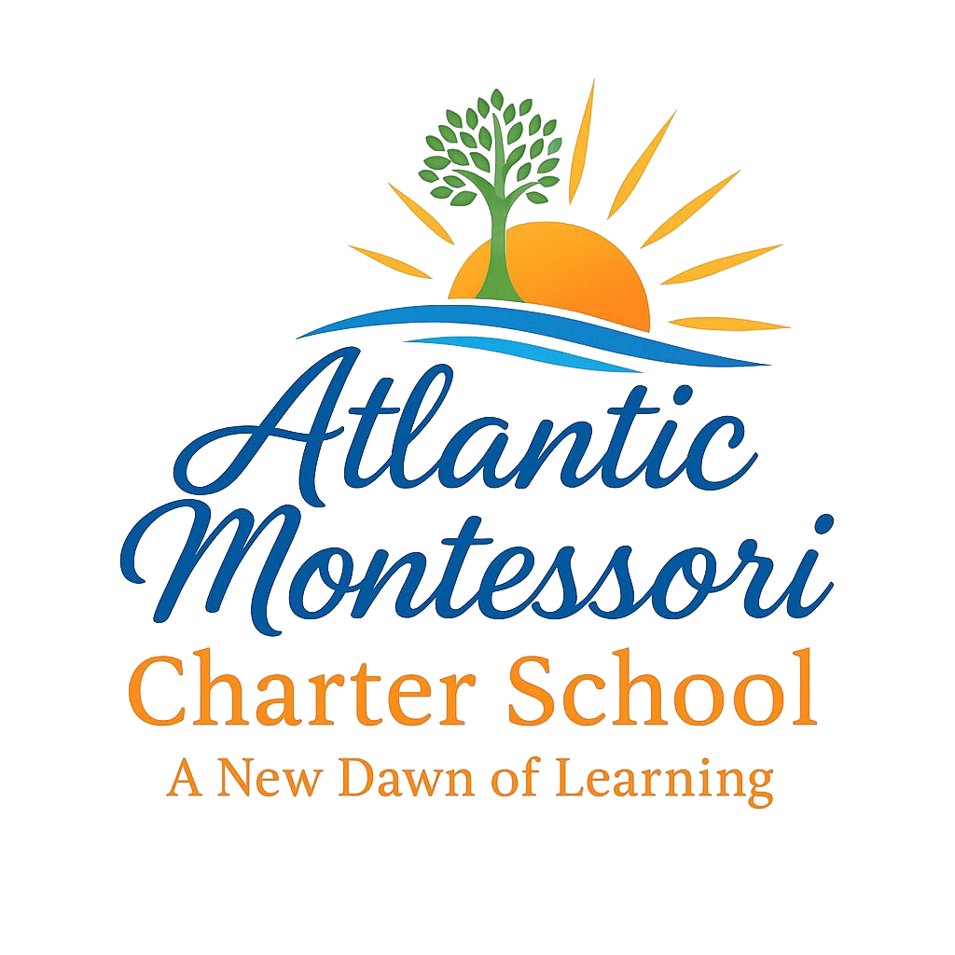

ATLANTIC MONTESSORI CHARTER SCHOOL

K-5 INSTRUCTIONAL MODEL

2026-2027

Mission
To ensure every student masters grade-level standards through explicit instruction, active engagement, differentiated small-group instruction, and authentic application of learning through Montessori principles and Micro-Society experiences.

ATLANTIC MONTESSORI CHARTER SCHOOL

2026-2027 INSTRUCTIONAL PLAYBOOK ACKNOWLEDGMENT

Teacher Name: ______________________________________

Grade Level/Position: _______________________________

Date: _____________________________________________

Purpose

The AMCS Instructional Playbook establishes the instructional expectations, systems, and practices that guide teaching and learning at Atlantic Montessori Charter School.

All instructional staff are expected to review the playbook in its entirety and implement the instructional practices outlined within the document.

By signing this acknowledgment, I confirm that I have read, reviewed, and understand the expectations outlined in the AMCS Instructional Playbook.

SECTION ACKNOWLEDGMENTS

Please initial each section after reviewing.
Section | Teacher Initials
Section 1: Instructional Non-Negotiables | ________
Section 2: Daily Master Instructional Blocks | ________
Section 3: Small Group Instructional Model | ________
Section 4: MTSS & Intervention Model | ________
Section 5: Micro-Society Integration Model | ________
Section 6: Professional Learning Communities (PLCs) | ________
Section 7: Instructional Walkthrough Framework | ________
Section 8: Teacher Accountability & Data Ownership | ________
Section 9: Yearlong Instructional Improvement Focus | ________

PROFESSIONAL COMMITMENT

By signing below, I acknowledge and agree to the following:

Instructional Expectations

_____ I understand that all instruction at AMCS must align to the AMCS Instructional Model.

_____ I will implement the instructional non-negotiables outlined in the playbook, including learning targets, retrieval practice, gradual release, checks for understanding, and active engagement.

_____ I understand that standards-based instruction is expected in every lesson.

Small Group Instruction & Intervention

_____ I understand that small-group instruction is a required component of daily instruction.

_____ I will use student data to create and maintain flexible instructional groups.

_____ I will provide intervention, enrichment, and differentiated instruction based on student needs.

_____ I understand my role in the implementation of the school's MTSS and WIN Block systems.

Data & Student Achievement

_____ I will regularly monitor student performance and use data to adjust instruction.

_____ I understand that I am expected to know the academic strengths, needs, intervention status, and progress of my students.

_____ I will participate in data discussions and maintain accurate records of student progress.

Professional Learning Communities

_____ I understand that PLC meetings are instructional in nature and require active participation.

_____ I will arrive prepared with student work, assessment data, standards, and instructional resources.

_____ I will contribute to collaborative problem-solving focused on student achievement.

Classroom Environment

_____ I will maintain a classroom environment that supports student learning, engagement, and academic success.

_____ I will establish and consistently enforce classroom routines and procedures.

_____ I will maintain instructional displays, student work, anchor charts, and learning resources that support current instruction.

Professional Growth

_____ I understand that classroom walkthroughs are designed to support instructional improvement.

_____ I will accept coaching and feedback professionally and work to continuously improve my instructional practice.

_____ I understand that implementation of the AMCS Instructional Playbook will be monitored through classroom observations, walkthroughs, coaching conversations, PLCs, and student achievement data.

ACKNOWLEDGMENT OF RECEIPT

I acknowledge that I have received, reviewed, and understand the expectations outlined in the Atlantic Montessori Charter School 2026-2027 Instructional Playbook.

I understand that these expectations establish the instructional framework for teaching and learning at AMCS and that I am responsible for implementing them with fidelity.

I understand that failure to implement the expectations outlined within this playbook may result in additional coaching, professional development, corrective action, or other personnel actions as deemed appropriate by school administration.

Teacher Signature: ____________________________ Date: _______________________

