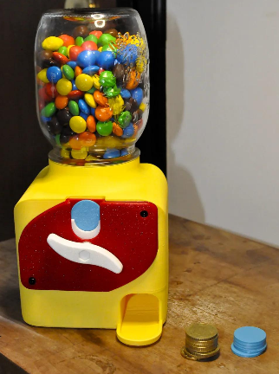
Slot Machine Candy Dispenser

- Best working token mechanism
- Candy Dispenser – Coin or Token Operated
- Best overall mechanism
- Takes a custom 3D-printed token.
- Insert the token and turn the knob to dispense sweets.
- Has a transparent glass candy container.
- Updated drum and funnel accommodate larger portions.
- Limitation: It looks more like a jar dispenser than a traditional vending cabinet, and its exact assembled height isn't specified.
- View the model, photos and assembly guide

