give me a bunch of useful 3d products

maybe somewhere to put your toothpase and brushes

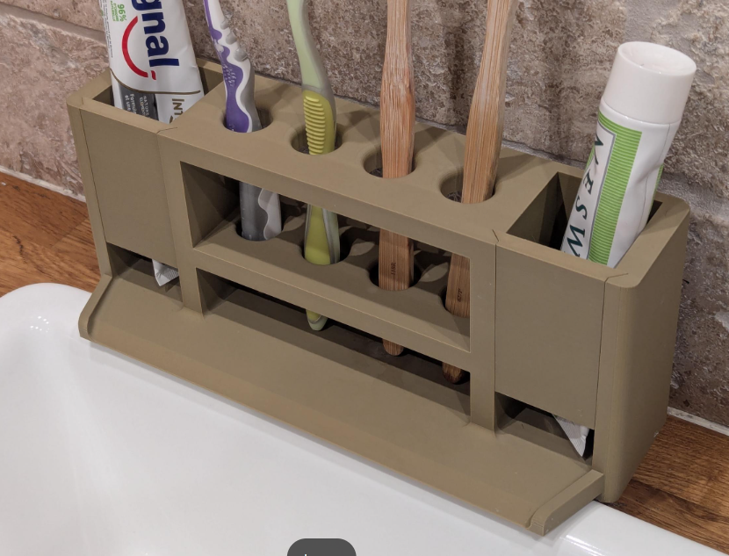

I want it to be colourful.

