My story is about a Dragon

- A cute dragon was flying
- Then an airplane hit the dragon
- but the dragon was strong and stayed intact

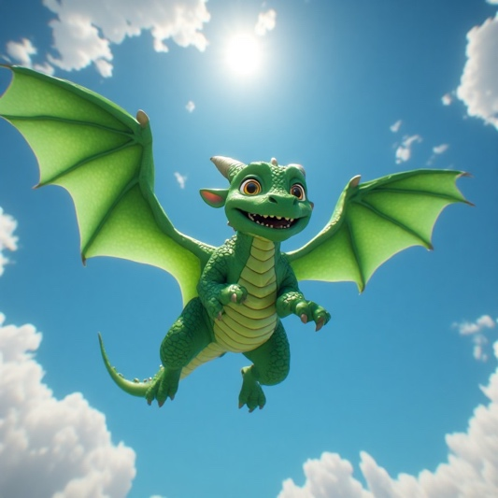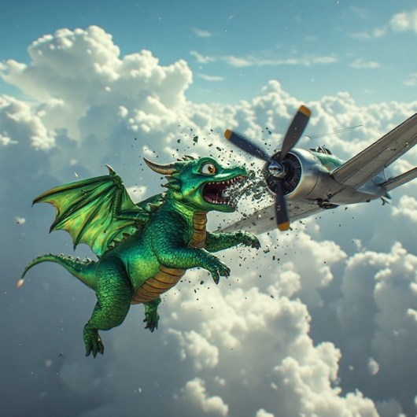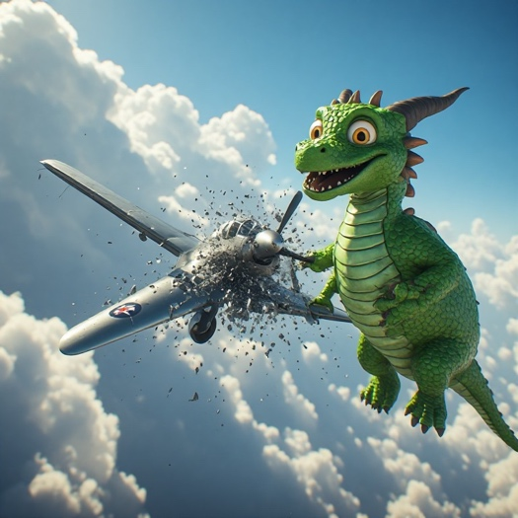

A cute dragon was flying an airplane hit the dragon But he was strong and stayed intact

