- Max Verstappen lost his red bull oracle F1car.
- Then he found it.
- He drove it and ended up in the hospital with Sponjy.

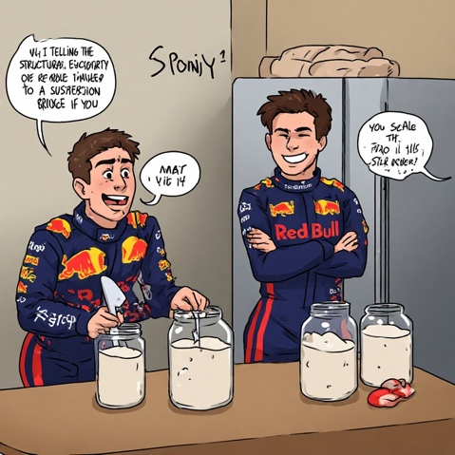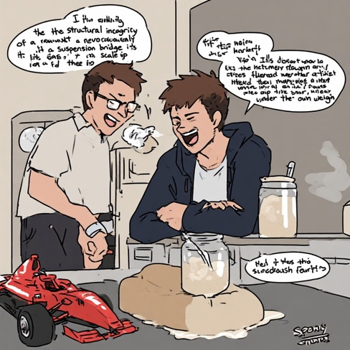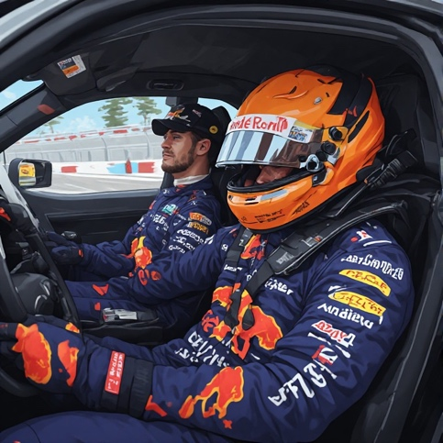
Max Verstappen lost his car The he found it Finally he drove it

