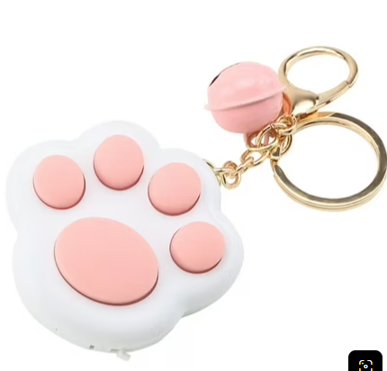

I want to have a paw clicker keychain that’s white and pink

