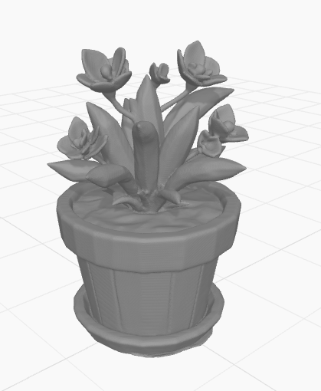

i want to make a cat clicker on print pal how do i do that

You can make a cat-shaped clicker on PrintPal! 🐱 If you mean a physical 3D-printed clicker that you can press and hear click, PrintPal has a tool called the Fidget Clicker Maker that lets you customize a design with an image or a 3D model.

printpal.io
+1

How to make your cat clicker

1. Open PrintPal
Go to PrintPal's tools page and find Fidget Clicker Maker.

2. Choose your cat design
Use a cat image, icon, or 3D model. A simple cat face with pointy ears is a good starting design.

3. Add the clicking mechanism
Follow the tool's instructions to position the MX-style switch mechanism and customize the design.

4. Export and print
Generate the model, download the printable file, and print it with a compatible 3D printer. You'll need a compatible switch for the clicking action.
Quick tip: Use a high-contrast cat image so the shape comes out clearly when printed.

printpal.io
One question so I can guide you the right way: do you mean a real clicker toy you 3D-print, or a cat clicker game on a screen where you tap the cat to earn points? 🐈

