Under the sea

- Sponge bob was swimming
- He saw his burger shop
- He ate his special burger

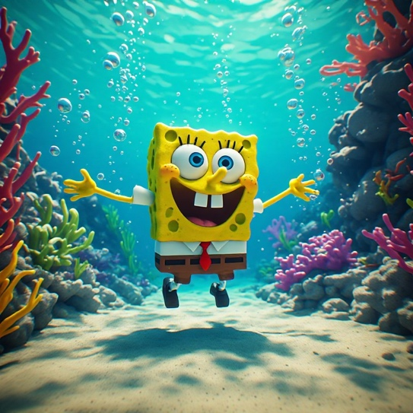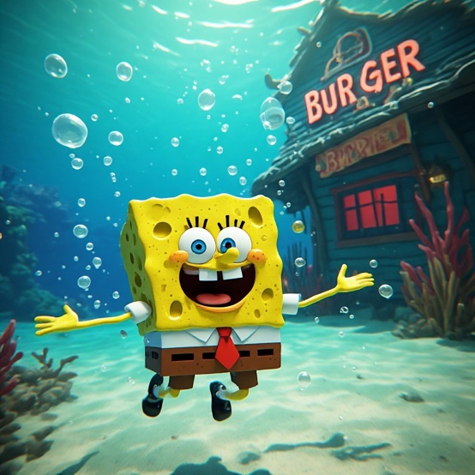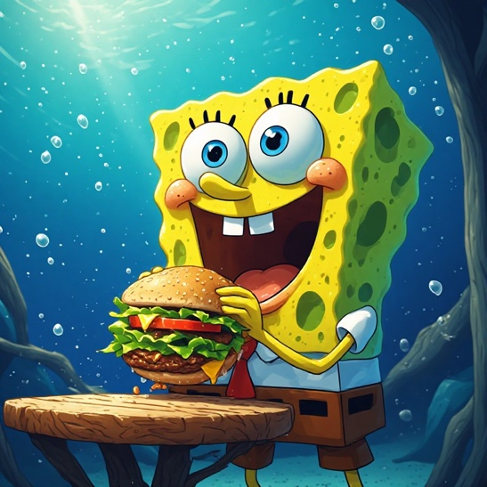
Sponge Bob was swimming He saw his burger shop He ate his special burger

