A fighting gorilla in a neo judo uniform and a black belt

🦁 The Lion vs. The Two Gorilla Judo Masters 🦍🥋
Once upon a time, deep in the heart of the jungle, there lived a mighty lion named Leo. He was strong, fast, and proud of his powerful roar. Leo believed he was the greatest fighter in the entire jungle.
One sunny morning, Leo walked into a jungle clearing and saw two enormous gorillas, Bruno and Kong, practicing judo on a soft patch of grass.
“Ha! What are you two doing?” Leo laughed. “Rolling around in the dirt? If you want to fight, come and face the king of the jungle!”
Bruno stood up and smiled. “You might be the king of the jungle, Leo, but we are the kings of judo!”
Kong slapped his chest. “Let's see what you've got!”

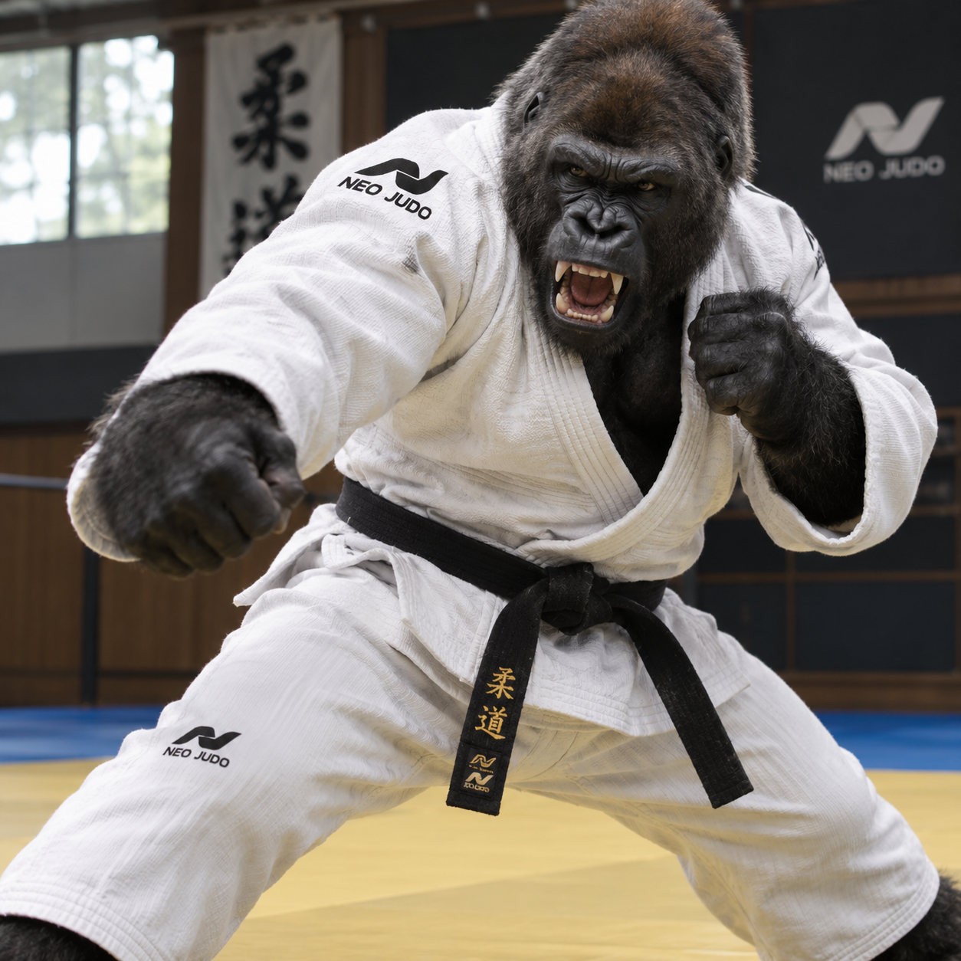

🥋 Round 1: The Lion Attacks!
Leo roared, charged forward, and tried to knock Bruno down with his powerful paws.
But Bruno was ready!
“JUDO THROW!” shouted Bruno.
He grabbed Leo's momentum, turned his body, and flipped the surprised lion onto the grass.
BOOM!
The jungle animals gasped.
Leo jumped back up, shaking his mane. “Lucky move! I'll get you this time!”
He rushed toward Kong, who calmly stepped aside, grabbed Leo's arm, and used a clever judo hip throw.
WHOOOOSH! THUMP!
Leo landed on his back for the second time.
A family of monkeys burst out laughing.
“THE KING HAS BEEN FLIPPED!” they shouted from the trees.
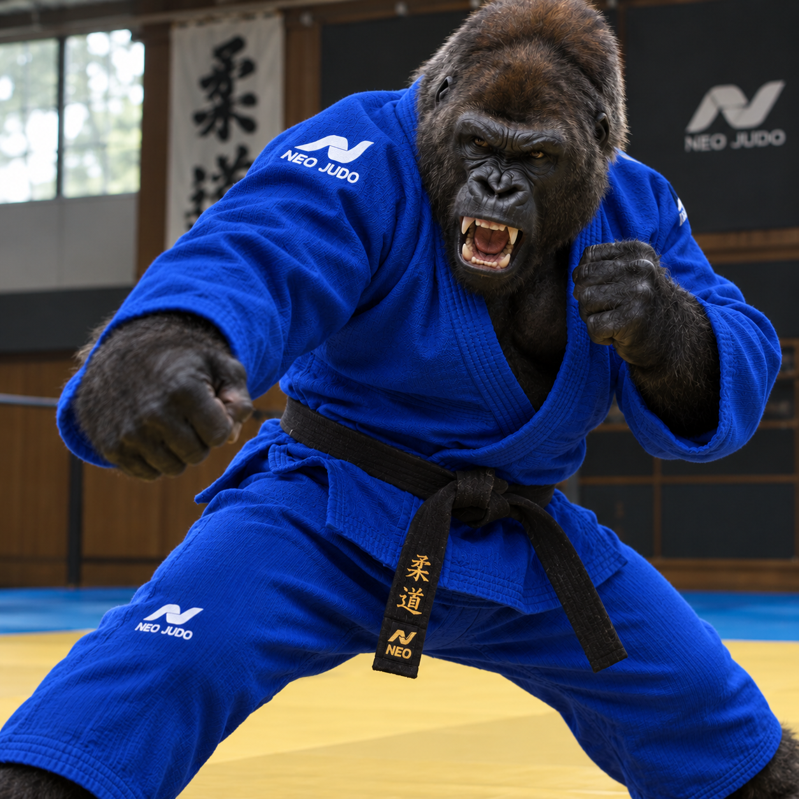

🦍 Round 2: Two Gorillas, One Lion!
Now Leo was determined to win.
“Both of you! Fight me together!” he roared.
Bruno and Kong looked at each other and nodded.
Leo charged at Bruno, but Bruno sidestepped. Kong moved behind Leo and gently hooked his leg.
FLIP!
Leo stumbled onto the grass again.
He scrambled to his feet and tried to tackle Kong. Kong used a judo foot sweep, sending the lion spinning harmlessly onto his side.
Bruno raised his arms. “That's four falls, Leo!”
“FOUR?!” Leo shouted. “I DEMAND A REMATCH!”
The jungle animals were cheering so loudly that birds flew out of the trees.

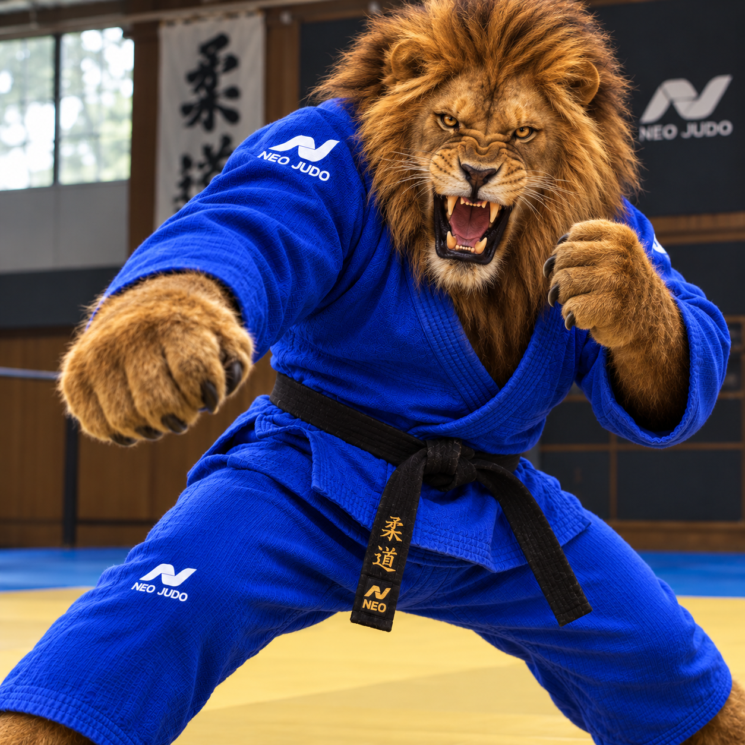

🏆 Final Round: The Lion's Secret Move
Leo took a deep breath. This time, instead of charging wildly, he watched the gorillas carefully.
Bruno reached for his sleeve. Leo shifted his weight and managed to stay balanced.
“Hey!” Bruno exclaimed. “He's learning!”
Kong stepped forward, attempting another throw. Leo turned with the movement, but Kong was too experienced. He guided Leo onto the mat with a controlled judo throw.
THUD!
Leo landed safely on his back.
For a moment, the jungle went silent.
Then Leo started laughing.
“That was AMAZING!” he said. “You two are incredible!”
Bruno offered him a hand, and Kong helped pull him up.
“You've got strength, Leo,” Bruno said, “but judo takes balance, patience, and practice.”
Leo nodded. “Will you teach me?”
“Only if you promise not to roar in our ears every time you lose!” Kong joked.
Everyone burst out laughing.

🥇 The Jungle Judo Champions
From that day on, Leo trained with Bruno and Kong every morning. Sometimes Leo won a round. Sometimes the gorillas threw him onto the mat so quickly that he barely knew what happened.
But Leo never stopped practicing.
Eventually, the three friends opened the Jungle Judo Academy, where animals of every size learned to fight fairly, respect one another, and stay in control.
And whenever someone asked who was the strongest fighter in the jungle, Leo would smile and say:
“Strength makes you powerful. Skill makes you dangerous. But friendship makes you a champion!”
Then Kong would challenge him to one more round.
“Ready, Lion?”
Leo grinned.
“BRING IT ON!”
WHOOSH! FLIP! THUMP!
And the jungle echoed with laughter once again. 🦁🥋🦍

