My story is about someone called Sponjy.

1- He fell of the Burj KHalifa and ended up with Max Verstopin wa wa wa wa I feel bad

2- HE SAID: I am gonna die !!!!!!

3- HE WENT TO THE HOSPITAL

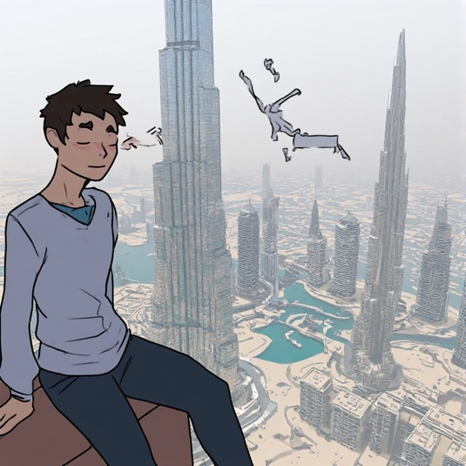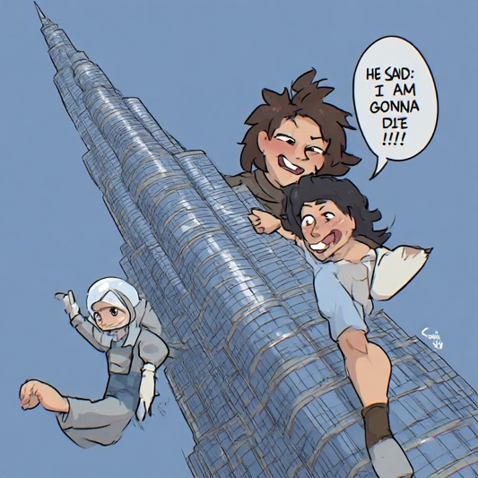
He fell of the Burj KHalifa and HE SAID: I am gonna die !!!!!! HE WENT TO THE HOSPITAL
ended up with Max Verstopin
“wa wa wa wa I feel bad”

