AI SHARED PRACTICE
Solution Intake &
Routing Operating Model
A scalable, auditable operating system for qualifying, routing, solutioning and measuring enterprise AI opportunities

RECOMMENDED OPERATING PRINCIPLE AI Shared Practice owns the intelligence layer. The domain practice owns the platform or transformation when that capability carries the dominant delivery and commercial scope.

Prepared for Jeff Joseph and Armando Franco
Prepared by Jory Pai, Solution Executive | September 2026 | Version 1.0

Executive Summary
The AI Shared Practice needs more than an intake form. It needs a consistent decision system that tells sellers and solution teams whether an opportunity is truly AI-led, which practice is accountable, who must participate, what evidence is required, and how the decision is recorded.
This operating model establishes one front door for AI-related opportunities while preserving the delivery strength and commercial ownership of GCP, AWS, Azure, Red Hat, Application Modernization, Data, Integration, Security and other domain practices. It is designed to be simple enough to launch with existing enterprise tools and disciplined enough to scale without becoming a political or administrative bottleneck.
DECISION REQUESTED Approve a 60-day MVP using Salesforce as the authoritative record, Teams as the collaboration surface, and named Shared AI triage leadership with published SLAs and decision rights.

What changes
- One intake: Sellers submit a short minimum viable intake connected to the Salesforce Opportunity.
- Two-stage qualification: Fast triage first; deeper architecture and delivery qualification only when warranted.
- Explicit engagement model: Every intake becomes OWN, CO-SOLUTION, CONSULT or HANDOFF.
- Evidence-based routing: AI criticality, platform gravity, delivery composition, commercial scope and risk determine accountability.
- Human decision rights: AI tools can summarize and challenge; designated leaders approve routing and solution release.
- Closed-loop measurement: The practice tracks owned, influenced and routed pipeline, solutioning effort, conversion and reusable IP.

Target outcomes for the first 90 days
Outcome | Target | Why it matters
Triage speed | ≥ 90% routed within 3 business days | Sellers know where to go and opportunities stop stalling.
Intake quality | ≥ 85% complete at first review | Architect time is spent solving, not chasing basics.
Decision traceability | 100% with owner, rationale and timestamp | Routing is defensible and auditable.
Cross-practice alignment | < 10% escalated for ownership dispute | Rules resolve routine cases; leaders handle true exceptions.
Value visibility | Owned + influenced + routed pipeline reported monthly | Shared Practice contribution is measurable.

Document map
Section | Purpose
1 | Charter and design principles
2 | Governance and engagement models
3 | End-to-end intake lifecycle
4 | Qualification gates and scoring
5 | Practice routing rules
6 | Decision rights, RACI and SLAs
7 | Tool architecture and controls
8 | Implementation roadmap and measures
Appendix A | Complete intake form
Appendix B | Scoring rubric
Appendix C | Routing scenarios

1. Charter and Design Principles

Proposed charter
CHARTER The AI Shared Practice is the enterprise center of gravity for AI qualification, architecture, governance and AI-specific solutioning. It connects cloud, application, data, integration, security and platform practices. Opportunity accountability follows the dominant business outcome, delivery capability, commercial scope and risk—not the mere presence of AI terminology.

The five questions every intake must answer
Dimension | Decision question
Business outcome | What measurable client problem is being solved?
AI gravity | Is AI incidental, helpful, significant or fundamental to the outcome?
Platform gravity | Where does the workload live and which platform capabilities dominate?
Delivery gravity | Which skills make up most of the work and delivery risk?
Commercial gravity | Where is most of the SOW value, margin, accountability and exposure?

Design principles
- One front door, many destinations: Users should not need to understand the org chart before asking for help.
- Progressive disclosure: The initial form stays short; conditional questions open only when needed.
- Rules before personalities: Documented criteria handle common cases and reduce ownership debates.
- AI is not the workflow engine: AI improves speed and quality, but deterministic workflow and human approvals remain authoritative.
- No orphaned handoffs: A receiving owner must accept before the originating team exits.
- Minimum necessary data: Do not paste client confidential data into AI tools unless the approved data-handling path explicitly permits it.
- Measure contribution, not just ownership: Credit sourced, owned, influenced and routed revenue separately.
- Learn from every decision: Overrides and outcomes tune the rubric and create reusable patterns.

2. Governance and Engagement Models

Four engagement models
Model | Primary owner | Use when | Control
OWN | AI Shared Practice | AI is the solution; AI-specific architecture, engineering and risk dominate. | AI lead is accountable; domain practices support.
CO-SOLUTION | Joint | AI and another platform/transformation are both material. | One accountable practice is named; both approve architecture.
CONSULT | Domain practice | AI expertise is useful but not material to ownership. | AI provides bounded review, advisory or quality gate.
HANDOFF | Domain practice | AI is incidental, future-state or marketing language. | Receiving practice accepts record; AI closes its action.

Governance forums
Forum | Core participants | Purpose | Cadence
Daily/async intake queue | Shared AI SE or intake manager | Validate completeness; assign triage owner; stop duplicate requests. | 15 min / async
Twice-weekly triage | Shared AI SE + rotating AI architect | Score, route, classify urgency, request missing evidence. | 30 min
Weekly solution council | AI, cloud, app, data, integration, security leads as needed | Resolve complex ownership, approve solution shape and exceptions. | 45 min
Monthly portfolio review | Practice leaders + sales leadership | Pipeline, conversion, capacity, disputes, wins/losses, rubric calibration. | 60 min
Quarterly operating-model review | Executive sponsor + practice leadership | Approve thresholds, SLAs, controls and investment changes. | 90 min

Non-negotiable ownership rules
- Every record has one accountable Practice of Record, even when several practices share delivery.
- AI Shared participation and opportunity ownership are separate decisions.
- A handoff is not complete until the receiving practice accepts ownership in Salesforce.
- The accountable practice owns the final SOW, estimate, assumptions, delivery model and commercial risk.
- AI architecture cannot be released without an AI-qualified reviewer when AI is rated significant or fundamental.
- Overrides require the approver, reason, affected score and expiration/review date.

3. End-to-End Intake Lifecycle
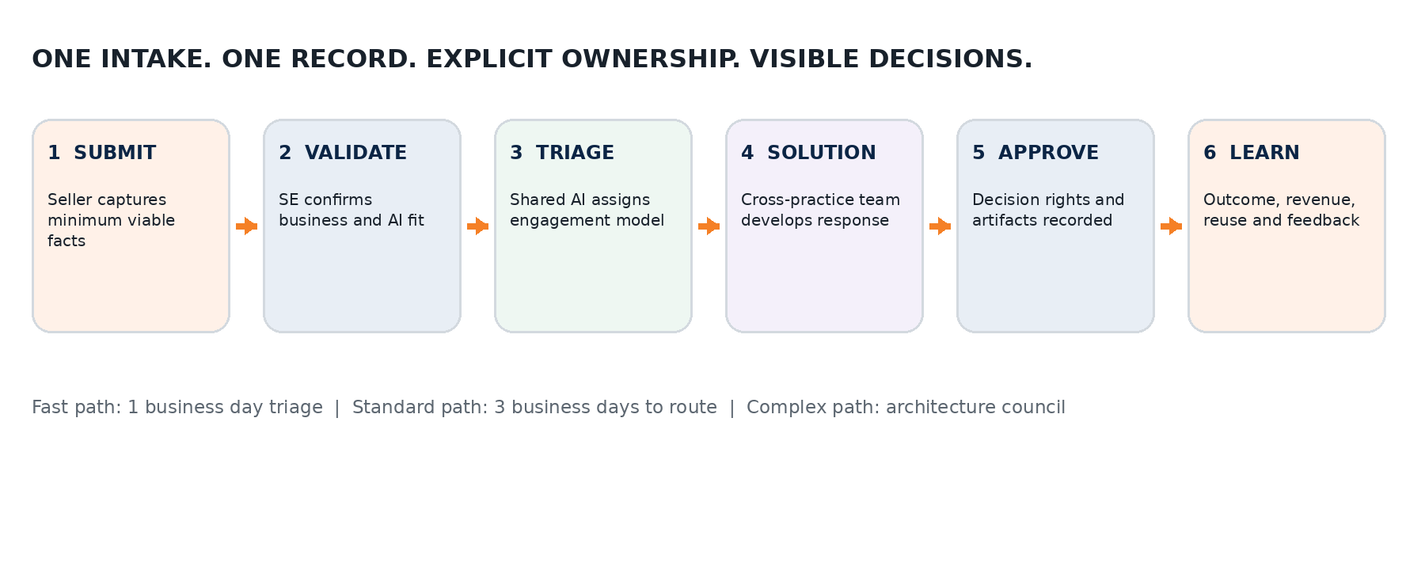
Stage | Accountable role | Core activity | Exit evidence
0. Pre-intake | Seller / account team | Confirm Salesforce Opportunity exists; avoid duplicate intake. | Opportunity ID; business problem; client contact.
1. Submit | Seller / SE | Complete minimum viable intake in 8–10 minutes. | New Intake ID; status = Submitted.
2. Validate | Intake coordinator | Check required fields, duplicates, urgency and data sensitivity. | Accepted or Returned for Information.
3. Triage | Shared AI SE + AI architect | Apply gates, score AI/platform gravity, assign engagement model. | Practice of Record; supporting practices; rationale.
4. Solution | Named solution team | Run discovery, architecture, estimate, risk and commercial reviews. | Solution artifacts; assumptions; estimate; SOW inputs.
5. Approve | Accountable practice leadership | Approve solution release and exception disposition. | Approved decision with named approvers.
6. Learn | Practice operations | Capture outcome, influence, reuse, win/loss and actual effort. | Closed-loop metrics and rubric updates.

Status model
Use a small, explicit status set: Draft → Submitted → Validation → Awaiting Information → Triage → Routed → Solutioning → Pending Approval → Approved → Closed/Won/Lost/No Pursuit. A status transition should be automated only when its entry and exit conditions are deterministic.

Priority classes
Class | Definition | Target response
P0 – Executive / active incident | Named executive request or material production risk; leadership confirms exception. | Same business day
P1 – Time-bound pursuit | Client event, RFP, renewal or proposal milestone within 10 business days. | 1 business day
P2 – Standard qualified pursuit | Real opportunity with sponsor, outcome and plausible timing. | 3 business days
P3 – Explore / nurture | Early idea, no confirmed sponsor or funding, future roadmap. | 5 business days or office hours

4. Qualification Gates and Scoring

Gate sequence
Gate | Question | Disposition
Gate 1 — Business qualification | Is there a defined problem, sponsor, outcome, urgency, buying path and plausible funding? | Advance / nurture / reject
Gate 2 — AI suitability | Would AI outperform a simpler workflow, rules engine, search or analytics approach? | AI fit / non-AI route / discovery required
Gate 3 — Technical feasibility | Are data, model, integration, security, hosting, performance and governance constraints understood? | Feasible / conditional / blocked
Gate 4 — Delivery feasibility | Can TGS staff, govern and commercially stand behind the solution? | Deliver / partner / no-bid / validate

POWER QUESTION If AI were removed, would the client still pursue essentially the same initiative? “Yes, almost unchanged” suggests another practice; “yes, but reduced” suggests co-solutioning; “probably not” or “absolutely not” suggests AI-led ownership.

AI Ownership Score — 0 to 24
Factor | 0 | 1 | 2 | 3
AI criticality | Incidental | Helpful | Significant | Essential
AI engineering complexity | None/trivial | Configured | Custom components | Advanced/custom platform
Model / LLM architecture | None | Single standard model | Routing/evaluation | Multi-model/customized
Agentic architecture | None | Single assistant | Multi-step agent | Enterprise multi-agent
Governance requirement | None | Existing controls | Control extensions | New enterprise framework
Integration complexity | Minimal | 1–2 interfaces | Multiple systems | Enterprise / event-driven
AI delivery effort | <10% | 10–30% | 30–50% | >50%
AI risk / materiality | Low | Moderate | High | Mission-critical / regulated

AI engagement thresholds
Score | Default result | Required participation
0–6 | HANDOFF or CONSULT | AI reviewer optional unless risk trigger applies.
7–13 | CO-SOLUTION | AI architect or qualified AI SE joins discovery and review.
14–18 | AI-LED | AI Shared is presumptive Practice of Record; platform practice supports.
19–24 | STRATEGIC AI | AI Shared leadership review; governance/security review mandatory.

Thresholds are starting defaults, not immutable truth. Regulated data, client-mandated platform ownership, material delivery risk or a dominant non-AI SOW may override the score—but only through a recorded exception.

Platform, delivery and commercial gravity
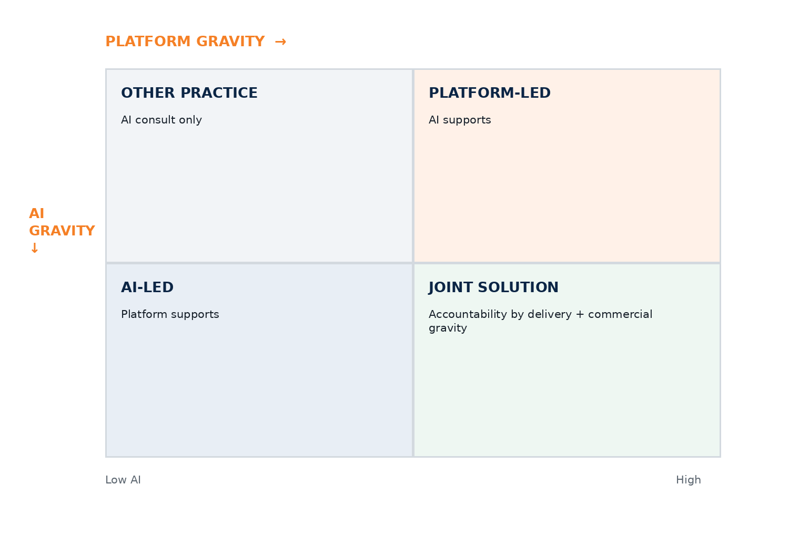
- Platform Gravity: percentage of scope dedicated to cloud, platform, data platform or OpenShift services plus the architectural dependency on that platform.
- Delivery Gravity: estimated work-effort mix across AI/ML, applications, data, cloud, integration, DevSecOps, security and change/adoption.
- Commercial Gravity: share of services revenue, margin, contractual accountability and delivery exposure attributable to each practice.

Recommended routing algorithm
- Apply the four qualification gates. Stop or nurture records that do not pass business qualification.
- Calculate AI Ownership Score and identify any mandatory risk triggers.
- Estimate platform, delivery and commercial gravity using percentages that total 100% within each category.
- Assign a provisional engagement model: OWN, CO-SOLUTION, CONSULT or HANDOFF.
- Name the Practice of Record using the dominant business outcome, then use delivery and commercial gravity as tie-breakers.
- Identify supporting practices and required reviewers.
- Record decision, rationale, approver and acceptance timestamp in Salesforce.
- Escalate only ties, exceptions, strategic pursuits or material-risk cases to the Solution Council.

5. Practice Routing Rules

AI Shared Practice — primary ownership indicators
- Enterprise GenAI or agent platform
- Custom RAG or enterprise knowledge intelligence
- Multi-agent orchestration
- Model selection, routing, evaluation or fine-tuning
- AI governance, guardrails, observability or responsible AI
- Intelligent document or conversational AI where AI provides the principal value
- Custom AI application where more than half of delivery effort and risk is AI-specific

Domain-practice presumptive ownership
Practice | Route there when | Keep AI engaged when
GCP | GCP adoption/migration, GKE, BigQuery, Apigee or platform engineering dominates. Gemini/Vertex alone does not make it AI-owned. | AI architecture, evaluation, agents or governance is material.
AWS | Landing zone, migration, EKS, serverless or AWS data platform dominates. Bedrock is one component of the broader transformation. | Bedrock/LLM solution is complex or AI delivery exceeds threshold.
Azure / Microsoft | Azure migration, M365/Copilot adoption, Fabric, Power Platform or Microsoft platform engineering dominates. | Custom Azure OpenAI, RAG, agents or model orchestration is material.
Red Hat | OpenShift, hybrid cloud, Kubernetes platform, RHEL or Ansible is the principal work—even if the platform will host AI. | AI application or model platform design is a material parallel scope.
Application Modernization | Legacy modernization, Java/.NET, APIs, microservices, application decomposition or SDLC transformation dominates. | AI creates the principal product value or an autonomous engineering platform is in scope.
Data & Analytics | Lakehouse, pipelines, MDM, data quality, semantic layer or data governance is the hardest and largest work. | Model/agent behavior, AI evaluation or responsible AI is significant.
Integration | API management, eventing, middleware, iPaaS or enterprise integration backbone dominates. | Agent/tool integration and AI-specific orchestration are material.
Security | Security transformation or control platform is the business outcome. | Threat modeling, model security, prompt injection or AI control design is material.

KEY DISTINCTION Building AI is not the same as building a platform capable of running AI. The former can be AI-led; the latter is usually platform-led with AI consultation.

Tie-break order
- Named client buying center and contracted outcome
- Largest share of delivery effort
- Largest share of services revenue and contractual exposure
- Highest concentration of solution risk
- Existing accountable transformation program or master SOW
- Executive sponsor decision when factors remain genuinely balanced

6. Decision Rights, RACI and Service Levels

Decision rights
Decision | Accountable authority
Accept / return an intake | Shared AI Intake Manager or delegated SE
Provisional score and route | Shared AI SE + AI architect
Accept Practice of Record | Receiving practice solution leader
Approve complex joint ownership | AI Solution Council chair + affected practice leader
Approve architecture release | Accountable practice architect; AI reviewer if AI ≥ significant
Approve commercial release | Accountable Practice of Record leadership under existing controls
Approve exception | Solution Council chair or executive sponsor based on materiality
Close and capture outcome | Opportunity owner + Shared Practice operations

Core RACI
Activity | Seller / Account | Shared AI SE | AI Architect | Practice Lead | Governance
Create intake | R/A | C | I | I | I
Validate completeness | C | R/A | C | I | I
Score AI gravity | C | R | A | C | I
Accept practice ownership | I | C | C | R/A | I
Build solution / estimate | C | C | R | R/A | C
Approve release | I | C | C | A | R
Capture outcome / reuse | R | A | C | C | I

Service-level expectations
SLA | Clock | Target
Acknowledge | Submitted → owner notified | 4 business hours
Completeness review | Submitted → accepted/returned | 1 business day
Standard routing | Accepted → routed | 3 business days
Urgent routing | P1 accepted → routed | 1 business day
Practice acceptance | Route proposed → accepted | 1 business day
Information request response | Owner requests missing data | 2 business days before auto-reminder
Escalation decision | Council receives complete exception | 2 business days

Escalation policy
- Escalate when two practices both claim or decline accountability after applying the tie-break order.
- Escalate any regulated, safety-critical, high-reputational-risk or mission-critical AI even if its numeric score is low.
- Escalate when the client requires a platform or partner commitment that conflicts with the default route.
- Do not escalate incomplete intakes; return them with the exact missing evidence and an owner.
- Every exception must include recommended decision, alternative, commercial impact, schedule impact and risk of delay.

7. Tool Architecture and Audit Controls
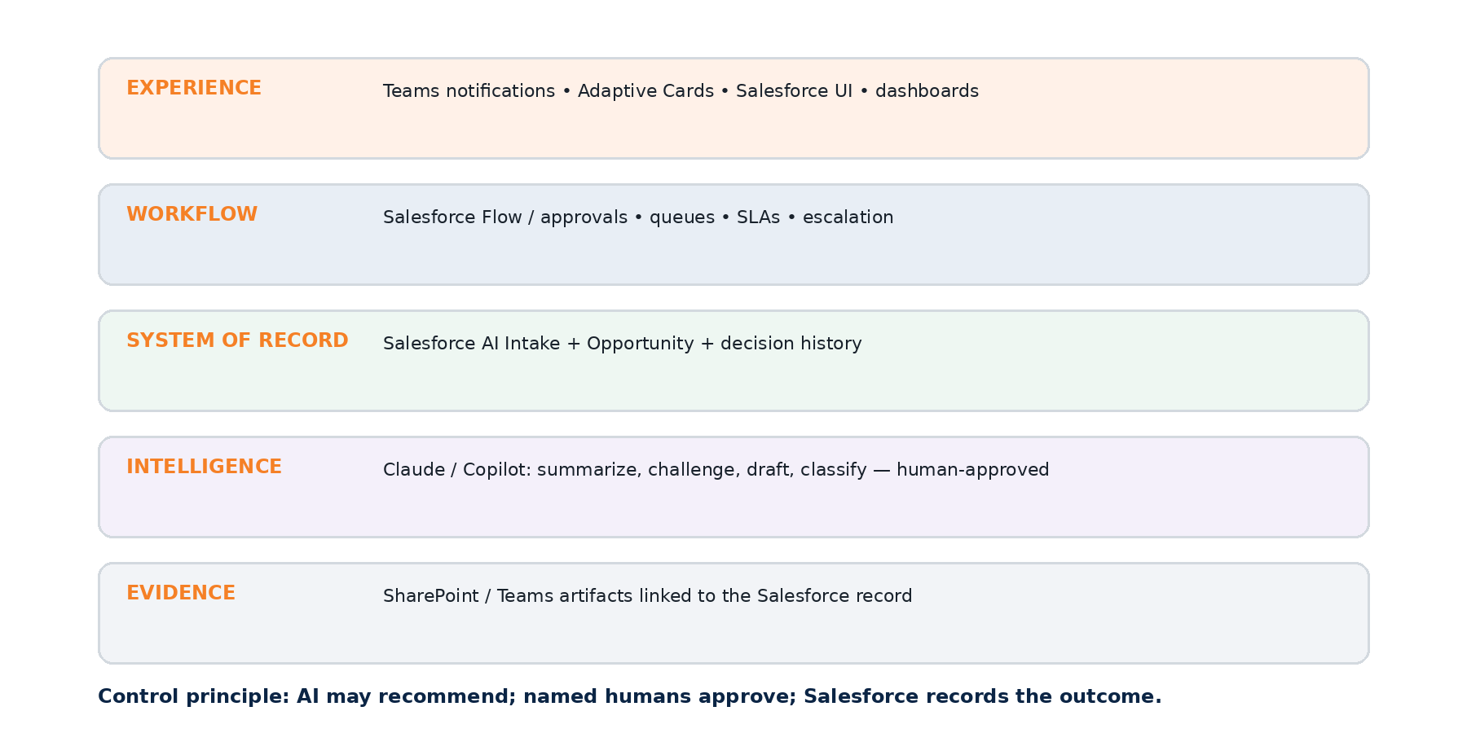

Recommended use of existing tools
Tool | Role | Authority
Salesforce | Authoritative intake, Opportunity linkage, owner, score, decisions, approvals, SLAs and metrics. | System of record
MS Teams | Notifications, triage channel, discussion, meeting artifacts and optional Adaptive Card actions. | Collaboration surface
Power Automate / Teams Approvals | Cross-platform notifications and lightweight human approvals where approved by enterprise architecture. | Orchestration bridge
Claude | Draft discovery questions, summarize notes, challenge assumptions, identify missing data and propose classification. | Advisory assistant; no autonomous approval
MS Copilot | Search/summarize approved Microsoft content, prepare briefs and assist Teams-based work. | Productivity assistant
SharePoint / Teams files | Store approved artifacts; link them to the Salesforce Intake ID. | Evidence repository

MVP data model in Salesforce
Record / object | Purpose
AI Intake | One record per request; unique Intake ID; linked Opportunity; status; priority; owner.
Routing Decision | Score, model, Practice of Record, supporting practices, rationale, approver, timestamp, override.
Solution Review | Architecture, delivery, security and commercial review outcomes with named reviewers.
Contribution Record | Sourced, owned, influenced and routed revenue; solutioning hours; reusable asset.
Intake Activity / History | Status changes, acceptance, requests for information, SLA milestones and decisions.

Mandatory audit controls
Control | Minimum requirement
Identity | Named submitter, owner, approver and receiving owner; no shared-user approvals.
Time | Immutable created/modified timestamps plus decision and acceptance times.
Version | Rubric version stored with each decision so historical scores remain explainable.
Rationale | Human-readable reason required for route, no-pursuit and override decisions.
Evidence | Links to approved discovery, architecture, estimate, risk and SOW artifacts.
Separation of duties | High-risk or strategic AI cannot be self-approved by its solution author.
Least privilege | Role-based field/object access; sensitive fields not broadcast to Teams channels.
Retention | Follow corporate retention, legal hold, customer confidentiality and CRM policies.
AI provenance | Label AI-generated drafts; retain final human-approved text, not hidden chain-of-thought.
Monitoring | Report overdue routing, unaccepted handoffs, overrides, reopened decisions and orphaned records.

Implementation note
Salesforce Flow can support record-triggered approval processes and work items, while Power Automate can post Adaptive Cards and approvals into Teams. Microsoft also documents Salesforce connectors for Power Platform and Microsoft 365 Copilot. Those capabilities make the proposed architecture feasible, but licensing, API access, field-level security, data-loss-prevention policy and production support ownership must be validated before build.
AI assistants should receive only the minimum approved context. They may produce a recommendation and confidence statement, but they should not update the authoritative route, approve an exception or release a solution without an identified human action.

8. Implementation Roadmap and Measures

60-day MVP roadmap
Phase | Work | Exit criteria
Days 0–10 — Decide | Confirm sponsor, process owner, Practice of Record taxonomy, score thresholds, SLAs, data owner and pilot group. | Signed operating decisions; backlog; named admins.
Days 11–25 — Configure | Create Salesforce intake object/fields, guided screen flow, validation, queues, status automation and base dashboard. | Sandbox MVP; test scripts; field dictionary.
Days 26–40 — Connect | Add Teams channel notifications, optional Adaptive Cards, artifact links and exception approvals. | End-to-end pilot flow; audit trail.
Days 41–50 — Pilot | Run 10–20 real intakes across at least three practices; compare rubric results with leader judgment. | Calibration findings; revised thresholds.
Days 51–60 — Launch | Train sellers/SEs, publish office hours, start SLA reporting and change control. | Production launch; runbook; KPI baseline.

Phase 2 — showcase and intelligence layer
The best showcase is a lightweight interactive HTML prototype that demonstrates the user journey before anyone commits to Salesforce configuration. It should use synthetic data, show conditional questions, calculate scores in the browser, generate an explainable routing recommendation, and display the audit record that would be written to Salesforce. This is a demonstration artifact—not a production system and not a shadow CRM.
- Screen 1: Seller quick intake (8–10 minutes).
- Screen 2: Dynamic qualification with conditional sections.
- Screen 3: Score explanation and ownership matrix.
- Screen 4: Recommended Practice of Record, supporting team and required approvals.
- Screen 5: Salesforce-style audit record and Teams notification preview.
- Scenario switcher: AI-led, GCP-led, Red Hat-led, App Mod-led and joint examples.

KPI dashboard
Dimension | Measures
Demand | Intakes by week, account, industry, seller, source, use case and priority.
Speed | Time to acknowledgement, completeness, route, acceptance and approval; SLA attainment.
Quality | First-pass completeness, information-request rate, decision reopen rate, exception rate.
Flow | OWN / CO-SOLUTION / CONSULT / HANDOFF mix; destination practice; aging and bottlenecks.
Commercial | Owned, sourced, influenced and routed pipeline/revenue; GP; conversion; average deal size.
Capacity | Solutioning hours by role/practice; load per architect; forecast demand.
Reuse | Accelerators, patterns, estimates and SOW modules reused; hours avoided.
Outcomes | Win/loss/no-pursuit, time-to-proposal, delivery acceptance and post-launch feedback.

Top implementation risks and mitigations
Risk | Mitigation
Form becomes too long | Use Tier 0 quick intake and conditional Tier 1; review abandonment and completion time monthly.
Teams becomes the unofficial record | Post links and limited metadata only; decisions must write back to Salesforce.
Routing becomes political | Publish rules, require acceptance, measure overrides, calibrate with real scenarios.
AI / data exposure | Use approved enterprise configurations, minimum necessary context and human review.
Capacity bottleneck | Publish priority classes, office hours, capacity dashboard and escalation rules.
Metrics create revenue-credit conflict | Report owned, sourced, influenced and routed as distinct measures; do not double count bookings.
MVP over-engineered | Configure native Salesforce and Microsoft capabilities before custom integration or agents.

Leadership decisions needed now
# | Decision
1 | Who is the executive sponsor and day-to-day process owner?
2 | Who can assign and accept Practice of Record?
3 | Which practices are included in the initial routing taxonomy?
4 | Are the score thresholds and four engagement models approved for pilot?
5 | What are the pilot SLAs and priority definitions?
6 | Which 10–20 live opportunities will calibrate the model?
7 | Who owns Salesforce configuration, Teams automation and production support?
8 | What client information may be processed by Claude or Copilot under current policy?

Appendix A — Complete AI Opportunity Intake Form
The production experience should present these fields progressively. “Required” means required before initial routing, not necessarily required on the first screen.
Section | Fields | Minimum for routing
A. Opportunity basics | Customer/account; Salesforce Opportunity ID; opportunity owner; seller/SE; industry; stage; estimated services value; target start; client deadline; incumbent/partners; priority reason. | Opportunity ID, owner, deadline, business problem.
B. Business problem | Problem in 2–3 sentences; affected users/process; baseline; target outcome; executive sponsor; business owner; urgency; budget/funding status; buying path; consequences of inaction. | Problem, outcome, sponsor status.
C. AI use case | Capability type; user interaction; decisions/actions automated; AI criticality 0–3; “remove AI” answer; simpler alternative considered; expected value. | Capability, criticality, remove-AI answer.
D. Client maturity | Explore/POC/production/platform; approved models; governance; model gateway; vector DB; RAG; eval; prompt management; observability; responsible AI; agent framework; GPU. | Current-state level.
E. Data & security | Data sources; ownership; quality; volume; classification; PII/PHI/PCI; residency; retention; permissions; grounding; human oversight; regulatory requirements. | Sensitivity and data owner.
F. Platform gravity | Target platform; existing commitments; cloud services; on-prem/hybrid; platform scope percentage; portability requirement; partner funding. | Platform and percentage.
G. Workload composition | AI/ML, app dev, cloud/platform, data, integration/API, DevSecOps, security and adoption percentages; total = 100%. | Initial estimates allowed.
H. Commercial gravity | Estimated revenue by practice; GP assumptions; SOW owner; delivery liability; procurement vehicle; funding source; partner credits. | Total value and leading practice.
I. Technical needs | Models, agents, RAG, evaluation, integrations, latency, scale, availability, environments, observability, testing, support and handoff. | Unknowns may be marked Discovery Required.
J. Delivery feasibility | Required roles; locations; clearances; capacity; accelerators; references; dependencies; subcontractors/partners; timeline feasibility. | Constraints and delivery lead.
K. Triage decision | Gate outcomes; AI score; platform/delivery/commercial gravity; engagement model; Practice of Record; supporting practices; required reviewers; rationale; exceptions. | System-generated then human-approved.
L. Outcome | Won/lost/no pursuit; bookings/revenue; contribution attribution; actual solutioning effort; delivery owner; reusable assets; lessons learned. | Required at closure.

Conditional logic examples
Condition | Additional requirement
If regulated/sensitive data = Yes | Require data classification, security reviewer, residency, retention and human-oversight fields.
If agent can execute actions = Yes | Require tool permissions, approval boundary, rollback, logging and kill-switch design.
If platform is known | Open platform-specific services, partner, landing-zone and engineering-scope questions.
If AI criticality ≤ 1 | Ask whether a rules/workflow/search solution meets the outcome; suggest consult/handoff.
If estimated value exceeds leadership threshold | Require commercial lead and executive visibility.
If workload percentages do not total 100% | Block final submission and show remaining variance.
If override = Yes | Require reason, approver, impact and review/expiration date.

Appendix B — Scoring and Decision Record

Required decision record
Field | Requirement
Intake ID / Opportunity ID | Unique linkage to source opportunity.
Rubric version | Example: AI-Routing-v1.0.
Gate outcomes | Business, suitability, technical, delivery.
AI Ownership Score | Eight factor values, total and brief evidence.
Gravity estimates | Platform, delivery and commercial percentages.
Recommended engagement model | OWN / CO-SOLUTION / CONSULT / HANDOFF.
Practice of Record | Exactly one accountable practice.
Supporting practices | Zero or more; specific roles requested.
Mandatory reviewers | AI, platform, security, data, delivery, commercial as triggered.
Decision rationale | 2–5 sentences; plain language.
Exception / override | Original result, override, reason, authority, date.
Acceptance | Receiving owner and timestamp.
Final outcome | Win/loss/no-pursuit, attribution, actual effort and learning.

Risk triggers that override numeric thresholds
- AI directly affects health, safety, employment, lending, insurance, legal rights or other high-impact decisions.
- Autonomous action can move money, change production systems, communicate externally or alter client records.
- Use involves regulated, classified, export-controlled or highly sensitive data.
- Solution lacks traceability, evaluation, monitoring, rollback or accountable human oversight.
- Model/provider terms, data use, intellectual property or security posture are unresolved.
- Client describes the workload as mission-critical or requires contractual AI performance commitments.

Appendix C — Routing Scenarios
Scenario | Evidence | Practice of Record | Model | Support
Enterprise multi-agent service platform | AI 20/24; AI effort 60%; Azure 20%; Data 20%. | AI Shared | OWN | Azure, Data, Security
Modernize 80 Java apps + Copilot testing | AI 7/24; App Mod 65%; Azure 20%; AI 15%. | Application Modernization | CO-SOLUTION | AI Shared, Azure
Customer data platform + churn models on GCP | AI 11/24; GCP/Data 70%; AI 30%. | GCP or Data | CO-SOLUTION | AI Shared
OpenShift platform for private LLM inference | AI 10/24; platform engineering 65%. | Red Hat | CO-SOLUTION | AI Shared, Security
AWS migration with possible future Bedrock | AI 3/24; AWS 90%. | AWS | HANDOFF | AI consult only if roadmap advances
Custom RAG assistant over governed knowledge | AI 16/24; AI 50%; Data 25%; Integration 25%. | AI Shared | OWN | Data, Integration, Security
M365 Copilot adoption and training | AI 6/24; Microsoft/adoption 80%. | Azure / Microsoft | CONSULT | AI governance review
AI-triggered data remediation program | AI demand exists; data quality/pipelines 75%. | Data & Analytics | CO-SOLUTION | AI Shared defines fitness-for-AI criteria

Example generated recommendation
RECOMMENDED ENGAGEMENT AI-LED / CROSS-PRACTICE. AI relevance: HIGH. AI complexity: HIGH. Platform gravity: GCP — MEDIUM. Delivery gravity: AI. Commercial gravity: AI. Practice of Record: AI Shared Practice. Supporting practices: GCP, Data & Analytics, Application Modernization. Required roles: AI Solution Executive, AI Architect, GCP Architect, Data Architect, Application Architect and Security reviewer.

Sources and Implementation References
- Salesforce Help — Build a Flow Approval Process: https://help.salesforce.com/s/articleView?id=platform.automate_automated_approvals_build.htm&language=en_US&type=5
- Microsoft Learn — Create flows that post Adaptive Cards to Teams: https://learn.microsoft.com/en-us/power-automate/create-adaptive-cards
- Microsoft Learn — Approvals in Microsoft Teams: https://learn.microsoft.com/en-us/power-automate/teams/native-approvals-in-teams
- Microsoft Learn — Salesforce connector: https://learn.microsoft.com/en-us/connectors/salesforce/
- Microsoft Learn — Salesforce CRM connector for Microsoft 365 Copilot: https://learn.microsoft.com/en-us/microsoft-365/copilot/connectors/salesforce-crm-deployment

