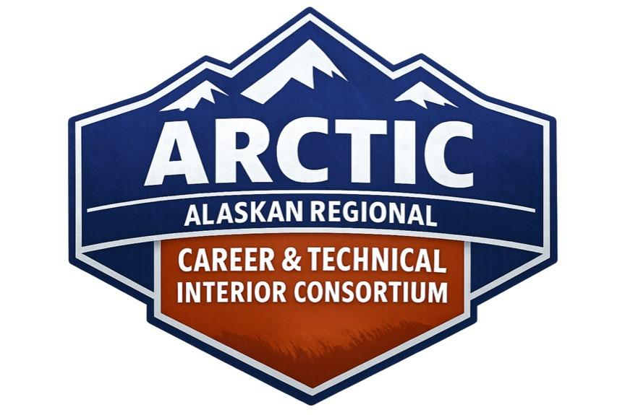ARCTIC Tobacco, Alcohol, and Drugs Policy
ARCTIC maintains a zero-tolerance policy regarding the use, possession, sale, or distribution of tobacco products, alcohol, drugs, drug paraphernalia, and vape products. These rules apply at all times and in all ARCTIC-owned or ARCTIC-operated spaces, including buildings, classrooms, vehicles, transportation, housing facilities, off-campus sites, and partnered program locations.
1. Prohibited Substances
- Tobacco products: including cigarettes, cigars, e-cigarettes, chewing tobacco, and similar items are not allowed.
- Alcohol: students may not possess or use alcohol under any circumstances.
- Drugs and drug paraphernalia: possession or use of illegal drugs or related items is prohibited.
- Vape products: students may not possess or use any vaping devices or materials.
The Alaska School Activities Association (ASAA) classifies possession or use of tobacco, alcohol, drugs, or vape products as a TAD violation. Students are expected to follow all ASAA guidelines.
2. Consequences for Violations
Any student found using or possessing tobacco, alcohol, drugs, or vape products while participating in ARCTIC:
- Will be sent home immediately.
- Will not be eligible for readmission for the remainder of the school year.
- Will have the violation reported to their site principal and superintendent.
The student’s home district will follow its established disciplinary protocol and develop a plan of action.
3. Reentry Recommendation
Before a student is considered for future participation, ARCTIC recommends completion of an appropriate intervention or support program, such as a comprehensive drug education or prevention curriculum.
4. ASAA TAD Information
ASAA enforces penalties for each TAD offense, which may include suspension from interscholastic activities such as basketball, volleyball, or wrestling, depending on district policy. Students and families should review the full ASAA TAD policy for complete details.
---
Student Acknowledgment
I have read and understand the ARCTIC Tobacco, Alcohol, and Drugs Policy. I agree to follow all expectations and understand the consequences for failing to do so.
Student Name: ___________________________________________
Student Signature: ________________________________________ Date: _______________
Reviewed By (ARCTIC Staff): ________________________________ Date: _______________

