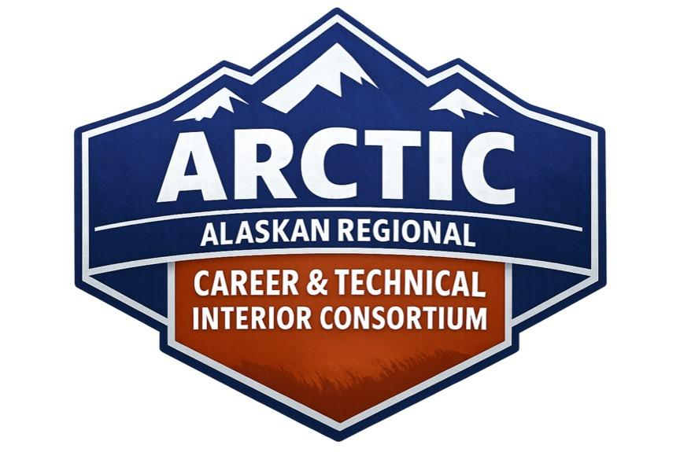ARCTIC Student Expectations & Behavioral Agreement
As a participant in the ARCTIC Program, I agree to uphold the following expectations throughout all ARCTIC activities, travel, classes, and partnered training sessions.
1. Professional Conduct
- I understand that ARCTIC training sites operate as professional workplaces, not school environments.
- I will follow all directions from instructors, staff, and chaperones respectfully.
- I will use professional language and avoid joking, side conversations, or disruptive behavior during presentations or demonstrations.
- I will represent my school, community, and the ARCTIC Program in a mature and responsible manner at all times.
2. Respect for Facilities and Equipment
- I will not touch tools, equipment, or materials unless instructed to do so.
- I will stay in designated areas and follow all site-specific procedures.
- I will leave all facilities cleaner than I found them.
3. Safety Requirements
- I will wear all required safety gear (such as glasses, vests, or PPE) when instructed.
- I will walk not run and stay alert in shop and training areas.
- I will not engage in horseplay, distractions, or cell phone use in work zones or classes.
- I understand that inappropriate relationships, harassment, and any form of violent behavior are not permitted.
4. Engagement and Participation
- I will maintain a positive attitude and fully participate in all scheduled activities.
- I will ask thoughtful questions and engage respectfully with professionals who are instructing me.
- I will show interest through eye contact, body language, and active participation.
- I will remain with the ARCTIC group and my assigned chaperone at all times.

5. Substance Use Policy
- I will not use or possess alcohol, drugs, drug paraphernalia, tobacco products, or vape products at any time while participating in ARCTIC.
- I understand these items are prohibited in all ARCTIC buildings, vehicles, housing, and partnered locations.
- I understand that violations will result in immediate dismissal from the session, will be reported to my site principal and superintendent, and may result in additional district disciplinary action.
Program Reminder
Apprenticeship and workforce training programs take professionalism seriously. My conduct during ARCTIC intensives can influence future opportunities for myself and for other students from my region.
---
Student Acknowledgment
I have read and understand the ARCTIC Student Expectations & Behavioral Agreement. I agree to follow all expectations and understand the consequences for failing to do so.
Student Name: ___________________________________________
Student Signature: ________________________________________ Date:
Parent Signature: _________________________________________ Date:
Reviewed By (ARCTIC Staff): ________________________________ Date:

