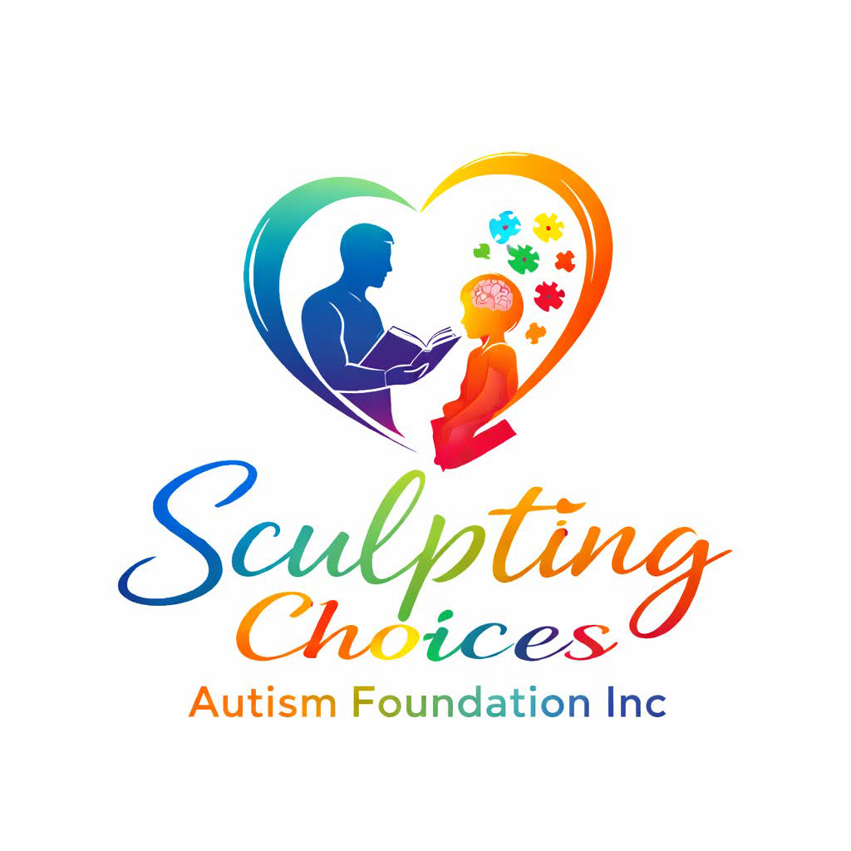
Sculpting Choices Autism Foundation Newsletter
Volume 1 • July 13, 2026
A Message from the Founder
Welcome to the inaugural edition of the Sculpting Choices Autism Foundation Newsletter.
Our mission is to empower individuals with autism and strengthen families through education,
advocacy, life-skills development, community partnerships, and innovative programs that promote
independence and inclusion. Thank you for believing in our vision and helping us build a brighter future.
Foundation Highlights
• Official 501(c)(3) nonprofit organization
• Building partnerships with schools, healthcare providers, businesses, and community organizations
• Developing innovative autism programs for Central Georgia and beyond.
Program Spotlight: Sculpting Independence
Our flagship program prepares children and adolescents with autism for greater independence through life-skills training, social development, communication support, emotional regulation, community participation, and caregiver education.
Coming Soon
• Autism Resource Directory with verified providers
• AI Family Resource Assistant
• Parent Empowerment Workshops
• Community Inclusion Events
• Volunteer Opportunities
How You Can Help
Donate, volunteer, become a community partner, sponsor a program, or share our mission with others. Every contribution helps expand opportunities for individuals with autism and their families.
Stay Connected
Website: www.sculptingchoicesfoundation.org
Email: president@sculptingchoicesfoundation.org
Founder & President: Tramaine Blash
Together, we are sculpting brighter futures—one choice, one family, and one community at a time.

