Article title
Author Name¹, Author Name² and Author Name^{1,2}
¹ Department One, Institution One, City One, Country One
² Department Two, Institution Two, City Two, Country Two

E-mail: xxx@xxx.xx

Abstract
Sample text inserted for illustration. Replace with abstract text. Your abstract should give readers a brief summary of your article. It should concisely describe the contents of your article, and include key terms. It should be informative, accessible and not only indicate the general scope of the article but also state the main results obtained and conclusions drawn. The abstract should be complete in itself; it should not contain undefined abbreviations and no table numbers, figure numbers, references or equations should be referred to. It should be suitable for direct inclusion in abstracting services and should not normally be more than 500 words.
Keywords: term, term, term

1. Section heading
Sample text inserted for illustration. Replace with article text, including headings where appropriate. Figures and tables can be single- or double-column width as appropriate. During the production process they will be placed at the top or bottom of columns, after they are first cited in the text.
Lorem ipsum dolor sit amet, consectetuer adipiscing elit. Maecenas porttitor congue massa. Fusce posuere, magna sed pulvinar ultricies, purus lectus malesuada libero, sit amet commodo magna eros quis urna. Nunc viverra imperdiet enim. Fusce est. Vivamus a tellus. Pellentesque habitant morbi tristique senectus et netus et malesuada fames ac turpis egestas. Proin pharetra nonummy pede.
Mauris et orci. Aenean nec lorem. In porttitor. Donec laoreet nonummy augue. Suspendisse dui purus, scelerisque at, vulputate vitae, pretium mattis, nunc. Mauris eget neque at sem venenatis eleifend. Ut nonummy. Fusce aliquet pede non pede.
1.1 Subsection heading
1.1.1 Subsubsection heading.
2. Equations, Tables, Figures…
If you want to insert equations, please use the button Equation in the toolbars. Detailed operations are as follows. Press the Tab key, then insert the equation, which will be centered. To insert the equation number, press Tab again. Number the equations consecutively. For example,
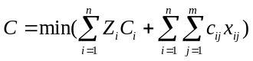 (1) (1)
Never use ordinary script for any equation, whether inline or numbered.
If you want to insert tables, please use the buttons Table Title, Table Footnote, and Format Table in the toolbars. Only the table number and the heading. need to be entered. For example,
Table 1. Title of the table.
Parameters | Value
Parameter 1 | 0.4
Parameter 2 | 0.45
Parameter 3 | 5
Parameter 4 | 2

If you want to insert figures, please use the button Figure Legend in the toolbars. Only the figure number and the caption need to be entered.
For example,
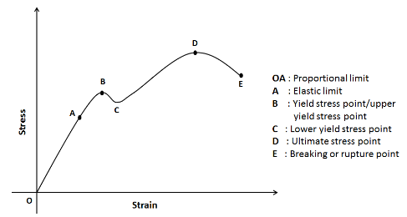
Fig. 1 Title of the figure
Figures, tables, and equations should be cited in the text using the following format:
Fig. 1 for figures, Table 1 for tables, and Eq. (1) for equations.
Examples:
“The experimental setup is shown in Fig. 1.”
“The material properties are summarized in Table 1.”
“The governing equation is given in Eq. (1).”
5. Conclusion
The conclusion of your paper is to past here.....
Acknowledgements
Authors may include an acknowledgement section (optional), if appropriate, to recognize individuals, institutions, funding agencies, research projects, or organizations that provided financial, technical, scientific, or administrative support and contributed to the completion of the research presented in the paper.
References
References should be cited in the text by putting author name/s and year of publication in parentheses: one author: (Miller 1991), two authors: (Miller and Smith 1994), three authors or more: (Miller et al. 1995);

Journal article
Gamelin FX, Baquet G, Berthoin S, Thevenet D, Nourry C, Nottin S, Bosquet L (2009) Effect of high intensity intermittent training on heart rate variability in prepubescent children. Eur J Appl Physiol 105:731-738. doi:10.1007/s00421-008-0955-8
Ideally, the names of all authors should be provided, but the usage of “et al” in long author lists will also be accepted:
Smith J, Jones M Jr, Houghton L et al (1999) Future of health insurance. N Engl J Med 965:325–329

Journal article only by DOI
Slifka MK, Whitton JL (2000) Clinical implications of dysregulated cytokine production. J Mol Med. doi:10.1007/s001090000086

Book
South J, Blass B (2001) The future of modern genomics. Blackwell, London Book chapter
Brown B, Aaron M (2001) The politics of nature. In: Smith J (ed) The rise of modern genomics, 3rd edn. Wiley, New York

Online document (no DOI available)
Marshall TG, Marshall FE (2003) New treatments emerge as sarcoidosis yields up its secrets. ClinMed NetPrints. http://clinmed.netprints.org/cgi/content/full/2003010001v1. Accessed 24 June 2004

Dissertation
Trent JW (1975) Experimental acute renal failure. Dissertation, University of California

