
04.1 Accidents and emergency treatment
Person responsible for checking and stocking first aid box: Sally Cotton
The setting provides care for children and promotes health by ensuring emergency and first aid treatment is given as required. There are also procedures for managing food allergies food safety and nutrition. Parents/carers' consent to emergency medical treatment consent on registration.
- At least one person who has a current paediatric first aid (PFA) certificate must always be on the premises and available when children are on the premises and must accompany children on outings, who regularly update their training. We consider the number of children, staff, staff breaks and the layout of our setting to ensure that a paediatric first aider is always available and can respond to emergencies. We ensure that the training provider who delivers PFA training to our staff are competent.
- Students and trainees that have PFA training may be included in ratios at the level below their level of study if we are satisfied that they are competent and responsible.
- First Aid certificates are renewed at least every three years. In line with the EYFS, all staff who obtained a level 2 and/or level 3 qualification since 30 June 2016 must obtain a PFA qualification within three months of starting work to be counted in ratios.
- All members of staff know the location of First Aid boxes, the contents of which are in line with St John’s Ambulance recommendations as follows:
- 20 individually wrapped sterile plasters (assorted sizes)
- 2 sterile eye pads
- 4 individually wrapped triangular bandages (preferably sterile)
- 6 safety pins
- 2 large, individually wrapped, sterile, un-medicated wound dressings
- 6 medium, individually wrapped, sterile, un-medicated wound dressings
- a pair of disposable gloves
- adhesive tape
- a plastic face shield (optional)
- No other item is stored in a First Aid box.
- Vinyl single use gloves are also kept near to (not in) the box, as well as a thermometer.
- There is a named person in the setting who is responsible for checking and replenishing the First Aid Box contents.
- For minor injuries and accidents, First Aid treatment is given by a qualified first aider; the event is recorded in the setting’s Accident Record and Tapestry recording system. Parents/carers may have a photocopy of the accident form on request.
- In the event of minor injuries or accidents, parents/carers are normally informed when they collect their child, unless the child is unduly upset, or members of staff have any concerns about the injury. In which case they will contact the parent for clarification of what they would like to do, i.e. collect the child or take them home and seek further advice from NHS 111.
Serious accidents or injuries
- An ambulance is called for children requiring emergency treatment.
- First aid is given until the ambulance arrives on scene.
- The registration form is taken to the hospital with the child.
- Parents/carers are contacted and informed of what has happened and where their child is being taken to.
- If the parents/carers do not arrive at the setting before the ambulance sets off for the hospital, a member of staff accompanies the child and remains with them until the parent/carer arrives.
Choking.
We are committed to food safety including reducing the risks of choking.
Ofsted guidance on food safety is given here:
https://help-for-early-years-providers.education.gov.uk/safeguarding-and-welfare/food-safety
How to reduce the risk of choking
Food preparation:
- remove any stones and pips from fruit before serving
- cut small round foods, like grapes, strawberries and cherry tomatoes, lengthways and into quarters
- cut large fruits like melon, and hard fruit or vegetables like raw apple and carrot into slices instead of small chunks
- sausages should be avoided due to their high salt content, but if offered to children these should be cut into thin strips rather than chunks and remove the skins
- remove bones from meat or fish
- do not give whole nuts to children under five years old
- do not give whole seeds to children under five years old
- cut cheese into strips rather than chunks
- do not give popcorn as a snack
- do not give children hard sweets

In every pre-school unforeseen emergencies, like choking incidents, can easily occur at any time. It’s essential for practitioners to be prepared and equipped to respond swiftly with choking first aid – as choking can escalate to being deadly in a matter of minutes.
At Ladybirds we will follow this step-by-step guide on how to save someone from choking

How to help a choking child

What is choking?
When a child is choking, their airway is partly or completely blocked, meaning that they may be unable to breathe properly. They might be able to clear it by coughing, but if they can't, you will need to help them straight away.
Signs and symptoms
Look for:
- difficulty breathing, speaking or coughing
- signs of distress and they may point to their throat or grasp their neck.

What to do
- 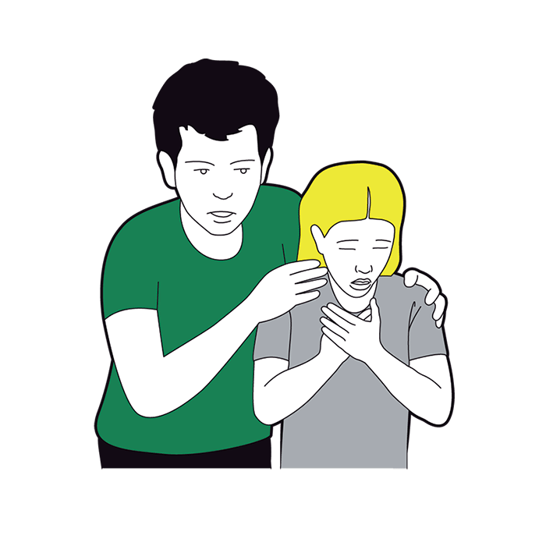
If you think a child is choking, ask them ‘Are you choking?'.
If they can breathe, speak, or cough then they might be able to clear their own throat. If they cannot breathe, cough, or make any noise, then they need your help straight away.
- 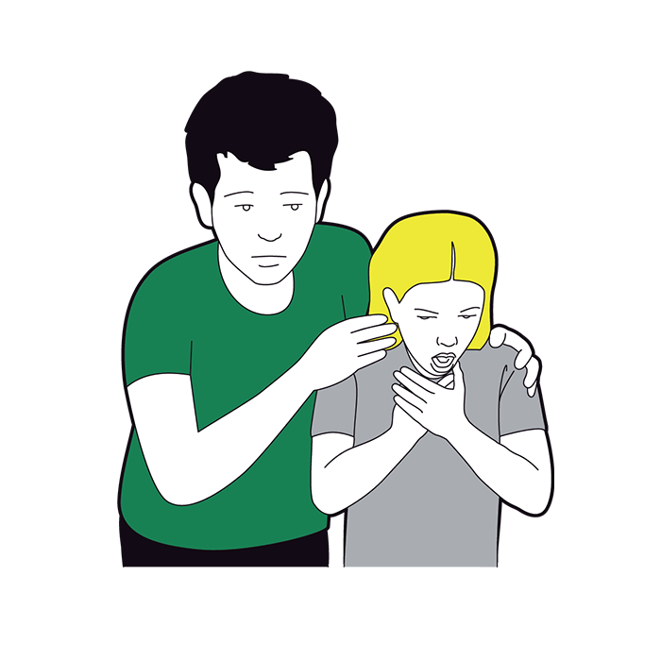
Cough it out. Encourage them to cough and remove any obvious obstruction from their mouth.
- 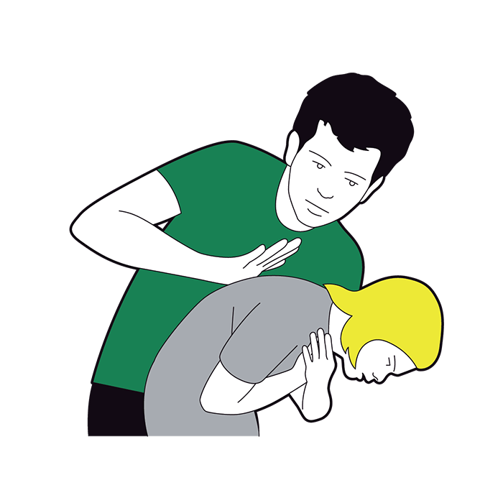
If coughing fails to work, you need to give five sharp back blows. To do this, help them to lean forwards, supporting their upper body with one hand. With the heel of your other hand give them five sharp back blows between their shoulder blades.
After each back blow, check their mouth and pick out any obvious obstruction.
  - Do not sweep the mouth as this could push the object further down the throat.
- 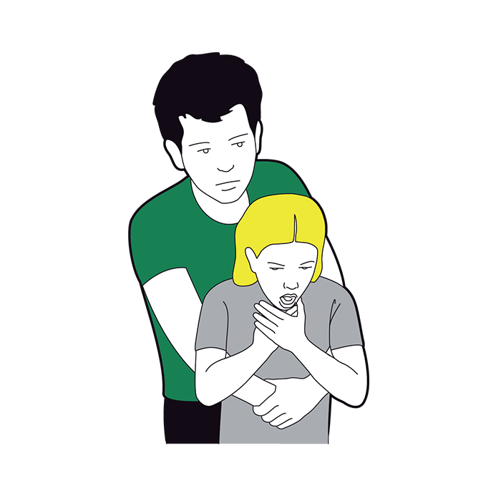
If back blows fail to clear the obstruction, give five abdominal thrusts. To do this, stand behind them and put your arms around the child's waist. Place one hand in a clenched fist between their belly button and the bottom of their chest. With your other hand, grasp your fist and pull sharply inwards and upwards up to five times.
Check their mouth again, after every thrust.
If the blockage has not cleared, call 999 or 112 for emergency help straight away. Repeat five back blows and five abdominal thrusts until help arrives, rechecking their mouth between every blow or thrust.
- Deploy LifeVac®: In cases where traditional methods fail, we will use the LifeVac® anti-choking device as a last resort to remove the obstruction.

Recording and reporting
- In the event of a serious accident, injury, or serious illness, the setting manager notifies the owner/trustees/committee using 6.1c Confidential Safeguarding Incident report form, or other agreed reporting format, as soon as possible.
- If required, a RIDDOR form is completed; one copy is sent to the parent/carer, one for the child’s file and one for the local authority Health and Safety Officer.
- The trustees are notified by the setting manager of any serious accident or injury to, or serious illness of, or the death of, any child whilst in their care to be able to notify Ofsted and any advice given will be acted upon. Notification to Ofsted is made as soon as is reasonably practicable and always within 14 days of the incident occurring. The designated person will, after consultation with the trustees, inform local child protection agencies of these events
Further guidance
Accident Record (Alliance Publication)
Choosing a first aid training provider https://www.hse.gov.uk/pubns/geis3.htm

