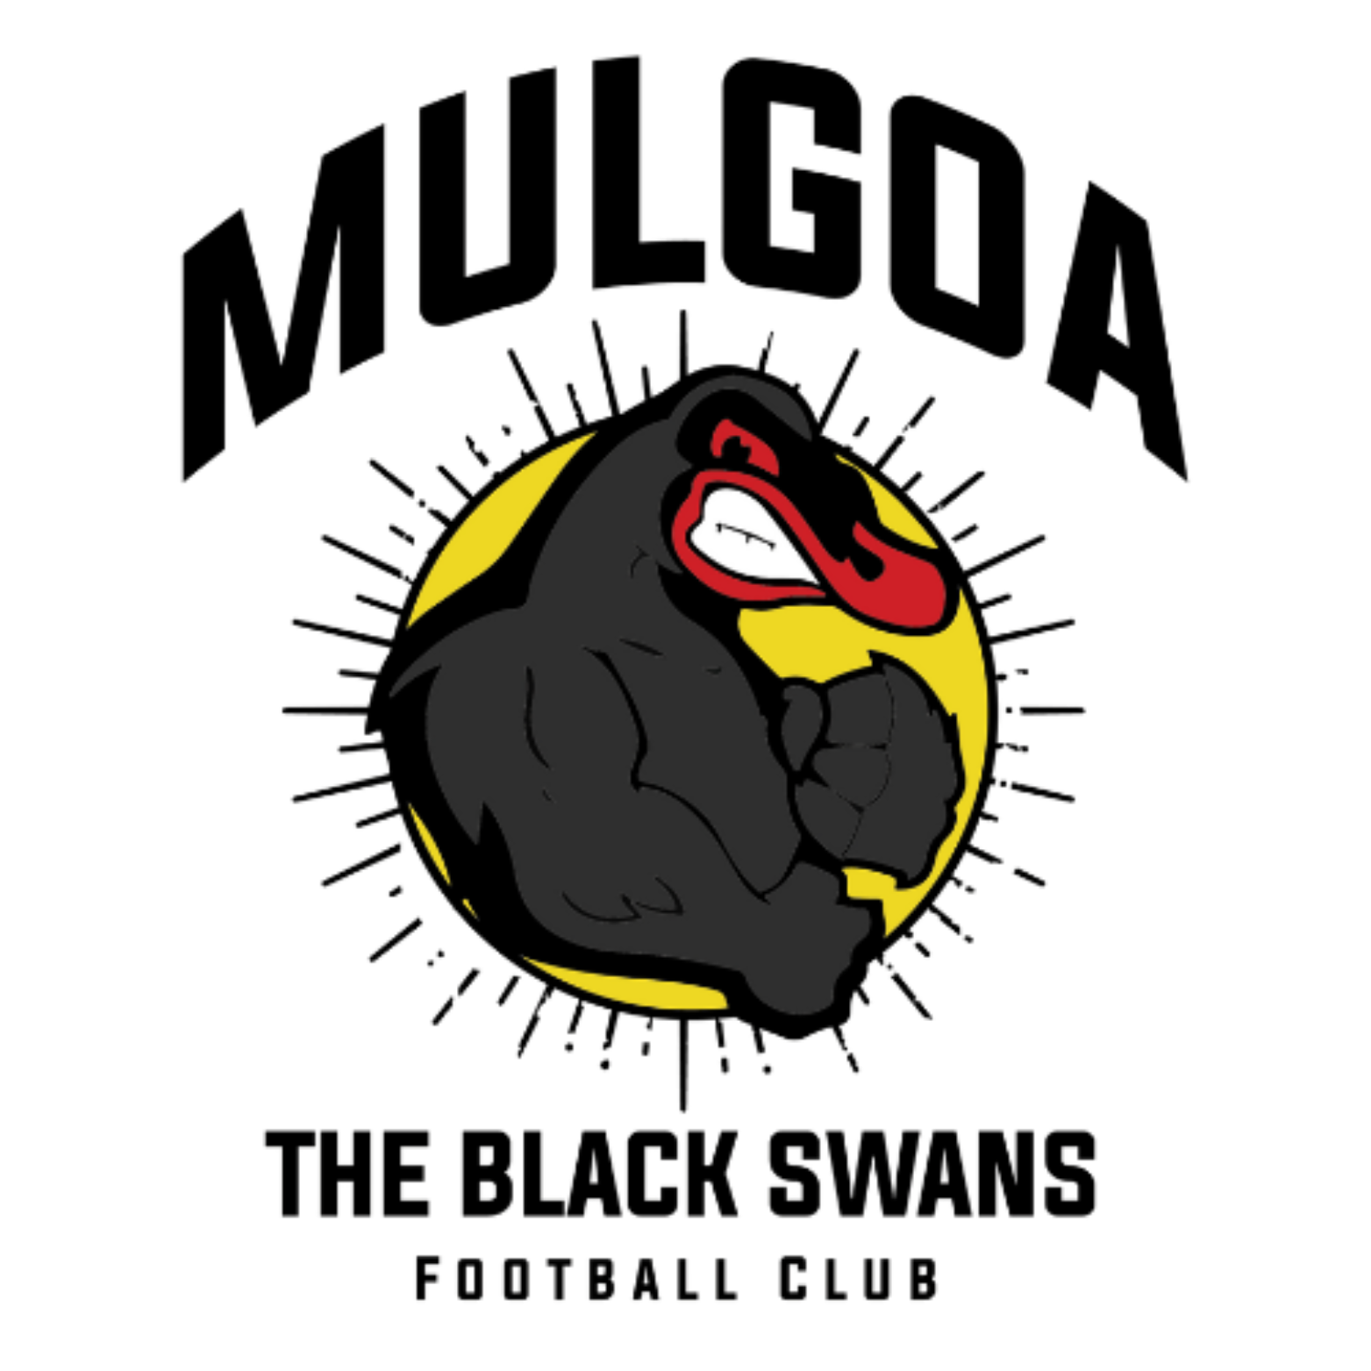

Mulgoa Valley Football Club Constitution
CONSTITUTION OF MULGOA VALLEY FOOTBALL CLUB INC.
(Modernised 2025)
1. Name
The name of the organisation is Mulgoa Valley Football Club Inc. (“the Club”).
2. Objects
The objects of the Club are:
(a) to foster, promote and develop football within the Mulgoa Valley community;
(b) to organise, manage and support teams representing the Club;
(c) to encourage sportsmanship, participation and community engagement;
(d) to affiliate with and comply with the requirements of Nepean Football Association (NFA), Football NSW (FNSW), Football Australia (FA) and FIFA;
(e) to carry out activities consistent with the development of football and the interests of members.
3. Not-for-Profit Status
(a) The Club must operate as a not-for-profit organisation.
(b) The income and assets of the Club must be used solely to promote its objects.
(c) No portion of income may be distributed to members except as bona fide compensation for services rendered.
4. Affiliation
(a) Mulgoa Valley Football Club shall affiliate with Nepean Football Association Inc. as required under the NFA Constitution.
(b) The Club acknowledges the authority of NFA within the Nepean region, FNSW within New South Wales, and FA at the national level.
(c) The Club will comply with all lawful requirements, determinations and regulations issued by NFA, FNSW and FA.
(d) The Club submits exclusively to the jurisdiction of NFA, FNSW and FA for all football matters and will not seek to resolve football-related disputes in a court of law.
5. Membership
(a) Membership categories:
(i) Individual Member
(ii) Junior Member
(iii) Life Member
(b) Membership is open to all persons who support the Club’s objects.
(c) Junior Members are non-voting members.
(d) The Committee may refuse membership only on reasonable grounds.
6. Register of Members
The Secretary must maintain an accurate register including names, categories and contact details.
7. Membership Fees
(a) Annual fees must be set by the Committee.
(b) A member is unfinancial if fees are not paid by the due date.
8. Cessation of Membership
A person ceases to be a member if they:
(a) resign in writing,
(b) fail to pay fees, or
(c) are expelled in accordance with this Constitution.
9. Disciplinary Matters
(a) The Committee may take action if a member acts contrary to the interests of the Club.
(b) The member must be given the opportunity to respond.
(c) The Committee may:
(i) dismiss the matter,
(ii) warn the member,
(iii) suspend the member, or
(iv) expel the member.
(d) Decisions are final within the Club.
10. Dispute Resolution
(a) A simple internal process applies:
(i) parties must first attempt to resolve the matter informally;
(ii) if unresolved, the Secretary must arrange a meeting between the parties and a Committee-appointed mediator;
(b) Football matters fall under NFA/FNSW/FA jurisdiction.
11. Committee
(a) The Club is managed by a Committee of not fewer than 5 and not more than 9 members.
(b) All positions are elected annually at the AGM.
(c) The Committee must include at minimum:
(i) President
(ii) Vice President
(iii) Secretary
(iv) Treasurer
(d) Additional roles may include Registrar, Competition Secretary and General Committee members.
12. Election of Committee
(a) All positions are vacated at each AGM.
(b) Nominations must be submitted before or at the AGM.
(c) Voting is by show of hands unless a ballot is requested.
13. Committee Powers
The Committee:
(a) controls and manages Club affairs;
(b) may delegate duties;
(c) ensures compliance with NFA, FNSW and FA.
14. Committee Meetings
(a) The Committee must meet at least six times per year.
(b) A quorum is 50% of elected members.
(c) Decisions are made by majority vote.
15. General Meetings
(a) The AGM must be held each year within six months of the financial year end.
(b) Additional SGMs may be called by the Committee or by 10% of voting members.
16. Notice of General Meetings
Members must receive at least 14 days' written notice (21 days for special resolutions).
17. Voting at General Meetings
(a) Individual and Life Members aged 18+ may vote.
(b) Juniors do not vote.
(c) A simple majority is required unless otherwise stated.
18. Special Resolutions
A special resolution requires 75% of votes cast.
19. Delegates to NFA
The Committee must appoint a Delegate to represent the Club at NFA meetings.
20. Public Officer
The Committee must appoint a Public Officer in accordance with NSW legislation.
21. Finance
(a) The financial year ends on 30 September.
(b) The Treasurer must maintain proper records and present annual financial statements.
(c) All expenses require Committee authorisation.
22. Bank Accounts
(a) The Club must operate one or more accounts in its name.
(b) Payments must be authorised by any two authorised signatories.
23. Audit or Review
If required by law or the Committee, an independent financial review may be conducted.
24. Records
The Club must maintain proper records including minutes, financials and registers.
25. Inspection of Records
Members may request access to records excluding personal or confidential information.
26. Common Seal
The Club may maintain a Common Seal if desired.
27. Insurance
The Club must maintain insurance as required by law or NFA/FNSW/FA.
28. Uniforms and Colours
The Committee may set playing colours and uniforms.
29. Selection of Players
Selection policies are determined by the Committee.
30. Coaches and Managers
The Committee appoints all coaches and managers and may remove them if necessary.
31. Discipline of Teams
Teams must abide by Club and NFA/FNSW/FA policies.
32. Alteration of Constitution
This Constitution may only be amended by special resolution.
33. Regulations
The Committee may create regulations consistent with this Constitution.
34. Status & Compliance of Club
(a) The Club recognises NFA as the governing football authority within the region.
(b) The Club recognises FNSW as the authority for football in NSW, and FA as the national authority.
(c) The Club submits to all determinations and dispute processes of NFA, FNSW and FA.
(d) The Club agrees not to seek resolution of football-related matters in courts.
35. Notices
Notices may be issued by email or other approved method.
36. Indemnity
Committee members and volunteers acting in good faith are indemnified against liability incurred while performing Club duties.
37. Winding Up
In the event of winding up, surplus assets must be transferred to another not-for-profit football organisation or charity.
38. Distribution of Property
No assets may be distributed to members.
END OF CONSTITUTION

