Certifications & Technical Education

Adam Connell – “Information Technology Specialist”
| revival.electronics.ebay@gmail.com | revival.electronics.llc@proton.me |
| 508-657-4301 | [Hours – 9:00am-11:00pm ; 7 Days] |
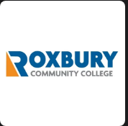
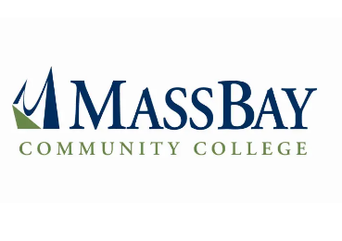

ProfessionalCertifications:
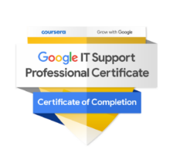

Google IT Support Professional Certificate
Provider: Coursera, in partnership with Google
Issued: Completed
Overview:
A comprehensive, five-module certificate designed to prepare IT professionals for entry-level technical support roles.
Key Skills Covered:
- Technical Support Fundamentals: Understanding computer components, the internet, applications, and customer service basics.
- The Bits and Bytes of Computer Networking: Networking layers, protocols, Wi-Fi troubleshooting, TCP/IP, DNS, LAN/WAN concepts.
- Operating Systems and You: Navigating Windows and Linux environments, using the CLI, and managing OS-level tasks.
- System Administration & IT Infrastructure Services: User permissions, directory services, system backups, and remote support.
- IT Security: Firewalls, malware protection, encryption, authentication, and threat detection strategies.

CompTIA A+ (Core 1 1101 & Core 2 1102)
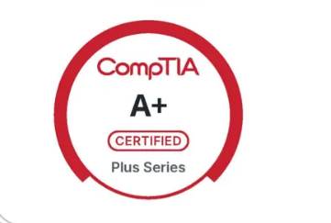
Provider: CompTIA
Issued: Completed
Overview:
An industry-standard certification for entry-level IT professionals, validating hands-on skills in computer hardware and software support.
Key Skills Covered:
- Hardware configuration and troubleshooting (desktops, laptops, mobile devices, and printers)
- Operating system installation, configuration, and command-line tools
- Networking basics, virtualization, and cloud computing
- Security best practices and mobile device management
- Software troubleshooting and operational procedures

CompTIA Security+ (SY0-701)
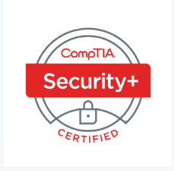
Provider: CompTIA
Issued: Completed
Overview:
A globally recognized certification covering foundational Cybersecurity concepts and practices across networks, devices, and applications.
Key Skills Covered:
- Network security and architecture
- Risk assessment and incident response
- Cryptography, access control, and authentication
- Governance, compliance, and policy development
- Secure coding practices and mobile/IoT security fundamentals

Google Cybersecurity Professional Certificate
Core Modules / Course Titles:
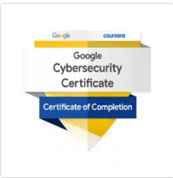
Provider: Google
Issued: Completed
Overview: Professional training program covering foundational and applied Cybersecurity skills. Includes coursework in network security, Linux & SQL, threat detection & mitigation, Python-based automation, and a capstone with applied labs. Optional AI foundations course included.
Key Skills Covered:
- Foundations of Cybersecurity
- Play It Safe: Manage Security Risks
- Connect and Protect: Networks & Network Security
- Tools of the Trade: Linux & SQL
- Assets, Threats, and Vulnerabilities
- Sound the Alarm: Detection & Response
- Automate Cybersecurity Tasks with Python

- Put It to Work: Prepare for Cybersecurity Jobs

9. Introduction to Artificial Intelligence

Technical Education & Skills Development


Ongoing Coursework & Independent Learning
- CS50 – Introduction to Computer Science (Harvard): Programming concepts in C, data structures, algorithms, and problem-solving.
- Python Programming Fundamentals (Harvard): Object-oriented programming, scripting, and debugging.
- C++ Programming Essentials (Harvard): Syntax, memory handling, basic algorithms, and compiling/debugging workflows.
------------------------------------------------------------------------------------------------------------------
- Self-Taught Business & Tech Operations: Built REVIVAL Electronics from the ground up, learning through field work, research, and customer needs. Registered LLC, Registered IT.
- Introduction to LLMs: Noncredit coursework lasting 60 minutes for basics in using different types of AI Models and their respective functions provided by Codecademy.com
------------------------------------------------------------------------------------------------------------------

Key Technical Competencies
- Operating Systems: Windows (98–11), macOS Ventura+, Linux distros (Ubuntu, Kali, Debian, Parrot OS, Raspberry Pi OS), Android, iOS
- Software & Dev Tools: Visual Studio (C#, .NET), Roblox Studio (Lua), GIMP, Adobe Creative Suite, Canva, Cura Ultimaker (3D printing)
- Networking & Cloud: TCP/IP, DNS, DHCP, Wi-Fi troubleshooting, Mesh Networks, FortiClient VPN, Microsoft Azure, Google Cloud, AWS
- Virtualization: Hyper-V, VMware, VirtualBox, Windows Subsystem for Android, general hypervisor environments
- Cybersecurity Practices: Encryption, firewalls, multi-factor authentication, remote support protocols, and secure backups
- Hardware Support: PC building, device repair, basic soldering, printer maintenance, BIOS updates, firmware flashing

