👽🚀🌎REVIVAL ELECTRONICS LLC🌎🚀👽

R E D U C E . R E U S E . R E V I V A L .

https://revival-electronics-llc.base44.app

Full Service Menu — September 2026 Edition

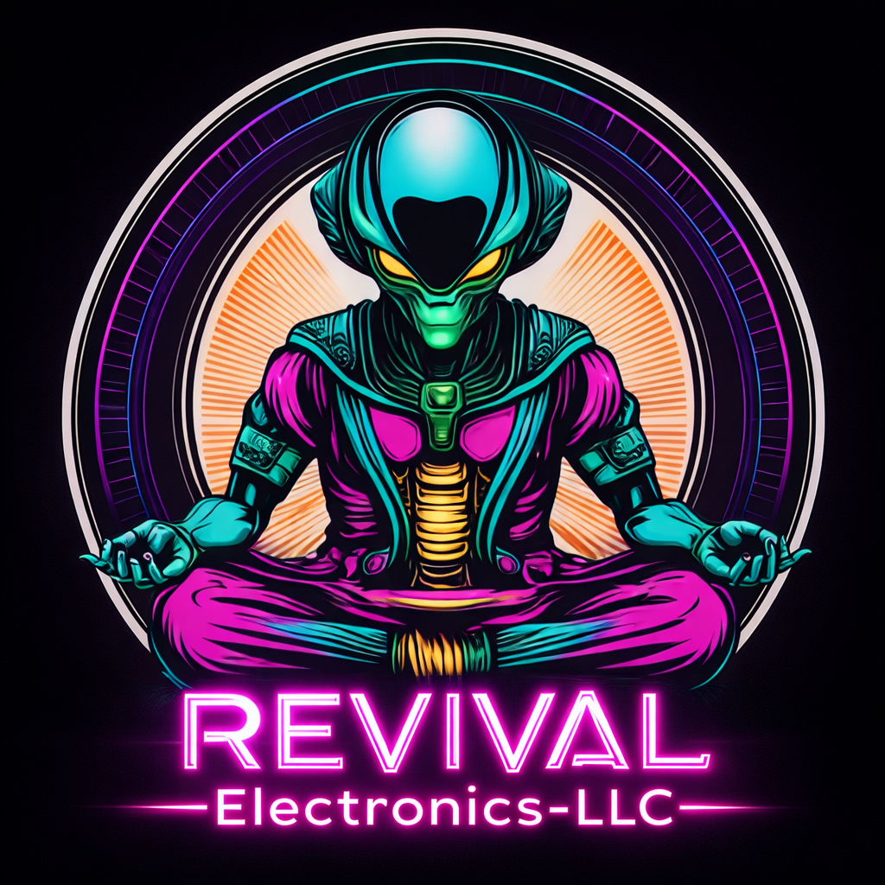
Serving individuals, families, and small businesses in our community since January 2020.

CompTIA A+ (1101/1102)

Security+ (SY0-701)

Google IT Support Professional

Google Cybersecurity Support Professional

🛡️ REVIVAL TECHNOLOGY HEALTH CHECK 🛡️

A free first look at your technology and security practices
The REVIVAL Technology Health Check is a free 20-question multiple-choice assessment designed to help individuals and businesses evaluate everyday technology use, security practices, device management, and operational habits.
The assessment and associated consultation are completely free. After completion, results can be submitted to REVIVAL for review and a follow-up discussion focused on practical recommendations.
Why take the assessment?
- Identify potential technology and security weaknesses.
- Find maintenance issues before they become larger problems.
- Understand where your current setup may be holding you back.
- Receive practical recommendations without committing to a paid service.
- Give your small business a clearer picture of its current technology environment.
________________________________________________________________________________

🔧 REPAIR SERVICES 🔧

💻 PC & Laptop Repair
Hardware diagnostics, component replacement, system repair, optimization, performance recovery, and troubleshooting for Windows 11/10/8/7/Vista/XP/98, macOS, Ubuntu, Debian, and Raspberry Pi systems.

📱 Mobile Device Repair
Diagnostics, screen and charging-port service, battery-related troubleshooting, and practical repair assistance for supported mobile devices.

⚙️ Mobile OS Optimization
Reconfigure supported mobile devices, remove unnecessary software, improve storage usage, optimize settings, and resolve common software slowdowns.

🎮 Game Console Repair
Thermal maintenance, drive-related service, diagnostics, supported firmware work, and repair or configuration assistance for compatible gaming systems.

🖨️ Printer Repair & Replacement
Troubleshoot paper-feed problems, rollers, connectivity, drivers, print systems, and determine when repair or replacement is the more practical option.

📼 VCR Repair
Mechanical repair, tape-path alignment, playback calibration, head cleaning, eject mechanisms, and restoration of supported vintage video equipment.

🚗 Smart Car Touchscreen Replacement
Infotainment display replacement and related troubleshooting for supported systems. Tesla systems excluded.

⌚ Smartwatch Repair
Battery, screen, diagnostics, and supported board-level repair for compatible smartwatches.

🔌 Device & Peripheral Installation
Set up supported monitors, docking stations, keyboards, mice, webcams, microphones, scanners, printers, and other everyday technology peripherals.

🆕 New Device Setup
Prepare new computers, phones, tablets, printers, and other devices for everyday use, including updates, accounts, applications, configuration, and basic security.

🔍 Technology Second Opinion
A practical diagnostic review when a device has been declared dead, uneconomical to repair, or ready for replacement. Determine what may realistically be repaired, upgraded, reused, or replaced.

🔐 DATA, SECURITY & PRIVACY 🔐

💾 Data Recovery
Attempt recovery of lost, deleted, corrupted, formatted, or inaccessible files from supported storage devices.

🔄 Computer-to-Computer Data Migration
Move documents, photos, profiles, applications where supported, and other usable information from an existing computer to a replacement system.

🚀 SSD Upgrade & Data Transfer
Upgrade compatible systems to SSD storage and migrate existing data or operating systems when technically practical.

📲 Phone-to-Computer Data Transfer
Transfer supported photos, videos, documents, contacts, and other personal information to a computer or external storage.

🗄️ Phone Data Transfer to Media Archive
Archive supported phone data to USB or external storage for safekeeping, organization, and easier long-term access.

☁️ Cloud Migration Assistance
Move files and supported workflows to Google Drive, iCloud, OneDrive, or another appropriate cloud environment.

🗃️ Local Backup Migration
Move or reorganize an existing backup collection onto new storage while minimizing unnecessary changes to the original data.

🔒 Data Encryption Services
Configure practical encryption solutions designed to help protect sensitive information from unauthorized access.

💿 Data Backup Solutions
Configure local, external, or cloud-based backup systems for individuals, families, and small businesses.

🧹 Secure Device Retirement
Prepare supported computers, phones, drives, and electronics for resale, donation, recycling, or retirement using appropriate data-removal procedures.

🗑️ Secure Data Destruction
Remove data from supported storage devices before disposal or repurposing using a method appropriate to the device and situation.

🛡️ Personal Cybersecurity Checkup
Review everyday device, account, password, browser, network, and security practices and identify practical improvements.

🔑 2FA & Account Security Setup
Configure two-factor authentication, authenticator applications, recovery methods, and other practical account-security protections.

🔐 Account Setup & Recovery Assistance
Assist with supported Microsoft, Google, Apple, email, and other accounts when ownership can be verified.

🗝️ Password Manager Setup
Configure a password manager and establish a more organized approach to storing, protecting, and using credentials.

👁️ Privacy & Tracking Review
Review device permissions, browser settings, application access, unnecessary tracking, and privacy-related configuration.

🧾 Technical Investigation & Digital Evidence Assistance
Technical research, documentation, organization, and preservation assistance involving online activity, electronic communications, websites, accounts, devices, digital transactions, and other electronic records. Services may include documenting URLs and timestamps, organizing screenshots and communications, creating timelines and evidence logs, reviewing client-provided records, and preparing clear technical documentation or reports. REVIVAL assists only with information a client lawfully possesses or is authorized to access and provides technical and documentation assistance only—not legal advice, legal representation, or private-investigator services.

💻 SOFTWARE & SYSTEMS 💻

🔄 Software Rebuild & Upgrade
Reinstall or upgrade supported operating systems and software while protecting and preserving existing data whenever practical.

🦠 Virus Removal & Security Check
Remove supported malware, investigate suspicious system behavior, identify potential security weaknesses, and strengthen systems against recurring problems.

🪟 Windows 11 Modifications
Optimize Windows 11 for performance, usability, legacy compatibility, privacy, workflow preferences, or reduction of unwanted software.

🤖 AI Training Cloud Setup
Configure GPU-backed cloud environments and supporting software for compatible AI training and development workloads.

🍎 macOS Upgrades & Installs
Upgrade supported Mac systems and resolve compatible operating-system installation, configuration, and compatibility issues.

🐧 Linux Assistance
Install, partition, configure, troubleshoot, and provide hands-on assistance with supported Linux distributions and environments.

🔄 Firmware Updates
Update supported firmware on routers, motherboards, storage devices, and other compatible equipment.

⚙️ BIOS / UEFI Optimization
Improve supported boot behavior, hardware recognition, compatibility, configuration, and system stability.

💿 Legacy Software Support
Run, repair, configure, or virtualize older software and operating systems including Windows 98, XP, and 7.

🧹 Digital Decluttering & Cleanup
Organize files, remove unnecessary applications, clean downloads, identify duplicates, recover storage space, and improve everyday digital organization.

🗂️ Digital Photo & File Organization
Organize large collections of photographs, documents, downloads, archives, and other files into a more manageable structure.

🌐 NETWORKING & INTERNET 🌐

🌎 Home Internet Analysis
Diagnose slow, unstable, or unreliable internet connections and identify practical improvements.

🖧 Computer Networking
Configure and troubleshoot LAN and wireless networks, routers, device connectivity, network access, and basic network security.

🧑‍🔧 Live IT Support (In Person)
On-site technical assistance for troubleshooting, setup, configuration, and supported computer or network problems.

🖥️ Remote IT Support
Remote technical assistance using screen sharing and diagnostics for supported software, configuration, and troubleshooting needs.

📡 Router Configuration & Firmware Updates
Configure supported firewall settings, parental controls, QoS, guest networks, wireless settings, and firmware, including DD-WRT where appropriate.

📶 Mesh Wi-Fi Installation
Configure and optimize supported mesh Wi-Fi systems to improve coverage across larger homes, offices, and multi-room environments.

🏠 IoT Device Configuration
Connect, configure, and secure supported smart cameras, thermostats, plugs, speakers, and other connected devices.

🛡️ Smart Home Security Bundle
Configure supported cameras, sensors, alarms, and related applications into a more organized home-security environment.

🔔 Remote Monitoring & Alerts
Configure supported monitoring and notification tools to help identify network or device problems before they become larger issues.

🗄️ NAS / Home Storage Setup
Configure supported network-attached storage for centralized files, backups, media, and household data.

📁 Home File Server Setup
Build or configure a practical local file-sharing environment for supported home and small-office needs.

☁️ Personal Cloud Storage Setup
Configure supported personal-cloud or self-hosted storage solutions for convenient access to files across compatible devices.

🔄 Automated Backup Server Setup
Configure supported automated backup workflows for computers, network devices, and storage environments.

💿 RAID Configuration & Maintenance
Configure, troubleshoot, monitor, and maintain supported RAID and multi-drive storage environments.

🎬 Home Media Server Setup
Configure supported local media-server environments for organizing and accessing personal media.

📺 TV & Streaming Device Setup
Set up supported smart TVs, streaming devices, applications, remotes, and network connections.

🎬 Home Theater Setup
Connect and configure supported televisions, audio equipment, streaming devices, and home-network components.

🎮 Game Console / TV Integration
Connect gaming consoles with displays, audio systems, networks, and supported streaming environments.

🎛️ Universal Remote Configuration
Program and organize compatible universal remotes and home-entertainment controls.

🧩 SMALL BUSINESS & COMMERCIAL SUPPORT 🧩

🏢 Small Business Infrastructure
Configure and improve POS systems, workstations, networking, storage, hardware, 3D printing, and practical technology infrastructure for small businesses.

💻 Business Computer Setup
Prepare computers and workstations for owners, employees, specialized business tasks, and everyday operations.

🖥️ Employee Workstation Setup
Configure replacement or new workstations with required hardware, software, peripherals, accounts, and connectivity.

👤 New Employee Technology Onboarding
Prepare supported technology for new employees, including workstation setup, peripherals, account configuration, connectivity, and basic security.

📧 Business Email Setup
Configure supported business email accounts, applications, devices, and everyday communication workflows.

🏢 Microsoft 365 / Google Workspace Setup
Assist with supported productivity-suite configuration, accounts, devices, applications, and practical small-business workflows.

💾 Business Backup Configuration
Design and configure practical backup routines for supported business computers, servers, and storage environments.

🔐 Business Network Security Review
Review supported network architecture, access controls, wireless security, device exposure, and everyday security practices.

🖨️ Printer / Scanner Deployment
Install and configure printers, scanners, drivers, connectivity, and multi-device access.

💳 POS Setup & Troubleshooting
Configure, troubleshoot, maintain, and connect supported point-of-sale equipment and peripherals.

📊 Technology Lifecycle Planning
Help businesses evaluate what should be repaired, upgraded, replaced, retired, or kept in service based on practical cost and useful life.

⚖️ Small Claims Assistance — Tech Disputes
Technical assistance with documenting, organizing, and preserving digital evidence for small-claims matters involving technology, online activity, electronic communications, or digital transactions. Help organize client-provided records, screenshots, URLs, timestamps, and timelines into clear technical documentation for personal use or presentation to a court, attorney, insurer, or other appropriate party. REVIVAL provides technical and documentation assistance only—not legal advice, legal representation, or private-investigator services.

🤖 Small Business AI & Automation Setup
Configure practical AI tools, chatbots, and everyday automations designed to reduce repetitive work and improve business operations.

🏪 COMMERCIAL EQUIPMENT & SPECIALTY REPAIR 🏪
Commercial repair is intentionally broad. If equipment helps keep a business operating, ask REVIVAL before assuming it needs to be replaced. Repairs are evaluated individually based on construction, parts availability, condition, safety, and technical feasibility.

🔧 Commercial Electronics Repair
Repair and maintenance of supported electronic equipment used in salons, grooming businesses, workshops, offices, retail environments, and other small-business settings.

🛠️ Small Appliance Repair & Maintenance
Diagnose, clean, maintain, and repair supported small appliances and electrically powered equipment.

🧹 Vacuum Cleaner Repair & Maintenance
Clean, inspect, troubleshoot, and repair supported residential and commercial vacuum cleaners, including common wear components and airflow-related problems.

🖨️ 3D-Printed Vacuum Attachments
Produce practical replacement vacuum heads, nozzles, adapters, clips, and related parts when a suitable design can be produced.

🔌 Residential Vacuum Heads & Nozzles
Custom or replacement 3D-printed attachments generally sized around 32 mm for compatible residential vacuum systems.

🔩 Shop-Vac Heads & Nozzles
Replacement and custom 3D-printed attachments generally sized around 34 mm for compatible shop-vac systems.

✂️ Commercial Grooming Equipment Repair
Repair and maintenance for supported professional grooming equipment, including hair dryers, clippers, motors, switches, brushes, and related components.

💨 Professional Hair Dryer Repair
Troubleshoot and service supported professional hair dryers used by barbers, salons, groomers, and other businesses.

✂️ Hair Clipper Repair & Maintenance
Clean, inspect, troubleshoot, and repair supported professional hair clippers and grooming equipment.

💅 Salon & Beauty Equipment Repair
Repair supported electrically powered tools and equipment used in salons, barber shops, beauty businesses, and related workplaces.

🔨 Commercial Nail Gun Repair
Troubleshoot and service supported nail guns and similar tools used in professional environments.

🏊 Pool Pump Cleaning & Maintenance
Disassemble, clean, inspect, and maintain supported pool-pump equipment, including components affected by buildup or routine wear.

🧰 Commercial Tool & Equipment Maintenance
Inspect, clean, maintain, and troubleshoot supported tools and equipment used by businesses in everyday operations.

❓ Odd Equipment? Ask REVIVAL.
If it plugs in, runs on a motor, contains electronics, or has a practical repair path, contact REVIVAL. Unusual jobs are evaluated individually.

🎨 CREATIVE & SPECIALIZED 🎨

🖨️ 3D Printing
Produce prototypes, replacement parts, functional components, mounts, adapters, and final-use pieces from STL files or custom designs.

🔌 Custom Cable & Mount Fabrication
Create practical 3D-printed cable clips, mounts, brackets, adapters, and technology accessories.

🎮 Custom Gaming Builds
Design and assemble performance-oriented computers around the client's requirements, intended use, and budget.

🕹️ Retro Emulation Console Builds
Build custom retro-gaming systems using supported emulation software and the selected case or hardware configuration.

📼 Vintage Media Conversion
Digitize supported VHS, cassette, and reel-based media to help preserve personal recordings and memories.

📹 CCTV & Security Camera Systems
Install and configure supported camera and security systems for homes and small businesses.

🔬 Board-Level & Micro-Soldering
Perform supported component-level electronic repair beyond standard part replacement when technically feasible.

🧩 Custom Replacement Parts
Design and 3D-print practical replacement components for equipment where compatible parts are difficult or uneconomical to source.

🧰 GENERAL SERVICES 🧰

♻️ General Electronics Repair & Sales
Diagnose, restore, repair, and sell supported electronics and small appliances, with an emphasis on practical reuse and extending equipment life.

📱 Cell Phone App Cleaning
Remove unnecessary applications, free storage, reduce digital clutter, and improve everyday phone performance.

🔓 Manual Password Removal
Remove supported device lock screens or restrictions when proof of ownership can be provided.

💿 Disk Scratch Repair
Resurface supported scratched discs to improve readability and playability.

🔄 Trade-In & Upgrade Credit
Trade qualifying devices toward credit on eligible repair services or a Factory Refreshed replacement or upgrade.

🧑‍🏫 Patient Tech Coaching
One-on-one, no-jargon technology guidance for seniors and beginners covering computers, AI tools, applications, digital organization, crypto-mining basics, and safer everyday technology use.

⏱️ TIME-BLOCK PACKAGES ⏱️
The only real choice is how much ground you want covered in one visit—from a single quick fix to a larger home or small-business technology sweep.
Length | Package | Best For
1 hr | Quick Fix Session | Single-device issues or a fast Wi-Fi or printer fix.
90 min | Stability Boost | 2–3 devices plus a Wi-Fi tune-up in one visit.
2 hr | Standard Refresh | Families or home offices with several devices.
3 hr | Home Infrastructure Sweep | Multiple PCs, tablets, printers, and network cleanup.
4 hr | Full Home / Small Biz Overhaul | Multi-room Wi-Fi, PCs, printers, phones, and backups.
6 hr | Business Infrastructure Day | Full-environment optimization for small businesses.
Every 2 wks | Bi-Weekly Maintenance Plan | Two hours every two weeks for consistent upkeep and faster fixes.
Every 3 mo | Quarterly Deep-Clean | Four hours every quarter for long-term stability and prevention.
Note: Specialty repairs, parts, advanced board-level work, commercial equipment repairs, technical investigation, digital-evidence work, and other jobs requiring additional evaluation may be handled separately.

🏪 SPECIALTY & COMMERCIAL WORK 🏪
Not every repair belongs in a neat category.
REVIVAL intentionally accepts inquiries for unusual equipment and commercial repair needs. Recent work has included:
- K9 III professional dog-grooming hair dryer brush replacement
- In-ground pool-pump disassembly and cleaning
- Nail-gun repair for a beauty salon
- Professional hair-clipper repair for a barber shop
- Professional hair-dryer repair for a barber shop
- Vacuum cleaner repair and maintenance
- 3D-printed replacement vacuum heads and nozzles
These are exactly the kinds of repairs that can be overlooked by conventional electronics or computer repair shops.
If a piece of equipment is important to your business, ask REVIVAL before assuming it needs to be replaced. Commercial and specialty jobs are evaluated individually based on construction, condition, parts availability, safety, and whether a practical repair path exists.

OUR STORY

A one-stop shop for tech that deserves a second life
Whether you're a tech enthusiast, a small-business owner, or someone who simply loves their gadgets, REVIVAL is built around extending the useful life of technology and improving everyday digital experiences.
From an older laptop to a damaged storage device to a smart-home system that has stopped cooperating, REVIVAL combines hands-on repair experience, industry certifications, technical research, and practical problem-solving.

WHY REVIVAL?
- Trusted in the community — Serving individuals, families, and small businesses since January 2020.
- Patient, clear problem-solving — We explain what is wrong and what we are doing about it in plain language.
- Real human support — You work directly with the person performing the service.
- Security-first approach — Cybersecurity best practices are incorporated into applicable repairs and setups.
- Practical solutions — Repair, reuse, upgrade, and recovery are considered before unnecessary replacement.

GET IN TOUCH

Let's REVIVE your tech, together
REVIVAL Electronics LLC
Hopedale, MA 01747
Website / Mobile Services
Email: revival.electronics.ebay@gmail.com
Email: revival-electronics-llc@proton.me
Phone: 508-657-4301 — call or text, 9:00am–11:00pm, 7 days


Sincerely,
Adam Connell
“Information Technology Specialist”
Founder / Technician
REVIVAL Electronics LLC

Facebook Market: Meta Business Profile: Official Website:
