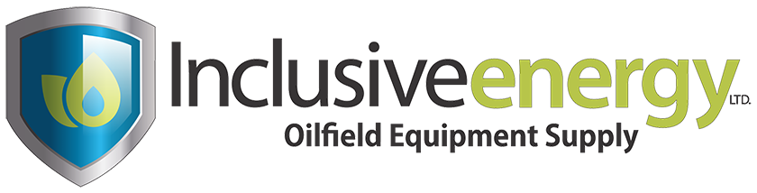 |   A Habib Group Company

INCLUSIVE ENERGY
UPSTREAM INVESTMENT PLATFORM

Inclusive Energy Ltd. is a recognized Canadian market leader in oilfield equipment services and a dedicated capital partner for upstream oil & gas companies across North America.
INVESTMENT STRATEGY

- Appetite to provide capital at all levels of the balance sheet, including equity, senior and subordinated debt, revolving facilities, or any combination thereof.
- Capacity to work directly with management teams to customize financing solutions to meet a company's distinct capital needs. Typical uses of proceeds include acquisitions, development drilling, optimization projects, refinancing existing lenders, and management buyouts.
- Target investment amounts from C$1MM (minimum) to C$30MM+ depending on investment type and associated term. Inclusive may also gain economic participation through direct investments or joint ventures.

INDUSTRY EXPERTISE  - Extensive experience across the oilfield equipment and energy services value chain  - Deep understanding of the upstream oil & gas market, commodity price cycles, and capital requirements of junior producers  - Proven track record of investing in the energy sector through multiple commodity cycles | KEY FEATURES  - Stable source of capital through economic and commodity cycles  - Unique advantage: financial capital combined with direct oilfield equipment supply  - Speed of execution with a streamlined investment process  - Ability to provide capital across the full capital structure  - Patient capital with capacity to grow with a company and adapt to market changes | INVESTING CAPABILITIES C$1MM – C$30MM+  - Senior Debt  - Revolving Credit Facility  - Term Debt  - Deferred Draw Term Loan  - Subordinated Debt  - Subordinated 2nd Lien  - Unsecured Note  - Equity  - Structured Equity  - Minority Equity  - Joint Ventures

ESTABLISHED CAPITAL PROVIDER

Inclusive Energy Ltd.
- Recognized Canadian market leader in oilfield equipment supply, sales, and rental since 2010, operating three facilities across Alberta and serving clients across Canada and the United States.
- Proven model of acquiring distressed and surplus equipment at significant discounts, refurbishing where required, and reselling or renting at considerable premiums — generating attractive returns on capital.

Habib Group
- Global conglomerate founded in 1912, providing financial and banking services worldwide across banking, asset management, equity brokerage, manufacturing, and Oil & Gas services.
- Active in over 10 countries including Canada, the United Kingdom, Switzerland, UAE, Pakistan, and China. The management team of Inclusive Energy carries decades of specialized experience in financial, banking, and energy sectors.

This document is intended for institutional and accredited investors only. All investments subject to applicable Canadian and U.S. securities regulations.

Bilal Hydrie  President & CEO  info@inclusivenergy.com | Capital Inquiries  Investment & Partnerships  sales@inclusivenergy.com | Central Alberta  Equipment & Rentals  +1 780.712.8881 | Calgary Office  Headquarters  +1 403.444.6897 | inclusivenergy.com  Web & Media  Crossfield, AB

