Be a Prince/Princess Disney Character for a Week!
RUP7*17 Disney Contest!
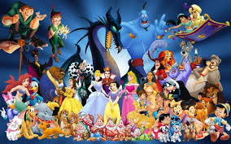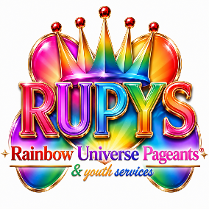
Register on our “Pageant Portal” website via the registration form, RSVP for our Registration Party once a month or nominate someone you think deserves to reign as royalty for 30 days!

Choose one of the eight thought provoking topics below: (must be between the ages of 7-17; you will see a section on the form for your parents’ consent to compete)

1. Politics: What do we need to change in the white house or the world to make a positive impact and move us forward into the future?
2. Social Media: what ideas do you have to improve social media or encourage your peers to use it in moderation or practice social etiquette?
3. Entertainment: What types of entertainment are best for youth and young adults? What kind of entertainment would you implement to create innovation and eliminate boredom?
4. Current Event: What current event is near and dear to your heart and what do you have to say about it? What kind of change has it caused in the world and is this a negative or positive change?
5. Religion/Spirituality: What are your thoughts about religion vs spirituality? What’s the difference and is one more effective than the other? What are your thoughts about God?
6. Community Service: What is the most important community service activity that we need to continue with or change? Or do you have a service idea that you would like to organize for your community?
7. Family/Relationships: What do you think is the biggest challenge in relationships? How can we all manage and overcome this challenge?
8. Youth Plight: What major angst is plaguing youth today? What do you suggest be done to resolve this plight?
9. Wellness: What does wellness look like for you in terms of taking care of the body, mind and spirit?
Send in your work via photos/videos submitted on our Pageant Portal website via the Documents and page. Once you register you will have access to the portal and you can upload your videos, photos or Word document there. More information will be conveyed during orientation or at the Registration party.
Tell your friends to vote for you using our special form on our website!
Word documents need to be 12-point font, double-spaced, Times New Roman or Calibri font, one half to a full page answer. Please spell check and correct any grammatical errors.
*Winners will be notified via email or text message and blasted on all our social media pages (Pinterest, Instagram, Tumblr, LinkedIn, Facebook and Twitter) and you will reign for a total of 30 days following your win once you have signed all paperwork and after you receive your sash and tiara or crown in the mail or during your crowning ceremony if you are in close proximity to our Headquarters.
**You get a sash and a crown specially designed for this contest with the Disney Character that we chose for each specific month, a Disney gift card, a brand-new social media following and presence because your win will make you more popular but don’t let that go to your head (it’s an opportunity to shine humbly and make a difference in the world.) If you win this contest you will win some hearts and Rainbow Universe Pageants & Youth Services has a lot of watchers, followers, fans, supporters and sponsors behind our rainbow belt so you will get attention.
Title winners/crown holders will be a Little Miss/Mister Prince or Princess (ages 7-9) & Jr. Miss/Mister Prince or Princess (ages 10-17) for 30 days (30 days max – that means you have four weeks to make an impact on the world based on your platform).
***We are looking for thought changers, world shakers, boat rockers, wave makers and the bold, fearless and confident (yes ages 7-17, there are some awesome intelligent children in the world). This is what it takes to create change, build effective connections, and be a catalyst to the future state of our world as you grow into adolescence and then adulthood. Let’s hear your voice! You are the future!
****Since you are under the age of 18 you need a parent to sign the Parental consent section on the form with their contact information included!

Rainbow Universe Pageants & Youth Services, LLC. Copyright ©2026. All Rights Reserved. www.rainbowuniversepageantyouth.org

