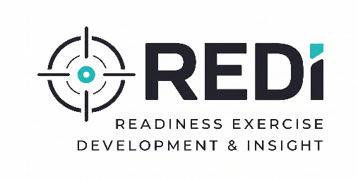


The New Standard in Readiness Training

Introducing REDI - Readiness Exercise Development & Insight - Platform
In today’s threat environment, readiness cannot rely on theoretical discussions alone. Authorities must be able to respond quickly, from operational to crisis mode, and coordinate effectively across relevant teams. By offering collaborative, scalable, realistic team-based training, the REDI platform ensures that the functional enactment of an actual incident is practiced in a simulated manner that mirrors an operational response; your personnel doesn’t just know the plan—they have already executed it.

Executive System Summary
Authorities protect people, critical infrastructure, and operational requirements in an environment where cyber threats, physical security incidents, and operational disruptions are increasingly complex and interconnected.

While traditional, occasional tabletop exercises provide value, they often fail to create the sustained preparedness or individual accountability required for modern resilience.
The REDI platform addresses this gap with a tiered suite of solutions that simulate real-world incidents in a dynamic, operationally realistic manner. By using a system that delivers immersive, multimedia "situational injects," we move training from the hypothetical to the operational. Whether you are training a coordinated team, testing individual staff via the REDI platform, or building a culture of continuous improvement through Readiness as a Service (RaaS), the platform ensures your organization is REDI for the unpredictable.

A Three-Tiered Approach to Readiness

1. Team-Based Exercises: Coordinated Response
Utilizing state-of-the-art software, these exercises focus on collective decision-making, stakeholder awareness, and team dynamics.
- Flexible Deployment: Injects are delivered via an internet connection, allowing teams to gather in a single room or be dispersed geographically.
- Real-Time Monitoring: All team actions are recorded via a dedicated exercise monitor, providing a clear record of coordination and command flow.
- High Engagement: Designed for high-intensity windows that test how departments—such as IT, operations, police, security, and leadership—work together under pressure.

2. Individual Operational Simulation: Focused Response
The REDI platform shifts the focus to the individual level. Instead of discussing a scenario, staff experience it:
- Direct-to-Participant Delivery: Alerts, email, or text (injects) are sent directly to personnel responsible during an actual incident.
- Individual Accountability: The REDI system captures the specific communications each participant initiates and the actions they document in real-time.
- Operational Continuity: Situational injects can be delivered anywhere, in one large gathering, or wherever staff happen to be at the time. Because participants don't need to be pulled into a single room, organizations can maintain shift coverage while still performing comprehensive readiness testing.
  - Organizations can maintain shift coverage while still performing comprehensive readiness testing.
  - The system can mimic the location of personnel as they progress through an incident.

3. Continuous Improvement & Analytics
Using the REDI platform as a regular Readiness-as-a-Service (RaaS) provides an additional layer, transforming REDI into an ongoing capability. This secondary tier is focused on measurable, long-term resilience.
- Iterative Testing: Run a complex scenario, identify gaps, and provide targeted training, and re-run the scenario to quantitatively measure improvement.
- Flexible Scaling: Available through an annual agreement or monthly, based on hours, allowing organizations to scale exercise frequency according to current needs or budget.
- Data-Driven Insights: Generates detailed reports on communication bottlenecks, decision-making delays, and coordination gaps.

The Realistic Edge
The two services utilize Immersive Assets to mirror the complexity of an actual incident. Injects may incorporate:
- Security and operational actions
- Cybersecurity alerts and technical indicators.
- Simulated media inquiries, social media activity, and news reports.
- Threat reports and multi-agency coordination requests.
- Multimedia elements, including video, audio, and realistic email traffic.
Current Event Scenarios
· Cybersecurity
· Ferry, cruise, and seaport Active Shooter/Hostile Event Response (ASHER)
· Airport Active Shooter/Hostile Event Response (ASHER) (In development)
Event scenarios can be virtual or on-site, and are available as pre-designed, location-based simulations, ready-made simulations, or customized to align with the authorities’ actual physical area environment.

