COMMUNITY LAND ACTIVATION
Sollom Splash Pilot Evidence & Future Stewardship Model
Proof of concept for funders, businesses, landowners and community partners
3  PILOT DAYS | 27  PEOPLE ENGAGED | 166+  VOLUNTEER HOURS | 8  LOCAL BUSINESSES | £960+  IN-KIND SUPPORT

1. Executive Summary
In July 2026, The Great Big Yawn CIC was introduced to a landowner through one of its Yawning Ambassadors. The shared ambition was to explore how woodland and water could support community activity, nature connection, practical volunteering, learning and wellbeing. A three-day activation on 6–8 August 2026 tested the idea before any long-term commitment.
The pilot demonstrated rapid community mobilisation, business support, physical improvements and meaningful social connection. It also proved the value of testing leadership capacity, governance, boundaries and partnership fit before significant funding, licensing or long-term operational responsibility is accepted.
CORE FINDING The activation model worked. The proposed long-term partnership configuration was not the right fit. The evidence and learning now form the basis of a stronger, transferable Great Big Yawn land-stewardship model.

2. What the Pilot Tested
Test | Decision question
Community appetite | Would people attend and contribute time, skills or resources?
Business response | Would local businesses support a practical community project?
Land potential | Could a short activation create visible, useful improvements?
Leadership capacity | Who could realistically hold local responsibility?
Partnership fit | Were expectations, boundaries and working relationships suitable?
Replicability | Could the process become a repeatable TGBY blueprint?

3. Delivery & Practical Outcomes
Area | Evidence delivered
Woodland regeneration | Overgrowth cleared; selected vegetation cut back to improve light, visibility and usable space.
Paths & access | Routes cleared and rough ground improved between emerging activity areas.
Site preparation | Four potential toilet areas excavated and practical requirements clarified through live use.
Community activity | Shared meals, drumming, wellbeing activity, outdoor play, conversation and wild swimming.
Digital preparation | Project website, initial booking system, imagery and community-day planning produced.
Evidence | Photographs, film, testimonials, volunteer records and business-contribution evidence generated.

4. Local Business & In-Kind Support
Contribution | Approx. value | Use
Refreshments | £200 | Volunteer hospitality
Walkie-talkies | £200 | Site communication
Digger hire/support | £360 | Groundworks and access
Gardening tools | £200 | Clearance and site work
Pallets, paint & materials | Not fully costed | Development resources
Identified total | £960+ | Excludes volunteer labour and uncosted donations
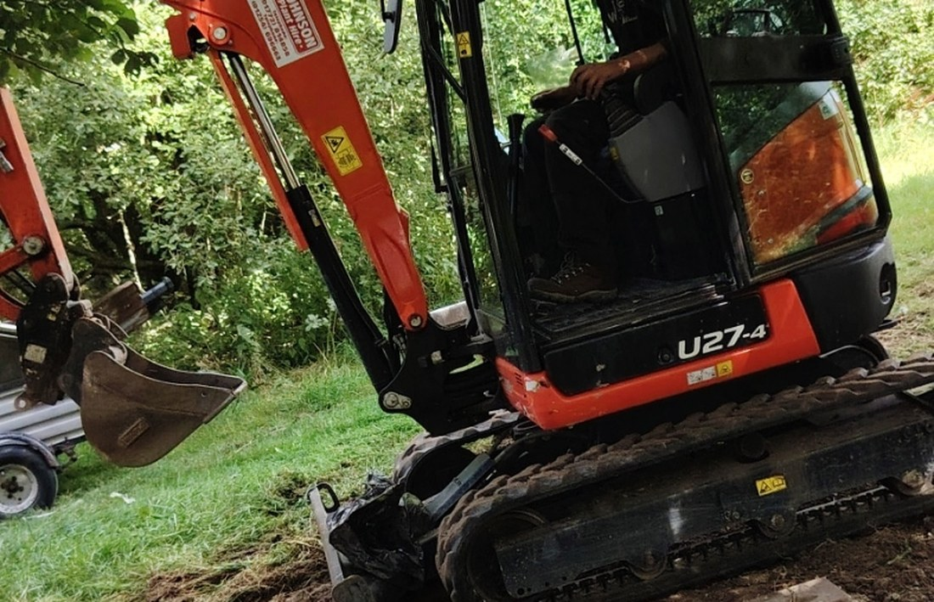  Business and machinery support accelerated practical work. | 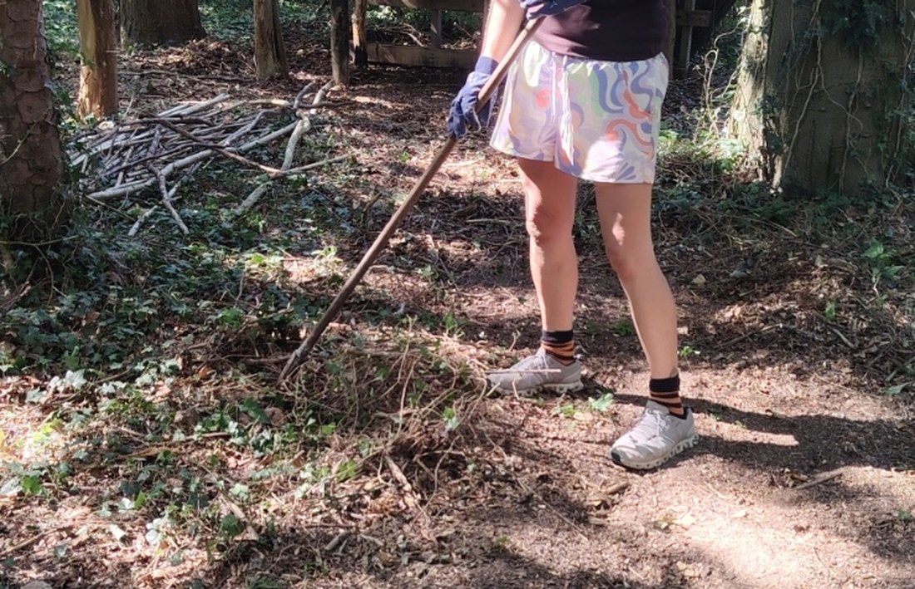  Volunteers opened woodland and access areas.
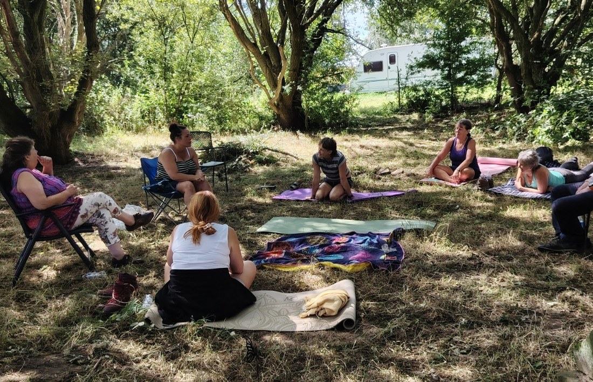  Connection and wellbeing sat alongside practical volunteering. | 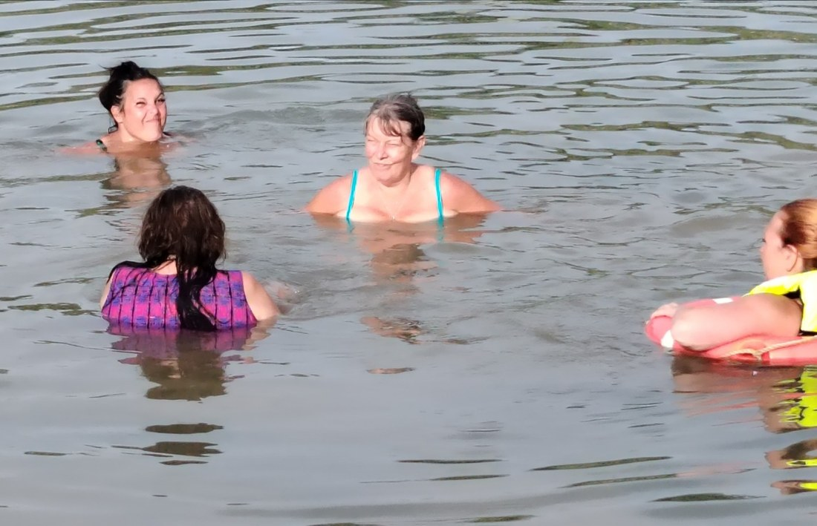  Shared outdoor experience helped people connect.

5. Community & Human Outcomes
Outcome | Observed evidence
Connection | New conversations and friendships developed through shared practical work and outdoor time.
Confidence & purpose | Participants completed visible tasks and experienced worthwhile contribution.
Children & nature | Children explored woodland, animals and water alongside adults.
Wellbeing | Work was balanced with rest, food, conversation, drumming, laughter and nature.
Belonging | People contributed at different levels, from short visits to sustained involvement.

6. Strategic Learning: Capacity Before Responsibility
Shared vision is a beginning, not a guarantee of delivery. The Great Big Yawn welcomes people with different histories, abilities and circumstances, while matching leadership responsibility to demonstrated capacity and preset boundaries.
Capacity | Leadership expectation
Emotional & mental | Can communicate, manage challenge, understand responsibilities, make decisions and recognise limits.
Physical & practical | Can fulfil role requirements with appropriate adjustment/support and has sufficient time, reliability and local presence.
Values / spiritual grounding | Acts with respect for people, place, nature and the agreed ethos.
Relational | Can collaborate and share responsibility without one person repeatedly compensating for gaps.
INCLUSION WITH DISCERNMENT Everyone can potentially contribute. Leadership is offered where emotional, mental, physical, practical and values-based capacity is sufficient for the responsibility accepted.

7. Four Tests for Future Partnerships
Test | Question
RESONANCE | Do we share enough of the same purpose and values?
READINESS | Are the people, site, resources and infrastructure sufficiently ready?
RESPONSIBILITY | Can each party reliably hold the role and boundaries agreed?
RECIPROCITY | Are access, time, benefit, resources and responsibility shared fairly enough to remain healthy?
RESONANCE • READINESS • RESPONSIBILITY • RECIPROCITY

8. Organisational Shift
From | To
Founder compensates for gaps | Structure and local team hold the project
Shared vision implies partnership | Vision is followed by a live pilot
Roles are assumed | Roles are observed and tested
Growth adds founder workload | Growth develops distributed local leadership

9. The Great Big Yawn Land Stewardship Pathway
Stage | Action | Purpose
1. Introduction | Understand the vision | Start with purpose
2. Site Review | Map opportunities, limits and responsibilities | Establish a baseline
3. People & Resources | Identify volunteers, facilitators and businesses | Build local capacity
4. Pilot Activation | Run a short practical community test | Test demand and relationships
5. Measure | Record people, hours, donations and feedback | Create fundable evidence
6. Review | Apply the four partnership tests | Go / adapt / stop
7. Agreement | Define governance, safety, finances and roles | Protect all parties
8. Local Stewardship | Capable local leads coordinate ongoing activity | Prevent founder dependency
9. Network Support | TGBY provides framework, training, promotion and evaluation | Create scalability

10. Transferable Model for Funders & Business Partners
The Great Big Yawn's scalable role is to act as an activator, connector and framework-holder rather than the permanent operator of every site.
Partner | Potential contribution | Value created
Landowners | Suitable land and clear site responsibilities | Structured community-use testing
Businesses | Funding, volunteer time, machinery, materials, skills | Visible local social value and outcomes
Funders | Project, capacity and infrastructure investment | Evidence before expansion
Volunteers | Time, skills and local knowledge | Purpose, learning and connection
Facilitators / Ambassadors | Coordination, wellbeing and specialist skills | Locally held activity
The Great Big Yawn | Activation model, network, training and evaluation | A repeatable blueprint

11. What Investment Can Enable
Investment area | What it strengthens
Local coordination | Reliable local stewardship
Volunteer infrastructure | Tools, PPE, communication, induction and safeguarding
Site readiness | Access, facilities and appropriate risk controls
Training | Ambassador, facilitator and volunteer-lead development
Digital matching | A future Land & People Exchange linking land, skills, businesses and needs
Impact measurement | Consistent evidence of participation, hours, in-kind value and outcomes
Community programming | Regular activity after successful pilot review

12. Why the Pilot Approach Protects Future Investment
Risk without a pilot | How the TGBY model responds
Long-term agreements based mainly on enthusiasm | Demand, behaviour and capacity are observed first
Funding committed before leadership is proven | Local leadership is tested through delivery
Responsibilities remain informal | Roles and boundaries are clarified before expansion
Founder becomes the default problem-solver | Local stewardship is required for sustainable growth
Projects continue because investment has already been made | Formal review allows a responsible go, adapt or stop decision

13. Alignment with Wider Regenerative Network Practice
The model sits alongside a wider international movement that connects people with place rather than requiring one central organisation to operate every location. WWOOF connects visitors with organic farmers for hands-on learning and exchange; the Global Ecovillage Network connects people and regenerative communities; and the Permaculture Association's LAND network supports demonstration sites where people can visit, learn and volunteer. The Great Big Yawn can add a distinctive wellbeing, community-activation and local-leadership layer to this network principle.
Reference examples: WWOOF (wwoof.net); Global Ecovillage Network (ecovillage.org); Permaculture Association LAND Network (permaculture.org.uk/land).

14. Evidence Available for Bids & Partnerships
Evidence | Available now
Participation | 27 people engaged and 166+ volunteer/project hours
Business engagement | 8 local businesses and £960+ identified in-kind support
Physical outcomes | Photographs and film showing site change and activity
Human outcomes | Participant observations and video testimonials
Delivery capability | Mobilisation, digital preparation and operational learning
Governance learning | Stage-gated partnership and capacity framework
Replicability | A defined process for future landowners and communities

15. Moving Forward
Sollom Splash is best understood as a successful proof-of-concept and discovery pilot. It demonstrated that The Great Big Yawn can mobilise people, businesses and practical resources quickly while showing why not every promising site should become a long-term partnership.
THE FUTURE MODEL The Great Big Yawn will scale the blueprint, not the founder's workload. Future projects will be activated, tested, measured and only progressed where local stewardship, capacity, shared values and reciprocal responsibility are demonstrably present.
EVERYONE CAN BELONG • EVERYONE CAN CONTRIBUTE • RESPONSIBILITY IS MATCHED TO CAPACITY
From Boredom, Apathy & Exhaustion towards Hope, Creativity & Possibility

