WELCOME TO 2028

AI Work and Financial Resilience in 2028
A newsletter analysis of layoffs automation risk and practical preparation
RESEARCH BASED ANALYSIS SEPTEMBER 2026

Key Takeaways
- Treat the 2028 crisis numbers as a thought experiment, not a forecast. The 10.2 percent unemployment rate and 38 percent market drawdown come from a hypothetical Citrini Research scenario.
- The labor market signal is already visible. Meta announced more than 11,000 layoffs in 2022, about 10,000 planned reductions in 2023, and a reported 8,000 cuts in 2026 while increasing AI investment.
- Expert expectations remain uncertain. In the featured Atlantic Council survey, 57.9 percent of 394 respondents said AGI could arrive by 2036.
- Personal resilience starts with cash flow and time. Reduce avoidable spending and aim for at least three months of essential living expenses before taking greater financial risk.
- Use AI to increase capacity, but keep human judgment. Domain knowledge, quality control, relationships and trust are the parts of the formula that remain hardest to automate.

The most dramatic forecasts about artificial intelligence are still scenarios, not settled outcomes. The labor market signals behind them are real enough, however, to justify a practical response now.
Imagine the year 2028. AI systems handle customer service, data analysis and much of the repetitive office work. A worker who has been laid off applies to jobs that all demand AI experience, then uses AI to rewrite a resume for roles that may themselves be automated. That opening is a thought experiment. It is not a prediction with a fixed date, and it should not be read as proof that 70 percent of jobs will disappear. It is useful because it concentrates a question that already feels immediate: what should people do if AI begins doing more of the work that supports their income?

The Layoff Pattern Already Exists
Meta offers a concrete timeline. In November 2022, Mark Zuckerberg said the company would reduce its team by about 13 percent and let more than 11,000 employees go. The following March, Meta announced plans to reduce its team by about another 10,000 people and to close roughly 5,000 open roles that had not yet been filled. These decisions predated the latest wave of agentic AI, but they established the efficiency logic that now accompanies large technology investments.
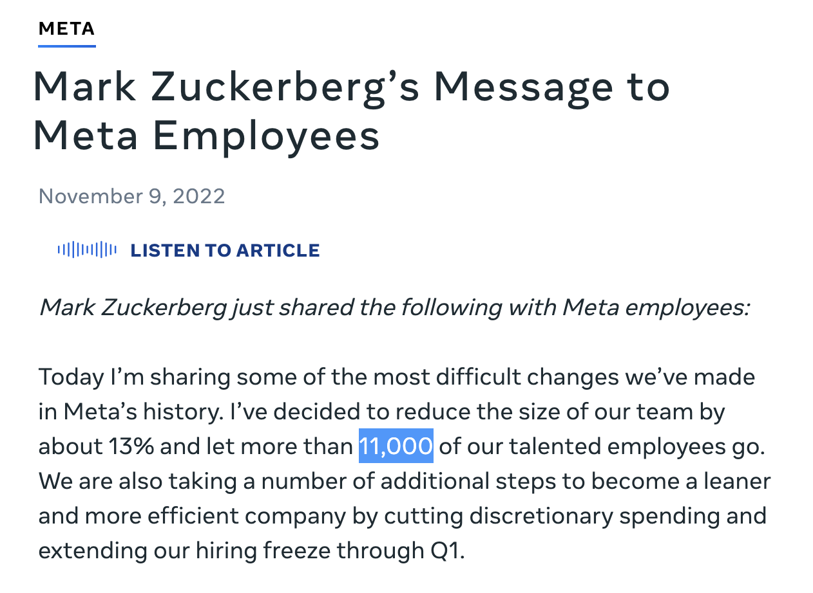
Figure 1 Meta said it would eliminate more than 11,000 jobs, about 13 percent of its workforce, in November 2022. Source Meta, Mark Zuckerberg's Message to Meta Employees, November 9 2022.
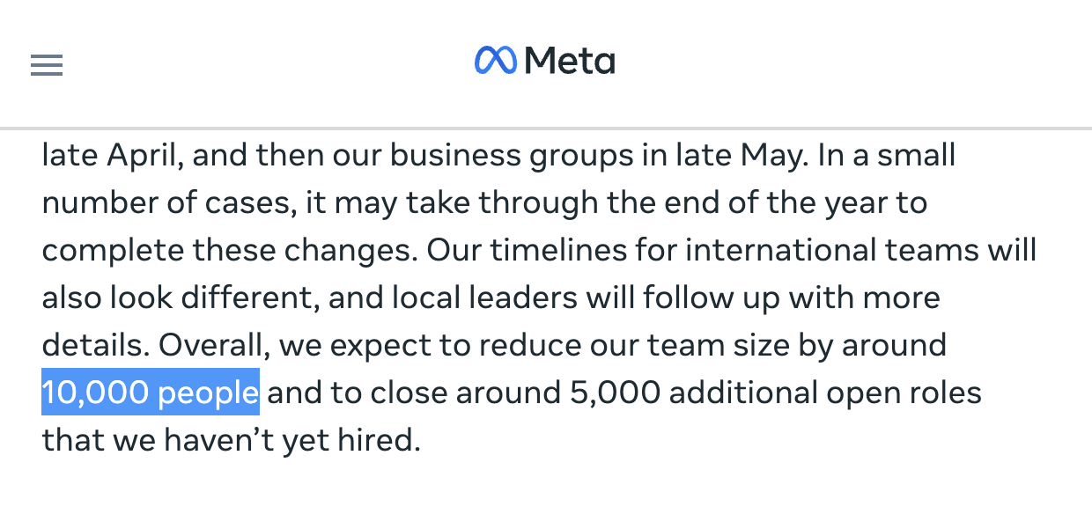
Figure 2 Meta's March 2023 plan called for reducing the team by about 10,000 people and closing roughly 5,000 unfilled roles. Source Meta, Update on Meta's Year of Efficiency, March 14 2023.
By April 2026, the Associated Press reported that Meta planned to cut about 8,000 more jobs, or roughly 10 percent of its workforce, while increasing investment in AI infrastructure and highly paid AI expertise. The report also said the company would leave about 6,000 positions unfilled. The direct causes of any layoff cycle are broader than AI alone, but the sequence illustrates the central tension: companies can spend more on automation and advanced technical capacity while reducing payroll elsewhere.
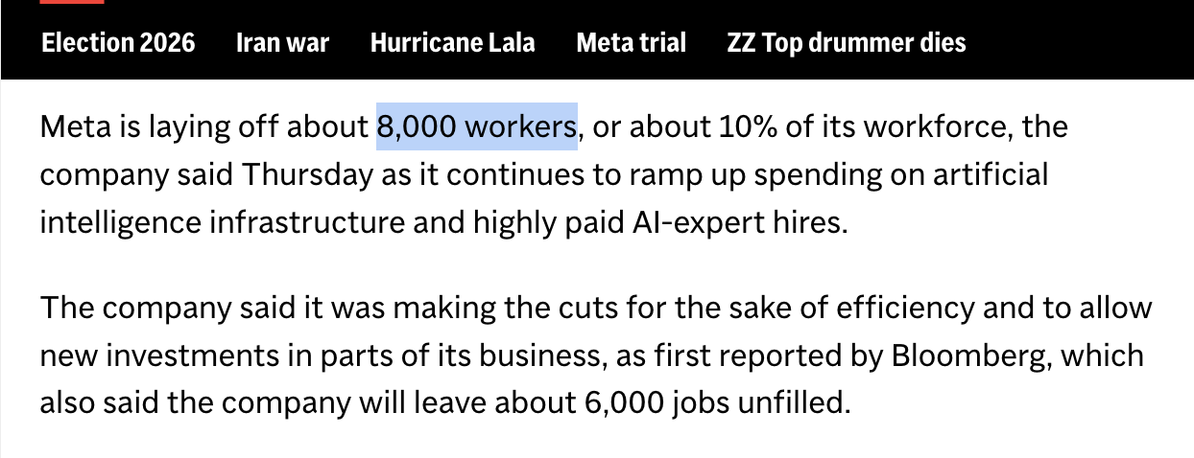
Figure 3 An April 2026 report said Meta would cut about 8,000 workers while spending more on AI infrastructure and AI specialists. Source Associated Press, Meta slashes 8000 jobs or 10 percent of its workforce as Microsoft offers buyouts, April 23 2026.

A Wall Street Stress Test
The most alarming numbers in the debate often come from scenario analysis. Citrini Research's The 2028 Global Intelligence Crisis is explicitly presented as a thought exercise rather than a forecast. Its imagined timeline follows an economy in which abundant machine intelligence sharply reduces demand for white-collar labor. In that scenario, the United States unemployment rate reaches 10.2 percent by June 2028 and the S&P 500 falls 38 percent from an October 2026 high.
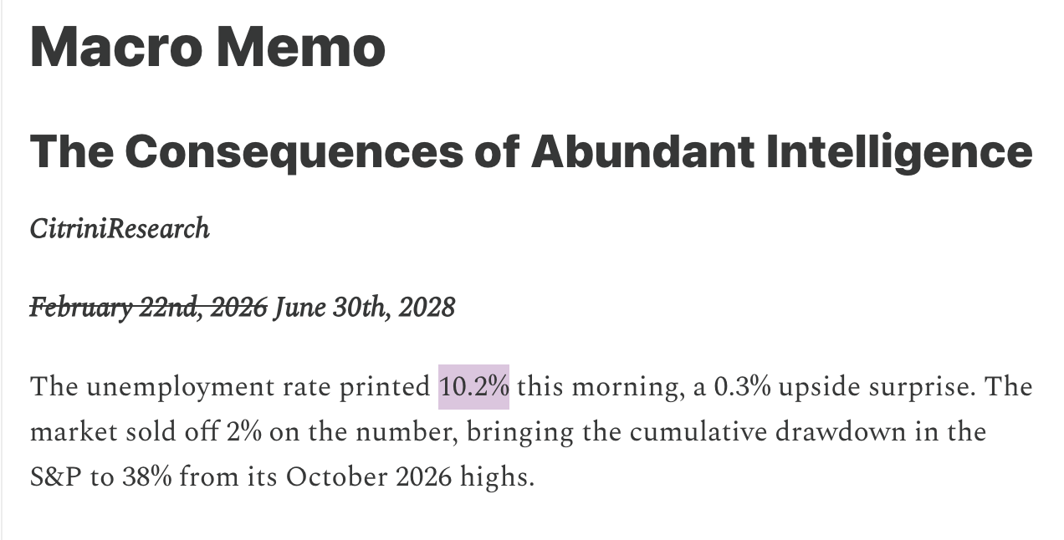
Figure 4 Citrini Research's hypothetical 2028 scenario shows unemployment at 10.2 percent. This is a scenario, not a forecast. Source Citrini Research, The 2028 Global Intelligence Crisis, February 22 2026.
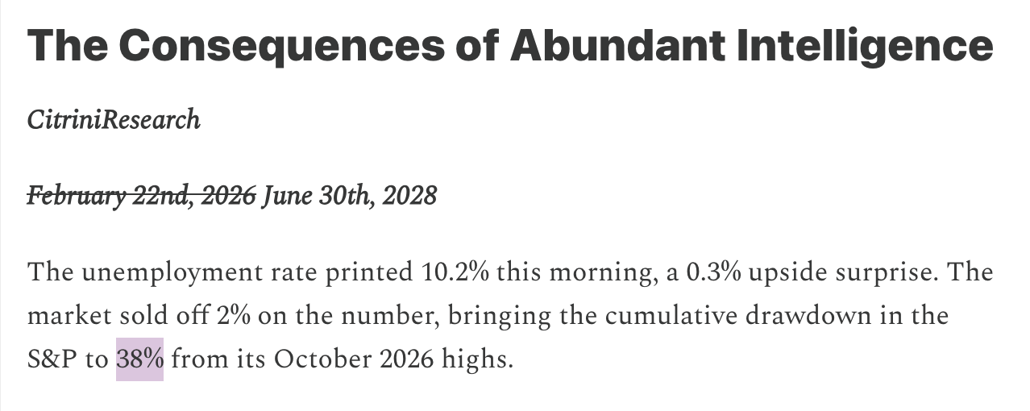
Figure 5 The same thought experiment imagines a cumulative 38 percent S&P 500 drawdown from its October 2026 high. Source Citrini Research, The 2028 Global Intelligence Crisis, February 22 2026.
The exact path is speculative, but the feedback loop is economically coherent. If a large group of workers loses income, household spending weakens. Lower demand then pressures business revenue, which can lead to additional cost cutting. Productivity may rise on paper while financial stress spreads through households. That possibility is why labor displacement matters beyond the workers whose roles change first.
Anthropic chief executive Dario Amodei has offered a separate and unusually severe warning. In a May 2025 Axios interview, he said AI could eliminate as many as half of entry-level white-collar jobs and could push unemployment to 10 to 20 percent within one to five years. The words could and warning matter. This was a chief executive's risk estimate, not a consensus forecast, but it shows that some builders of frontier AI believe the transition could move faster than institutions and workers expect.
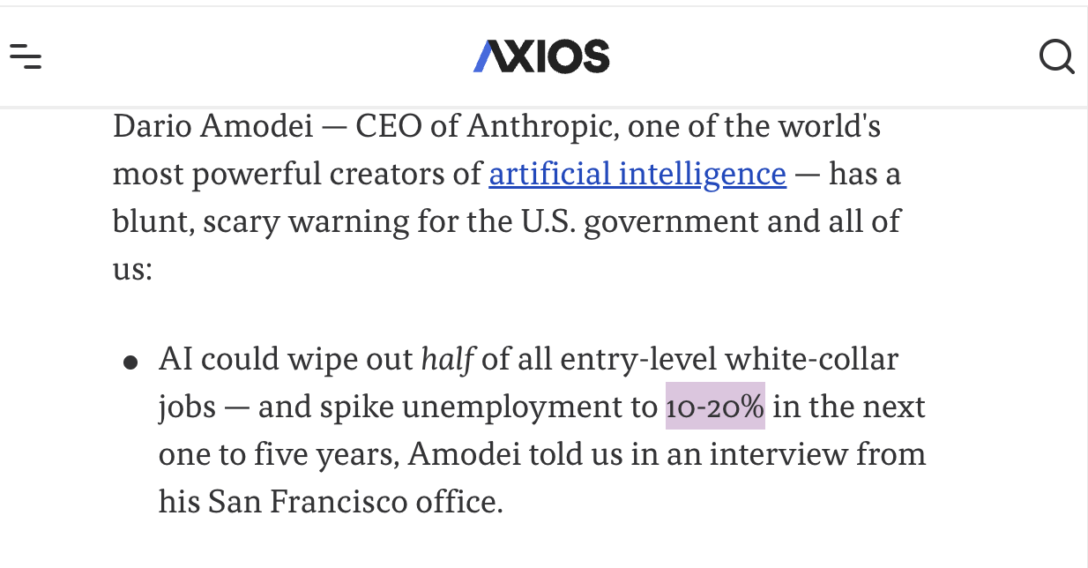
Figure 6 Dario Amodei warned that AI could eliminate half of entry-level white-collar jobs and push unemployment to 10 to 20 percent within one to five years. Source Axios, Behind the Curtain A white-collar bloodbath, May 28 2025.

AGI and the Long Horizon
The long range version of the argument centers on artificial general intelligence. AGI usually means a system that can match or exceed human cognitive abilities across a very wide range of tasks. In an Atlantic Council survey shown in the accompanying chart, 57.9 percent of 394 respondents said AGI could be achieved by 2036, while 42.1 percent said it would not. The result records expert expectations; it does not establish that AGI will arrive on that schedule.
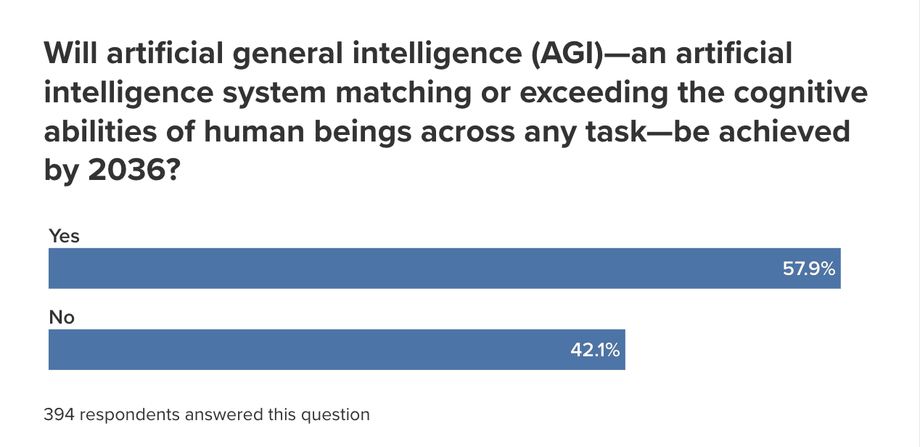
Figure 7 In this survey of 394 respondents, 57.9 percent said AGI could be achieved by 2036 and 42.1 percent said it would not. Source Atlantic Council, Welcome to 2036 What the world could look like in ten years according to nearly 450 experts, 2026.
If systems eventually perform most general cognitive tasks at a high level, routine knowledge work is likely to become cheaper. People who depend on one broadly available skill and one paycheck would face greater risk. Those who combine domain knowledge, judgment, relationships and ownership of productive assets may have more leverage. This is not a claim that every ordinary job becomes worthless. It is a reason to build capabilities that are harder to reproduce and income that is less exposed to a single employer.

Why Productivity Can Still Feel Like a Crisis
Technology has repeatedly changed the value of labor. Land and planning mattered in agricultural economies. Machines reorganized physical work during industrialization. Software rewarded people who learned to use computers early. Each transition reduced demand for some skills, increased demand for others and forced workers to adapt. AI fits that historical pattern, but its reach across language, analysis, design and software makes the current adjustment unusually broad.
The benefits are easy to state: lower costs, faster output and higher productivity. The distribution of those benefits is less automatic. Asset owners can invest in AI companies, purchase better tools and absorb a period of retraining. Most households mainly own their time, their skills and the income generated by their work. If AI lowers the market price of a skill, the worker feels the loss immediately even if the overall economy becomes more efficient.

Three Ways to Build Personal Resilience

Protect Cash Flow
The first step is to act as your own chief financial officer. Review recurring subscriptions, food delivery, impulse purchases and high risk investments that can drain cash without strengthening your future earning power. Then build an emergency fund. A starting target of at least three months of essential living expenses can create time to search, retrain or change direction after an income shock. The exact amount will vary by household, but the principle is simple: basic security gives you room to make better decisions.

Use AI to Rebuild Income
The second step is to ask whether one person working with AI can perform functions that once required a small team. AI can reduce research time, narrow information gaps and lower the cost of testing a service or product. That creates room for flexible work and very small businesses, especially when the operator already understands an industry and can judge whether the output is accurate and useful. Experience remains important because speed without quality control merely produces mistakes faster.

Build Relationships and Trust
The third step is to invest in reputation. As polished writing, images and presentations become easier to generate, surface quality becomes weaker evidence of competence. People still decide whom to hire, recommend and pay. Small projects delivered on time, an honest explanation of process and a public record of results give others evidence that you are reliable. AI can imitate a style, but it cannot quickly reproduce years of dependable behavior.

Use AI Without Outsourcing Judgment
AI is already entering personal finance. A 2025 Credit Karma survey found that 66 percent of Americans surveyed who had used generative AI said they used it to seek financial advice. The figure rose to 82 percent among Gen Z and 82 percent among Millennials. Among respondents who acted on financial advice from an AI tool, 80 percent said it improved their financial situation, while 75 percent of GenAI users said the tools let them ask questions they were too embarrassed to ask other people.
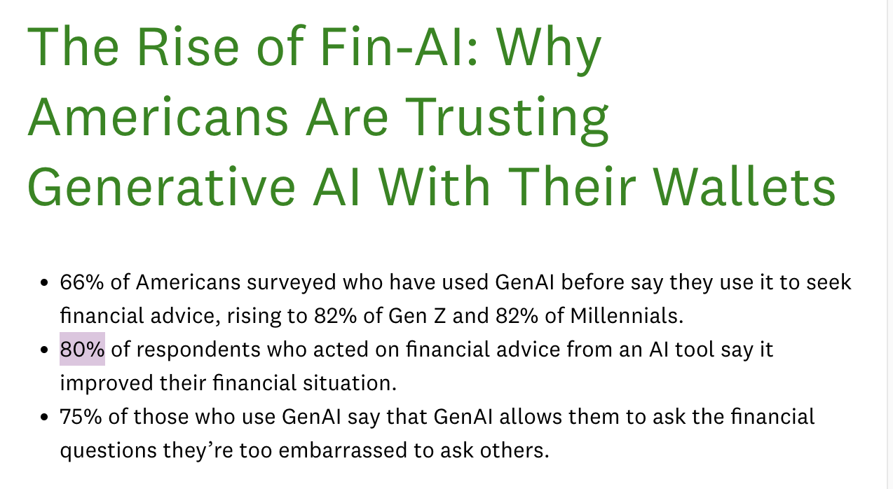
Figure 8 Credit Karma reported that 82 percent of surveyed Gen Z and Millennial GenAI users sought financial advice from AI tools. Source Intuit Credit Karma, The Rise of Fin AI Why Americans Are Trusting Generative AI With Their Wallets, September 2 2025.
Those figures show adoption, not proof that every answer is suitable or correct. AI can help organize questions, compare broad options and explain unfamiliar terms. It should not replace verification, independent judgment or personalized advice from a qualified professional, particularly when taxes, legal obligations, investment risk or a household's full financial situation matter.

The Durable Advantage
The strongest position in an AI driven economy is not AI alone. It is AI combined with experience, taste, a network and trust. AI supplies speed. Experience supplies context. Taste helps a person distinguish acceptable work from good work. Relationships create access to opportunities, and trust gives other people a reason to choose you when competent looking output is abundant.
AI plus experience plus taste plus network plus trust
The useful question is therefore not whether AI will replace every individual worker. The more practical question is whether a person is waiting for change to force a move or using the available time to strengthen cash flow, learn the tools, deepen domain knowledge and build a reputation for reliable work. No strategy can remove technological risk. Moving early can make the transition less fragile and expand the number of paths available when the labor market changes.

