SPORTS ECONOMY NEWSLETTER

How American Sports Became a Global Business
A newsletter analysis of media rights live events fan identity and personal spending
RESEARCH BASED ANALYSIS SEPTEMBER 2026

Key Takeaways
- Sports revenue extends far beyond athletes. Media, tourism, merchandise, youth participation and host city spending form the wider business ecosystem.
- Live attention makes media rights unusually valuable. The NFL's major broadcast and streaming agreements run through 2033 and have been reported as worth more than USD 100 billion.
- A major event can create a temporary local economy. The 2025 NBA All Star Game generated an estimated USD 328.2 million in Bay Area economic impact.
- Fan identity supports recurring demand for jerseys, footwear and collectibles because the purchase represents belonging as well as utility.
- A profitable event can still be expensive for an individual fan. Calculate tickets, travel, lodging, food, transportation and merchandise before deciding whether the experience fits your budget.

American sports generate revenue far beyond the scoreboard. Media contracts, tourism, merchandise and youth participation turn games into an economy that reaches households and cities around the world.
The scale becomes visible around the world's largest events. FIFA's 2023 to 2026 revenue budget totals USD 11 billion, an increase of USD 4.56 billion from the previous four year cycle. The 2026 World Cup anchors that period, while the Los Angeles Olympics in 2028 will extend the cycle of media attention, travel and fan spending in the United States. The country accounts for roughly 40 percent of the global sports market, according to the source script, which helps explain why American leagues and host cities treat sports as both entertainment and infrastructure for business.
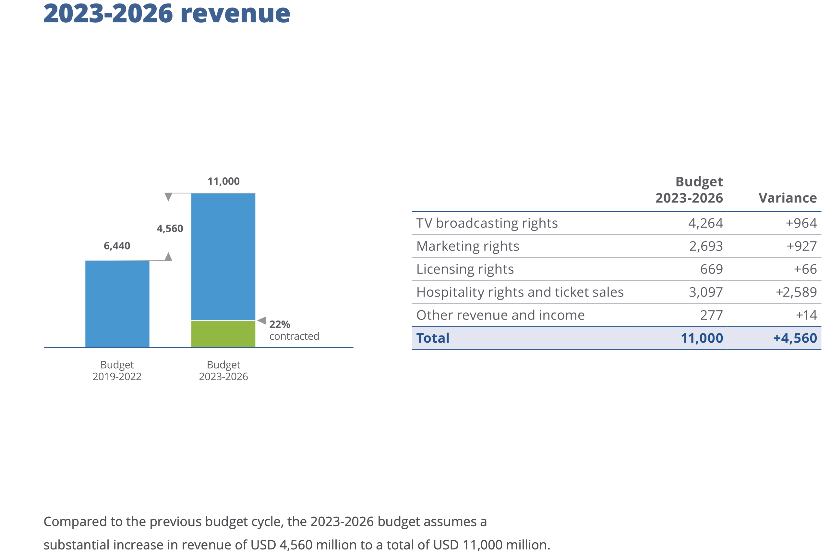
Figure 1 FIFA's 2023 to 2026 revenue budget totals USD 11 billion, up USD 4.56 billion from the 2019 to 2022 budget cycle. Source FIFA, Budget 2023 to 2026, 2023 to 2026.

The Business Around the Game
When people hear the phrase sports economy, they often picture highly paid athletes. Player salaries are only the most visible part. The larger economy includes the team, the stadium, the broadcast agreement, the advertising inventory, the training system, the children playing after school and the city hosting a major event. Each piece earns revenue from the attention created by competition.
Winning still matters, but the strongest sports organizations build an ecosystem around it. They give fans several ways to participate before, during and after a game. A single event can be watched on television, streamed on a phone, attended in person, discussed on social media and represented through clothing or collectibles. That range of participation turns an athletic contest into a durable commercial product.

Media Rights and Live Attention
Media rights are the first major revenue engine. Live sports are among the few programs that large audiences still prefer to watch in real time. A Super Bowl replay two weeks later does not create the same suspense or shared conversation. That time sensitivity makes premium games unusually valuable to television networks and streaming platforms because they can gather a large audience at a specific moment.
The NFL provides the clearest example. Its agreements with Amazon, CBS, ESPN and ABC, Fox, and NBC run through the 2033 season and have been reported as worth more than USD 100 billion. Amazon also secured exclusive streaming rights to Thursday Night Football. The source script values that agreement at about USD 1 billion per year. A game broadcast therefore carries more than athletic performance. It carries subscription growth, advertising inventory and a reliable block of live attention.
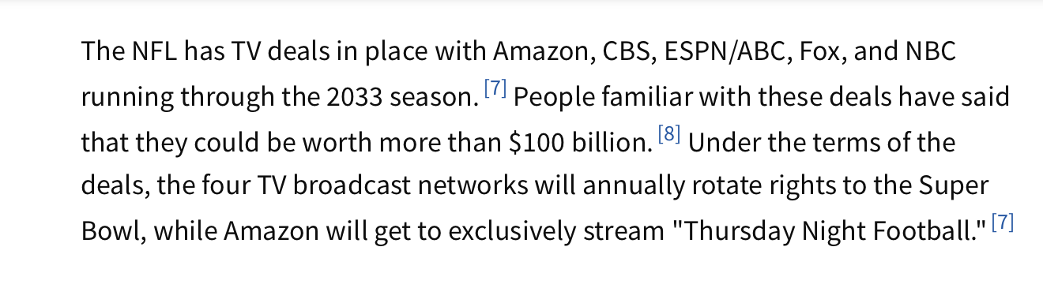
Figure 2 The NFL's major television and streaming agreements run through the 2033 season and have been reported as worth more than USD 100 billion. Source Investopedia, How the NFL Makes Money, accessed 2026.

Stadiums and the Weekend Economy
The second revenue engine is the live event. A stadium is more than seats and a field. For several hours, it becomes the center of a temporary local economy. Fans buy tickets and food, travel with friends, stay in hotels, use transportation and purchase merchandise. The spending often begins before game day and continues after the final whistle.
The 2025 NBA All Star Game in San Francisco illustrates the effect. The event generated an estimated USD 328.2 million in economic impact for the Bay Area and attracted more than 142,000 attendees from 40 states and 44 countries. The 2026 World Cup is expected to operate on an even larger scale, with billions of dollars in projected United States spending and tourism activity. This is why cities compete to host major sports events. A game can fill hotels, restaurants and transit systems across an entire weekend.

Merchandise and Fan Identity
The third revenue engine is identity. Fans do not buy only useful products. They buy symbols of belonging. A jersey has practical value as clothing, but its larger value comes from the statement it makes about a team, a city and a community. The same logic applies to hats, sneakers, collectibles and limited releases.
This emotional connection separates sports merchandise from ordinary shopping. A fan may keep purchasing across seasons because the product represents memories and relationships rather than a one time need. Teams and brands can build recurring demand by linking products to athletes, rivalries, championships and moments that supporters want to remember.

Youth Sports and Lifelong Participation
American sports culture begins early. Children participate in basketball, football, gymnastics and many other activities through schools, clubs and private training. That participation creates demand for coaching, facilities, travel, equipment and clothing, but its personal value is broader than spending.
For me, gymnastics is more than exercise. It develops flexibility, balance, confidence and discipline. It also teaches the habit of trying again when a skill feels difficult. Those experiences help explain why youth participation can create lifelong fans. A child who learns a sport may later watch professional competitions, follow athletes, buy equipment and introduce the activity to another generation.

The American Entertainment Model
American sports culture influences the world by exporting an entertainment model. The NBA has helped turn basketball into a global lifestyle brand. The NFL continues to stage international games. Social media allows American athletes to become global celebrities without relying only on traditional broadcasts.
The model starts with an exciting game, then develops recognizable personalities, rivalries and stories. Media, products, events and fan communities grow around those stories. Other leagues and markets can adapt the formula because it gives people reasons to remain engaged between games. The commercial power comes from extending attention beyond the competition itself.

The Cost for an Individual Fan
The economics look different from the perspective of one household. A World Cup can create substantial revenue for cities, hotels, sponsors and governing bodies, while one fan faces a concentrated bill. Tickets, flights, lodging, meals, local transportation and merchandise can quickly turn a game into a major discretionary expense.
Ticket prices vary sharply by match and category. A ticket around USD 1,000 may already require planning, while the highest priced Category 1 ticket for the 2026 World Cup final shown in the supplied chart exceeds USD 10,000. A more typical trip can still rise above USD 2,500 once travel and lodging are included, even without choosing the most expensive final ticket. These are different spending cases and should not be treated as one standard price.
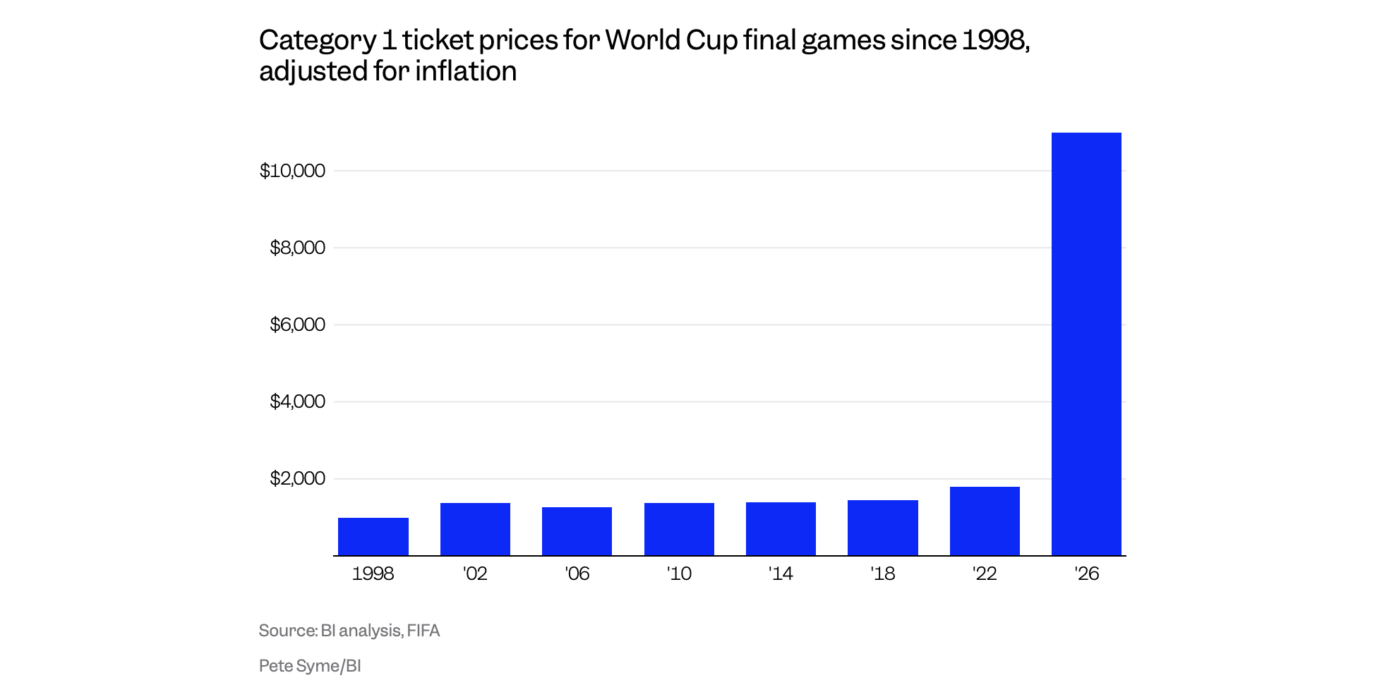
Figure 3 Inflation adjusted Category 1 prices for World Cup final matches rose gradually through 2022, while the listed 2026 price exceeds USD 10,000. Source Business Insider analysis of FIFA data, Category 1 ticket prices for World Cup final games since 1998, 2026.
The excitement is real. The crowd, the goal and the shared energy can make a live event unforgettable. The credit card bill remains after the adrenaline fades. Being your own chief financial officer does not mean refusing every experience. It means calculating the full cost before buying and deciding whether the expense fits your budget without forcing your future self to carry the balance for months.

