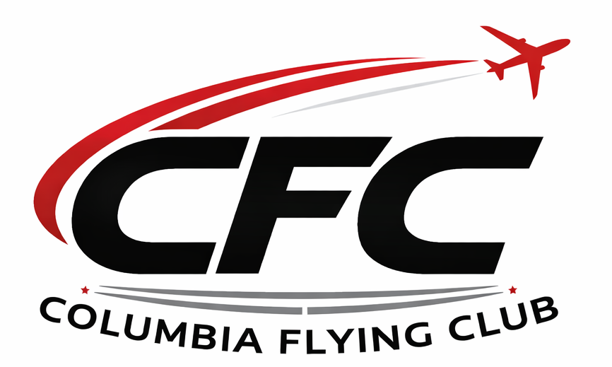
Columbia Flying Club
Member Handbook & Operating Rules
Revision 1.2
Welcome to the Columbia Flying Club (CFC)!
The Columbia Flying Club is a South Carolina nonprofit member organization dedicated to making aviation more accessible, affordable, and enjoyable. Our mission is to provide safe, well-maintained aircraft while fostering a professional aviation community built on safety, education, and camaraderie.
Membership in the Club is a privilege. Every member is expected to operate Club aircraft responsibly, comply with all Federal Aviation Regulations, and treat fellow members, instructors, aircraft, and Club facilities with professionalism and respect.
These Operating Rules establish the standards and procedures governing Club operations. Compliance with these rules is a condition of membership.

Table of Contents
1. Membership
2. Membership Dues & Billing
3. Member Conduct
4. Flight Operations
5. Aircraft Checkout & Currency
6. Aircraft Scheduling
7. Aircraft Pull-Out & Return Procedures
8. Aircraft Care
9. Damage to Aircraft
10. Maintenance & Aircraft Discrepancies
11. Clubhouse Rules
12. Financial Responsibility
13. Miscellaneous
14. Disciplinary Actions
15. Amendments
16. Member Acknowledgement

1. Membership
Membership is open to responsible individuals who support the mission of Columbia Flying Club. Membership applications are reviewed and approved by the Board of Directors. Members in good standing receive access to Club aircraft, events, and educational opportunities.

2. Membership Dues & Billing
• General Membership: $50/month or $500/year.
- Social Membership: $15/Month
• Scheduling privileges may be suspended if dues remain unpaid.
• Monthly Memberships must be paid with credit card via FSP
• Membership may be terminated if unpaid beyond the last day of the month.
• Members must maintain a valid payment method in Flight Schedule Pro.
- Members may add funds to account via Cash or Check to avoid 3% processing fee
• Credit cards incur a 3% processing fee.
• Flight charges are due immediately after each flight.

3. Member Conduct
Members shall conduct themselves professionally, operate aircraft safely, comply with FAA regulations, and treat Club property and fellow members with respect. Unsafe conduct, abuse of Club property, or failure to comply with Club rules may result in disciplinary action.

4. Flight Operations
Only Club-approved instructors may provide instruction in Club aircraft. Commercial operations are prohibited except authorized instruction. Hand-propping is prohibited. Operations from unimproved runways are prohibited unless specifically authorized.
No member, other than approved club flight instructors, shall operate club aircraft from the right seat. Aircraft may not fly outside the boundaries of the contiguous United States. In addition, no member may land at an airport unless it is a public airport published in the FAA airport/facility directory, except as a precautionary or emergency measure.

5. Aircraft Checkout & Currency
All members must complete a Club checkout before acting as PIC in Club aircraft. Members must remain current under FAA regulations and Club policies.
All new members will be subject to a check ride with a club approved instructor for each airplane the member wishes to fly
Any member may lose flying privileges and fined for the following reasons:
- Uses, operates or maintains the club equipment in a manner deemed irresponsible, hazardous, or unlawful whether it be motionless, or in motion.
- Acts or behaves in a manner detrimental, harmful, or disruptive to the clubs existence, operations, efficiency, safety, or morale.
- Fails to remit any payments required by the club

6. Aircraft Scheduling
Aircraft reservations shall be made through Flight Schedule Pro. Members shall cancel unused reservations promptly and notify the next member if delayed.
Members must note, in the comments section, on the scheduling page all points of intended landing or, if no landing is planned away from home airport, state other intentions.
Members reserving an aircraft for more than 12 hours will be charged as follows:
1-12 hour reservation: Actual Hobbs time
12-24 hour reservation: Minimum 2 hours or actual Hobbs time
24 hours or greater reservation: Minimum 2 hours per 24 hour period

7. Aircraft Pull-Out & Return Procedures
Hangar Access: Members are NOT authorized to access the Columbia Flying Club hangar unless specifically authorized by Club management.
Aircraft Pull-Out: Contact Eagle Aviation FBO before each flight and request the aircraft be pulled from the hangar. The aircraft will be staged on the ramp.
Aircraft Return: Return the aircraft to the Eagle Aviation ramp and notify the FBO that it is ready to be put away.
After Hours: If Eagle Aviation is closed, secure the aircraft with covers, control lock, and tie-downs (if applicable). Do not enter the hangar. Contact Eagle Aviation the next business day to arrange hangaring.

8. Aircraft Care
Leave the aircraft in better condition than you found it. Remove trash, clean bugs from the windshield and leading edges, secure the aircraft, install control locks, and verify all switches are OFF.

9. Damage to Aircraft
Any member using a club aircraft is responsible for damage to that aircraft not covered by insurance until determination of responsibility. Determination of responsibility will be decided by investigation of the FAA inspector, NBTSB, insurance company investigator, and/or the club.
If the member is found at fault he or she will pay full cost. (Full cost refers to deductible insurance costs and any fees and costs associated with returning the aircraft to the home base.) If the equipment or airplane is found to be at fault beyond the control of the member, the costs shall fall on the club.

10. Maintenance & Aircraft Discrepancies
Report all discrepancies immediately to the owner/club officer. Do not authorize maintenance or perform maintenance unless specifically approved by Club management.
Club aircraft are maintained by, or under the supervision of, proper certified mechanics and in accordance with FAA Regulations.
Members will be help responsible for any negligent act that caused unnecessary loss of revenue (i.e. Master switch left on, flat spots on tires, etc.) In this instance (Master switch left on and battery becomes fully depleted member will be required to cover the costs of purchasing a new battery)

11. Clubhouse Rules
Keep the clubhouse clean, lock all doors, turn off lights, and do not provide access to non-members. Smoking and vaping are prohibited.

12. Financial Responsibility
Members are responsible for aircraft rental charges, applicable fees, damage resulting from negligence, and lost equipment as outlined by Club policy.

13. Miscellaneous
Members using club aircraft for cross country and vacation flights shall be responsible for safe tiedown or hangaring of aircraft and all fees associated with same. Landing fees and overnight tiedown fees at airports other than the airplanes home base are the responsibility of the member.
Rental of the aircraft on a “wet” basis includes the cost of fuel used up to the price per gallon of aviation fuel from the fuel truck at the airplanes home base. A member who fuels a club airplane elsewhere will be reimbursed for fuel purchases up to $7.50/gallon on presentation of valid fuel receipts. Member will place the fuel receipt in the airplane binder with the N-number, member name, and date noted on the receipt.
Aircraft owners require that our members use Sporty’s online course. The club sells the kits for cost.

14. Disciplinary Actions
Violations may result in verbal warning, written warning, suspension of flying privileges, or termination of membership.

15. Amendments
These rules may be amended by the Board of Directors. Members will be notified of significant changes.

16. Member Acknowledgement
I acknowledge that I have read and understand the Columbia Flying Club Member Handbook & Operating Rules and agree to comply with all Club policies.

Member Name: ____________________________

Member Signature: _________________________

Date: _______________

